**Report on several structure analyses and learnings from the course**

By

**Siva Subramanian Sreekanth**

A Compilation of Exercises

Submitted in Partial Fulfillment of the Requirements for

the Applied Finite Element Analysis (MECH-8240-1) Course

in the Department of Mechanical, Automotive & Materials Engineering

at the University of Windsor

Windsor, Ontario, Canada

2022

© 2022 Sivasubramanian Sreekanth

**DECLARATION OF ORIGINALITY**

I hereby declare that this document solely contains my original work with no plagiarism or copied materials, subject to an automatic ‘zero’ grade in the (MECH-8240-1) course and disciplinary action per any/all relevant University of Windsor Senate Bylaws outlined in the course syllabus.

|  |  |  |
| --- | --- | --- |
| Siva Subramanian Sreekanth |  | November 24, 2022 |
| Student Signature |  | Date |

**Table of Contents**

Chapter 1: Executive summary 7

# Chapter 2: Solid generation using finite elements and analysis of the spring and damper system

12

2.1 Methodology Solid generation using Finite element model 12

2.1.1 OUTER PART CREATION 12

2.1.2 INNER PART CREATION 13

2.2 Analysis and Discussion Finite element model 14

2.3 Methodology 15

2.3.1 Methodology for Spring and Damper analysis by Implicit solution 15

2.3.2 Methodology for Spring and Damper analysis by Explicit solution 24

2.4 Discussion of Implicit and Explicit Analysis of Spring and Damper 26

2.4.1 Displacement Graph 26

2.4.2 Velocity Graph 27

2.4.3 Acceleration Graph 28

2.4.3 Force Graph 29

Chapter 3: Analysis of Square plate with hole in center having different number of elements 31

3.1 Methodology for creation of square plate with hole in center 31

3.1.1 Geometry 1 and 2 31

3.2 Analysis 34

3.2.1 Geometry 1 (d = 25.4 mm, W = 127 mm, t = 6.35 mm) Manual Calculation 34

3.3 LS- DYNA result and discussion 35

3.3.1 Geometry 1 35

3.3.2 Relative Error Graph 38

3.3.3 Geometry 2 39

3.3.3 Relative Error graph 42

Chapter 4: Solid vs. Shell Comparison 44

4.1 Methodology 44

4.2 LS- DYNA result and discussion 48

4.2.1 SHELL: Steel end to be fixed and Aluminium end to be loaded 48

4.2.2 SHELL: Aluminium end to be fixed and Steel end to be loaded 52

4.2.3 SOLID: Steel end to be fixed and Aluminium end to be loaded 56

4.2.3 SOLID: Aluminium end to be fixed and Steel end to be loaded 59

Chapter 5: Vibrational Analysis and Axisymmetric analysis of Structures 64

5.1 Methodology for creation of Z beam 64

5.2 LS- DYNA result and discussion 67

5.2.1 Vibrational analysis at first natural period for length 50,75 and 100mm 67

5.2.2 Vibrational analysis at fifth natural period for length 50,75 and 100mm 69

5.2.3 Vibrational analysis at tenth natural period for length 50,75 and 100mm 71

5.2.4 Vibrational analysis at twentieth natural period for length 50,75 and 100mm 73

5.2.5 Frequency vs Natural Period for 50, 75 and 100mm 75

5.3 Methodology for Axisymmetric beam 76

5.4 LS- DYNA result and discussion 79

5.4.1 X Displacement at node 87730 80

5.4.2 Y Displacement at node 87730 81

Chapter 6: Calculating the cumulative error and validation metrics between software and theoretical values 83

6.1 Formula Used 83

6.2 Methodology 83

6.3 LS- DYNA result and discussion 88

6.3.1 Lateral Displacement 88

6.3.2 Theoretical Calculation 91

Chapter 7: Conclusions 97

Reference 97

Appendix 97

# Executive summary

The rationale behind mesh resolution, how to mesh, and how to appropriately provide the number of elements/nodes in the LS Dyna software was understood, and finite element mesh is constructed. In Fig. 1.1, the finite element is depicted.

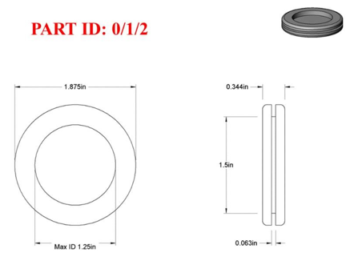

**Fig. 1.1: Dimensioned drawing of machine component which should be modeled as 3D structure using hexahedral elements.**

The displacement/time, velocity/time, acceleration/time, and force/time responses for the spring and damper were found for the suspension system by modelling a simple vehicle suspension as shown in Figure 1.2 and subjecting it to various load situations. In this study, results of both implicit and explicit analysis are identified and contrasted.

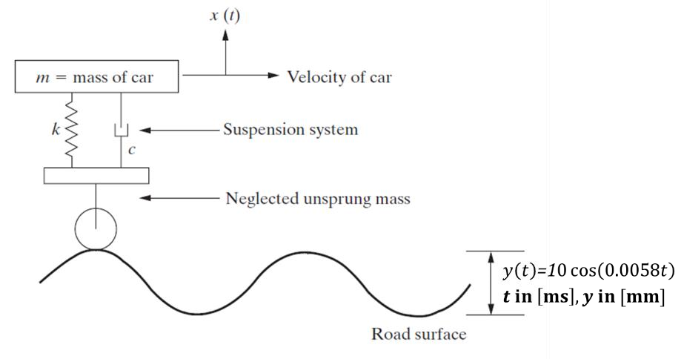

**Fig 1.2: Visualization of a simple car suspension model driving over a rough surface.**

In this course, it is noted that mesh sensitivity varies with element count. In addition, the analysis was performed for two square plates with various geometrical configurations, assuming aluminium material and shell section, with a 7.5 kN edge load applied at one end and boundary conditions at the other. Analysis is done for four different simulations of each geometry with different element sizes. By using stress calculations, the numerical values of the Kirsch stress concentration factor (Kt) for each mesh are compared to the corresponding analytical value. The relative inaccuracy for each scenario is calculated. The boundary condition and how the load works are shown in Figure 1.3. and in fig. 1.4, the number of elements is shown.

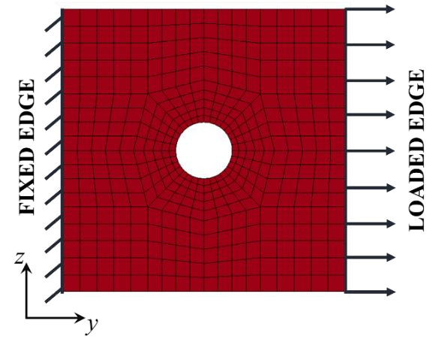

**Fig. 1.3: the boundary conditions for a finite element simulation.**

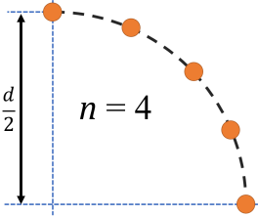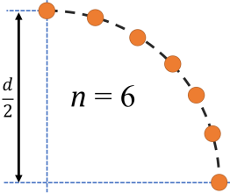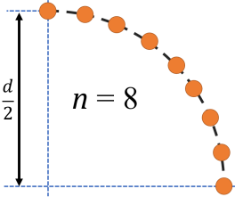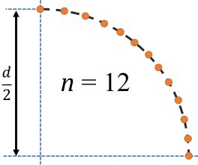

**Fig. 1.4 Required number of elements, *n*, on the quarter-radius for the mesh sensitivity study.**

The analysis includes distortion of cantilever made by combining two separate extrusions with a rigid adhesive. Four simulations are run, two with steel as the material presumed to be solid and the shell, and two with aluminium as the material. One end of a structure is subjected to constant cantilever distortion, while the other end is kept fixed. The study focuses on the stress analysis between shell and the solid elements. The material is depicted on Fig 1.5.

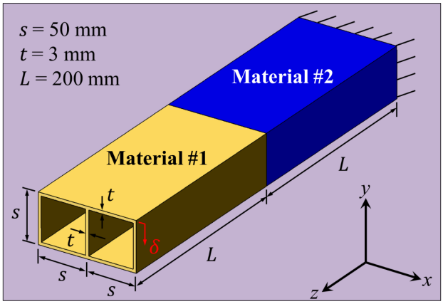

**Fig. 1.5 Schematic of the multi-material extrusion subjected to cantilevered deformation.**

The structure's vibrational analysis is a topic covered in the course. The vibrational frequency of an extruded structural part with the cross-section and material of 425 copper depicted in Fig. 1.6 is measured over a range of natural periods of vibration.

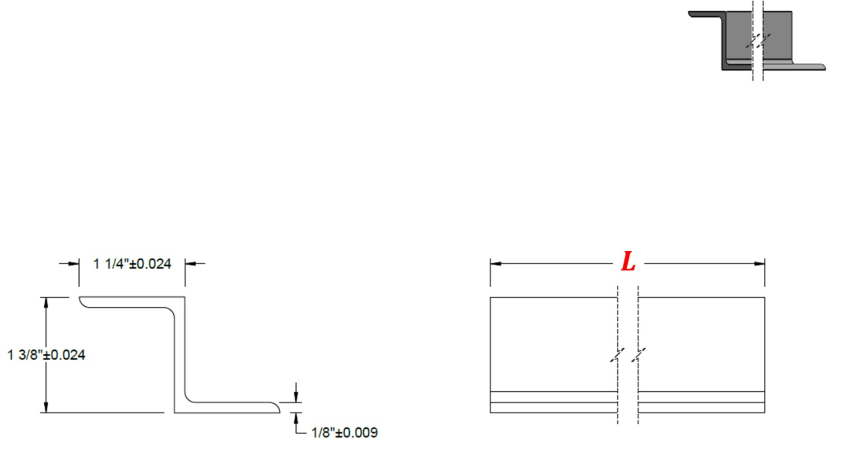

**Fig 1.6 Schematic of the cross-section of a structural member.**

The study of axisymmetric structure is one of the most important topics covered in this course. For both full mesh and half symmetry, a static load is applied to the specified beam. Certain boundary conditions are used for both symmetries. For the half-symmetry mesh, the load value is scaled, whereas the full load is applied to the nodes of the full mesh solid. The outcomes of the full and reduced models are then contrasted. The axisymmetric model is shown in Fig. 1.7.

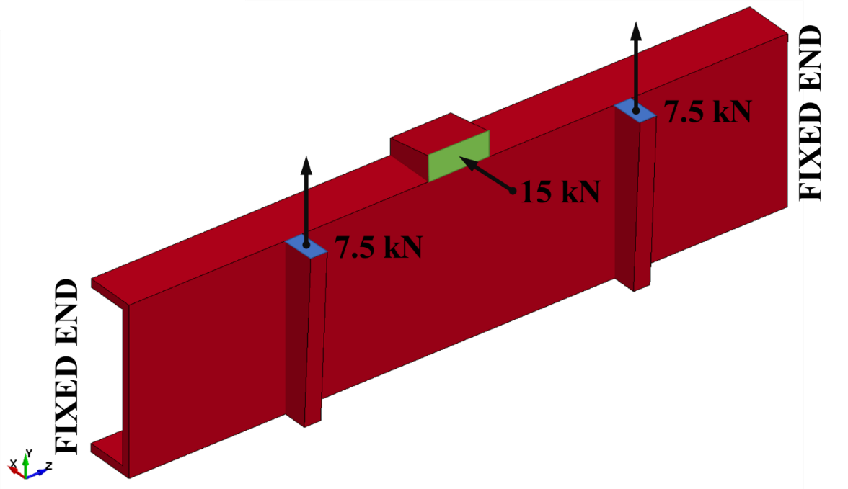

**Fig. 1.7 Schematic of a structural member subjected to multiaxial bending**

Software-generated solutions are intended to be precise. By generating a Multi Section solid and studying it for 250ms with a specific load and displacement at each millisecond, an analysis is done. Formulas are provided for calculating the theoretical value. The validation metric and cumulative error discovered with the data are used to compare the numerical and theoretical values. The most axial and lateral deformation-resistant segment is condensed. Finally, several reasons why the simulations and the accompanying theoretical answers differ from each other are examined. The multi-celled geometries are depicted in Fig. 1.8.

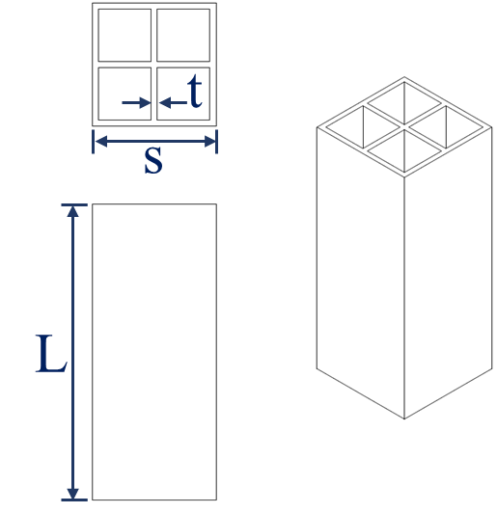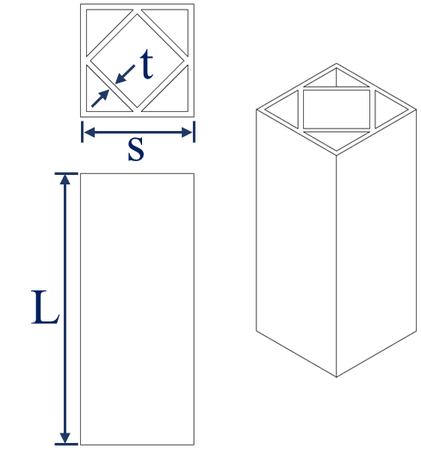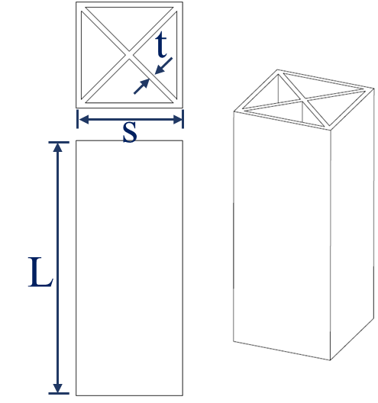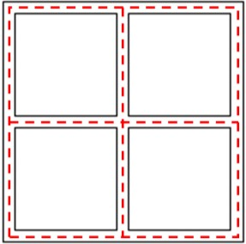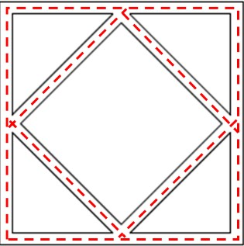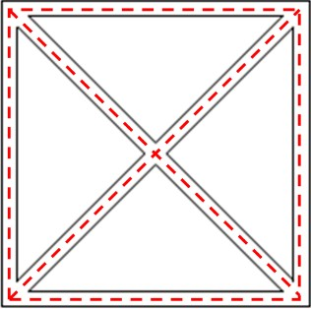

(a) (b) (c)

**Fig. 1.8: Hypothetical multi-celled geometries for a square cross-sectioned tube, presented as (a) Geometry I, (b) Geometry II and (c) Geometry III; L = 150 mm, s = 30 mm, t = 3 mm.**

# Solid generation using finite elements and analysis of the spring and damper system

## Methodology Solid generation using Finite element model

The 3D model is done in LS-Prepost as 2 parts. One the outer part and the inner part.

### OUTER PART CREATION:

Create a 2D sketch in LS-Prepost using 2D mesh interface in page 7. Create a sketch with the dimensions mentioned in the question as shown in Fig 2.1.

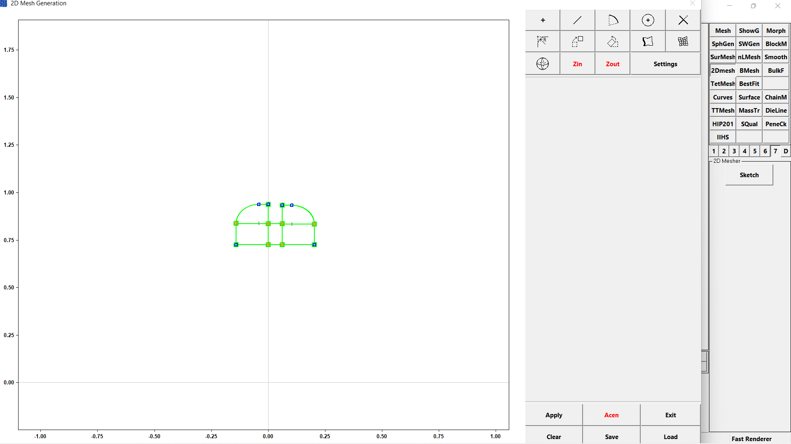

**Fig 2.1 2D sketch of outer part**

Create edge using “**create/delete edge option”.** To create an edge, click on **create** radio button **🡪 select the line 🡪 create** button. Select **No. ele/edge** radio button, enter value for “**No. ele/edge**” and click on the edge to create node elements on the edge. The number of nodes determines the mesh quality. Create Mesh by selecting the **create/Delete Mesh** option as shown on fig 2.2.

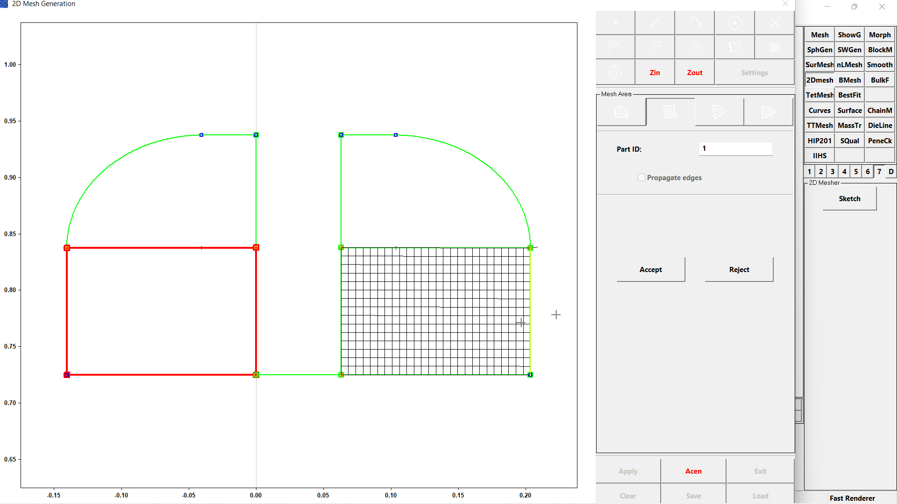

**Fig 2.2 2D sketch of outer part**

Once the mesh is created part will be created under **\*Part.** To generate solid element use **Elgen** interface. Select the part to be generated by checking the **Bypart** radio button. Select **solid** radio button to create a solid structure, select **Solid_Face_spin** option, provide angle as 90 and adjust the segment value to get better mesh. Then click on **Create🡪 Accept🡪Done.**

### INNER PART CREATION

Save the sketch 1 and click on clear button on **2Dmesh 🡪 Sketch** to clear the existing sketch. Create a new 2D Sketch of circle with diameter of 0.725 inch. Convert the circle into quarter circle for better meshing. Create lines in the quarter circle to create a butterfly mesh. Break the lines wherever it is necessary and delete the unnecessary line if any lines are there. Create edges on the quarter circle wherever it is needed. Createthe node elements on the edges. It is better to give segment value of part 1 and number of node elements in curve surface of part 2. Create the Mesh once the node elements are mentioned and click on **Apply🡪 Exit** to view the part. Click on **Rotate** interface, select the part and rotate the part at 90 degrees with respect to X axis. Click on the **ElGen 🡪 Solid 🡪** select the part **🡪 Solid_Face_Drag 🡪** enter the number of segments and thickness as 0.063 **🡪Create 🡪 Accept 🡪 Done** to generate element for part 2. The part will be created as shown in fig 2.3.

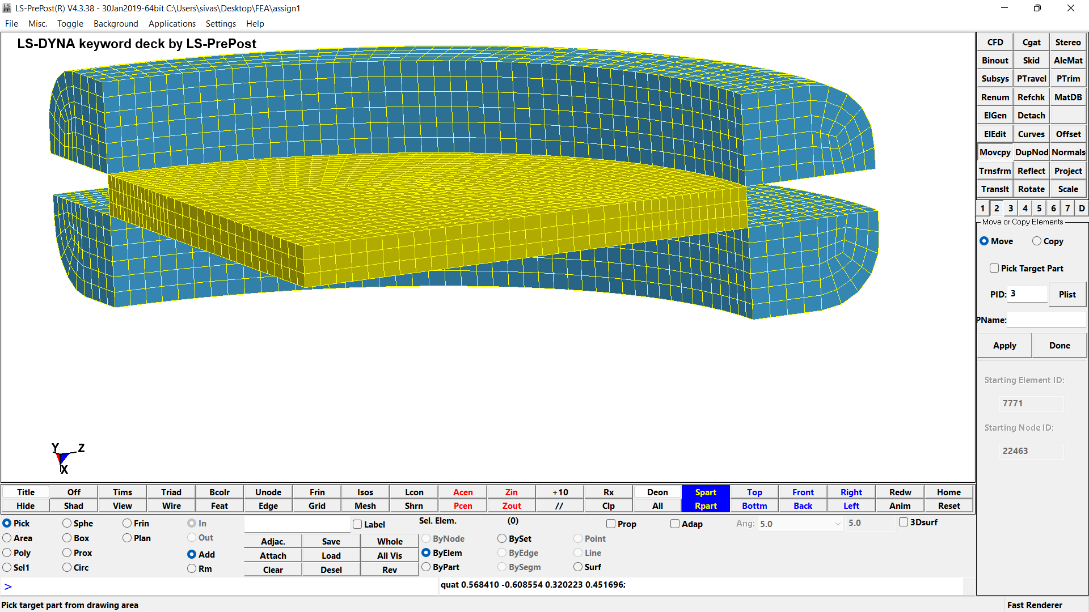

**Fig 2.3 Solid part 1 and part 2 after element generation**

Delete the Mesh created initially before the element generation.Use **Movcpy** interface to combine the two parts into one single part. This is done by checking the **move** radio button 🡪selecting part 1 **🡪** checking the **Pick Target Part** checkbox 🡪 select part 2 🡪 Apply 🡪 Done. Go to **DupNodes** interface click on **Show Dup Nodes** button and select **Merge Dup Nodes** to remove all the duplicate nodes. Use **Reflect** interface to create the copy of same part to form a full part. Remove the duplicate nodes created after creating the complete part. Click on **Renum** interface to renumber all the parts in the file.

## Analysis and Discussion Finite element model:

In LS Prepost, new parts are produced when mesh and element generation are created using the ElGen option. When there are more parts than are necessary, Ls prepost does not produce the desired outcome. Therefore, the leftover components must be eliminated after solid creation. Duplicate nodes need to be merged since they affect the model's outcome differently.

## Methodology

### Methodology for Spring and Damper analysis by Implicit solution

To create a discrete element, first nodes must be defined. To create nodes " **\*Node**" interface is used fig 2.4. Click on **NewID 🡪 Accept 🡪 Done.** Node 1 is created at the origin withX, Y and Z as 0. Create node 2 at X=0, Y=100, Z=0. (Units are in mm). The total length of the system is assumed to be100.

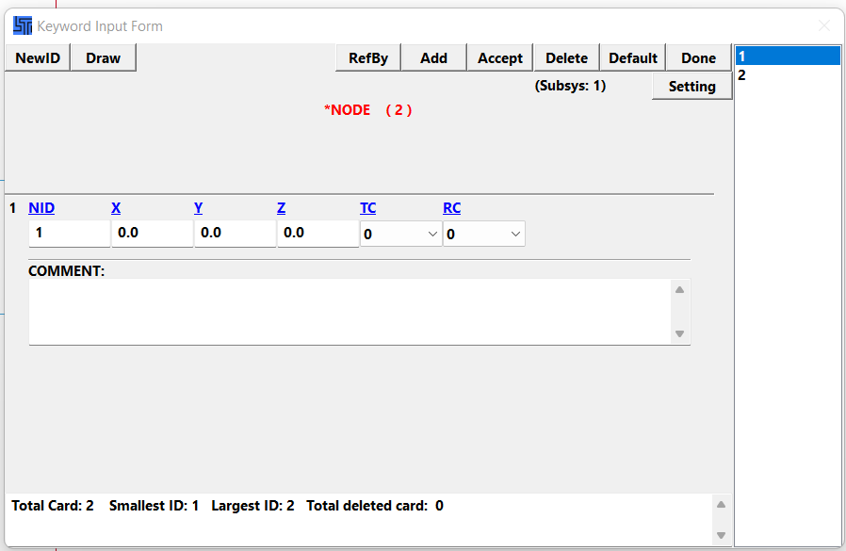

**Fig 2.4 *Node – Keyword Input Form**

Use the "**\*Elem**" to create the element. To create a discrete element, select “**DISCRETE”** keyword. In the keyword input form click **NewID 🡪 Enter the values (PID - 1, N1 -1, N2 - 2) 🡪Accept 🡪 Done** asshown in fig 2.5**.** Similarly create total of two discrete elements are to be created.

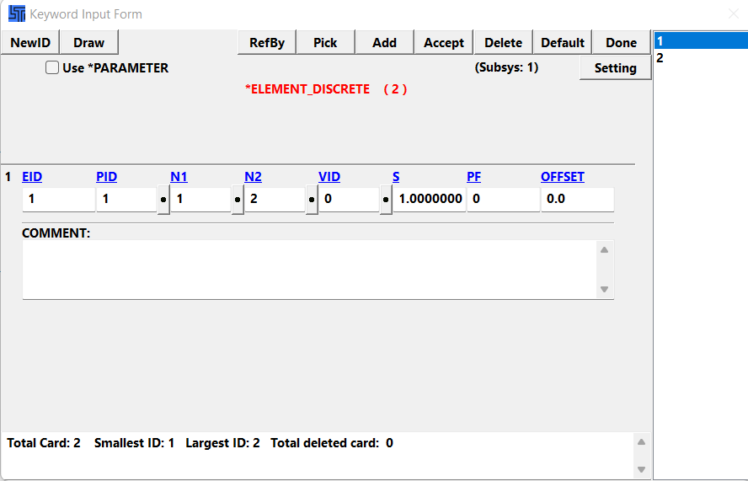

**Fig 2.5 *Elem – Discrete – keyword form**

To create a mass element, select “**MASS”** keyword and click **NewID 🡪 Enter the values (NID – 2, MASS – 1000000 (grams) ) 🡪Accept 🡪 Done** asshown if fig 2.6**.**

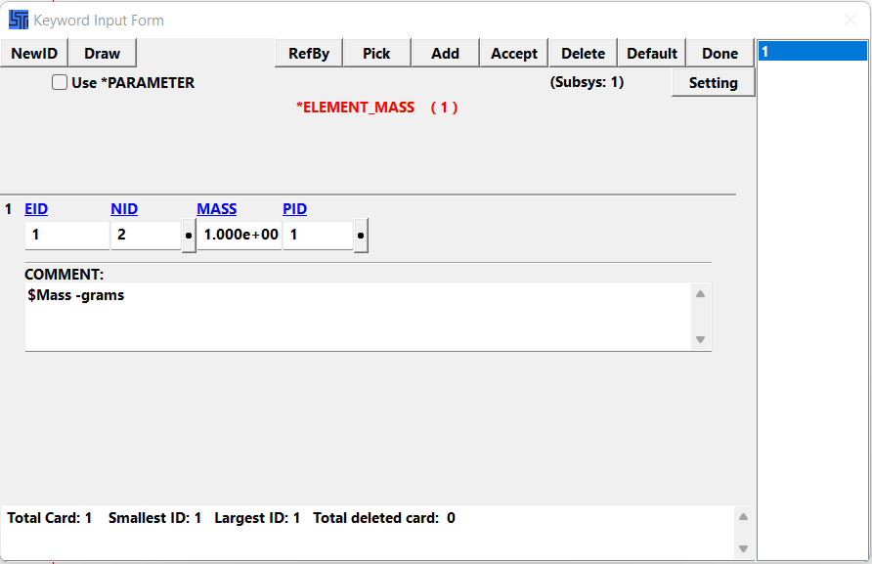

**Fig 2.6 *Elem – MASS – Keyword Input Form**

Using the "**\*Section**" create two discrete sections, one for the spring and another for damper as shown in fig 2.7. Select **DISCRETE** keywordand click on **NewID 🡪 TITLE (SPRING) 🡪Accept 🡪 Done.** Follow the same steps to create one for Damper.

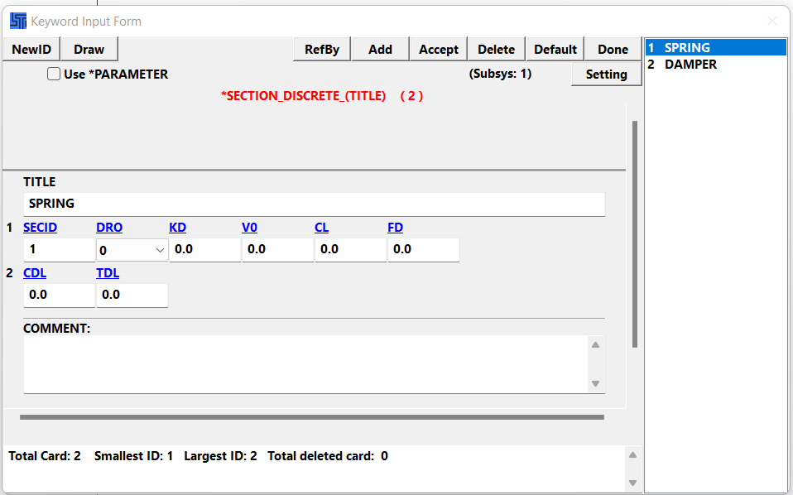

**Fig 2.7 *Section – DISCRETE – Keyword Input Form**

To define the material of spring, click on **\*Mat** 🡪 **S01-SPRING_ELASTIC** 🡪**NewID 🡪 Enter the values (Title -SPRING, k- 40 (N/mm)) 🡪 Accept 🡪 Done.** The spring material will be created as show in the fig 2.8.

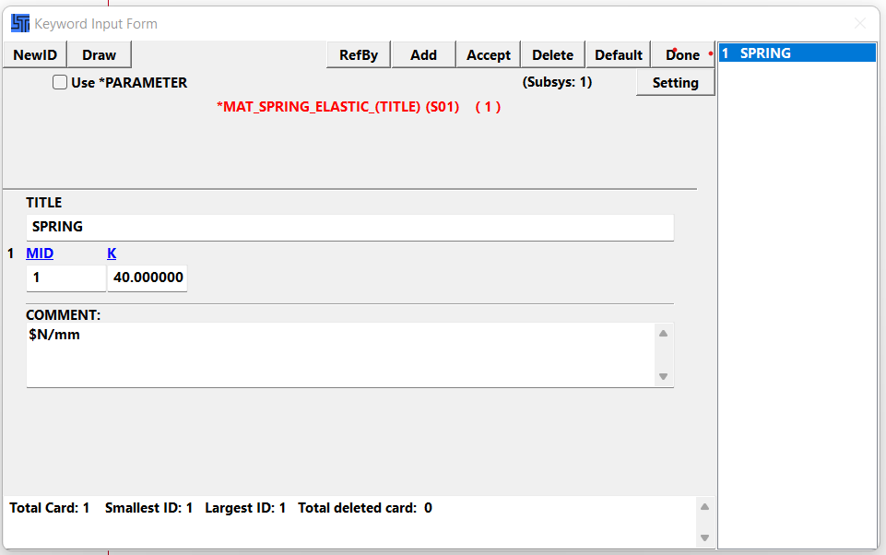

**Fig 2.8 *Mat – S01-SPRING_ELASTIC – Keyword Input Form**

For damping material click **\*Mat** 🡪 **S02-DAMPER_VISCOUS** 🡪**NewID 🡪 Enter the values (Title -DAMPER, DC- 2000 (g/ms)) 🡪 Accept 🡪 Done.** The damping material will be created as shown in fig 2.9.

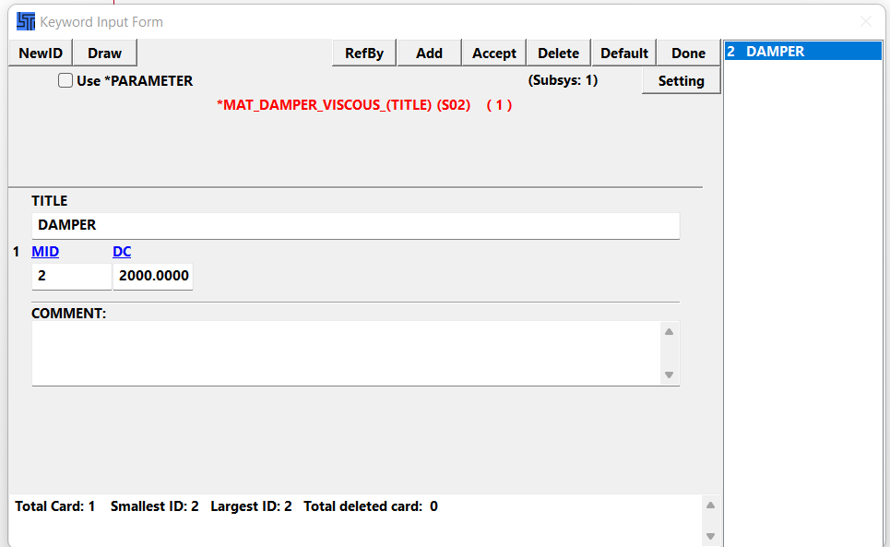

**Fig 2.9 *Mat – S02-DAMPER_VISCOUS – Keyword Input Form**

Add the material and section to the parts in **\*PART** asshown in fig 2.10.

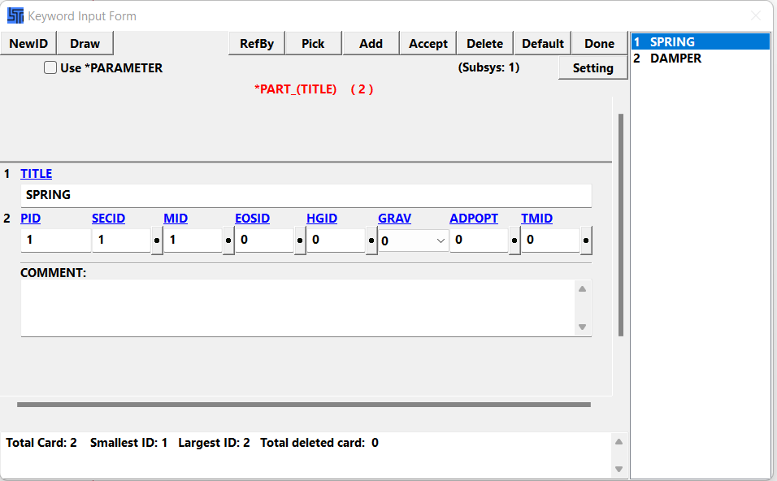

**Fig 2.10 *PART– Keyword Input Form**

The movement of node is constrained by setting the boundary conditions. **\*SPC 🡪 select the node (node 1) 🡪 check the x, z, rx, ry, rz box (can move only in y direction) 🡪Apply 🡪 Done.** To define the given curve function go to **\*Define🡪 CURVE_FUNCTION 🡪 NewID 🡪 Enter the values (TITLE – (D-T), FUNCTION - 10*COS(0.0058*TIME))** 🡪 **Accept 🡪 Done** as done in Fig 2.11.

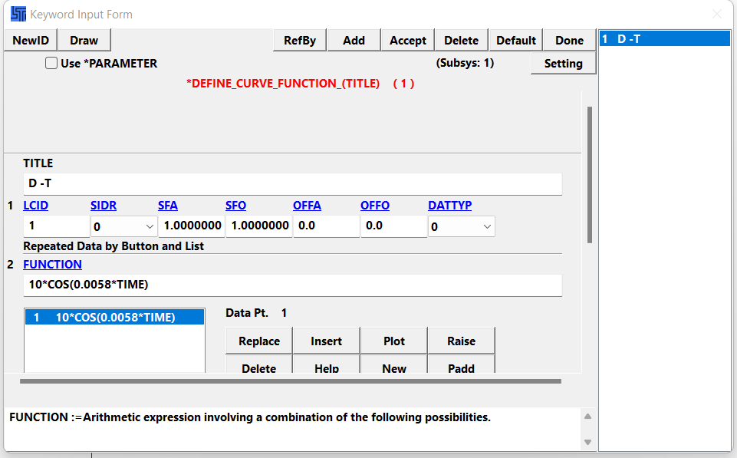

**Fig 2.11 *PART– Keyword Input Form**

Under **\*Control** interface, do the following.

1. click on “**TERMINATION”** andenter the time value in millisecond. Click on “**Accept”** and “**Done”.** Refer fig 2.12.

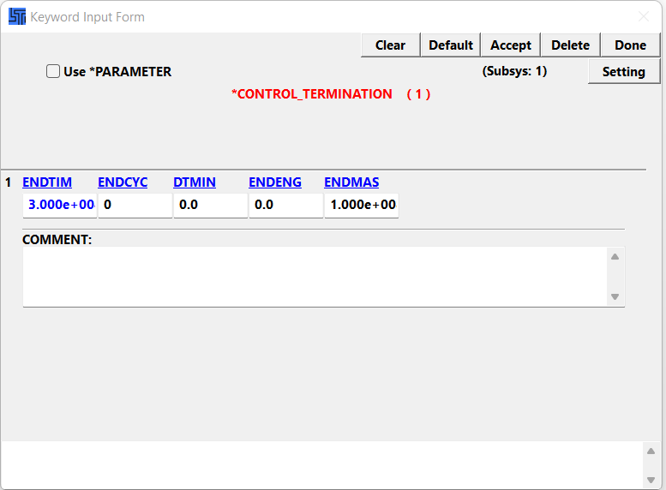

**Fig 2.12 *Control – TERMINATION - Keyword Input Form**

1. click on “**IMPLICIT_GENERAL”** andenter IMFLAG as 1 and set DT0 as 10. Click on “**Accept”** and “**Done”.** Refer fig 2.13.

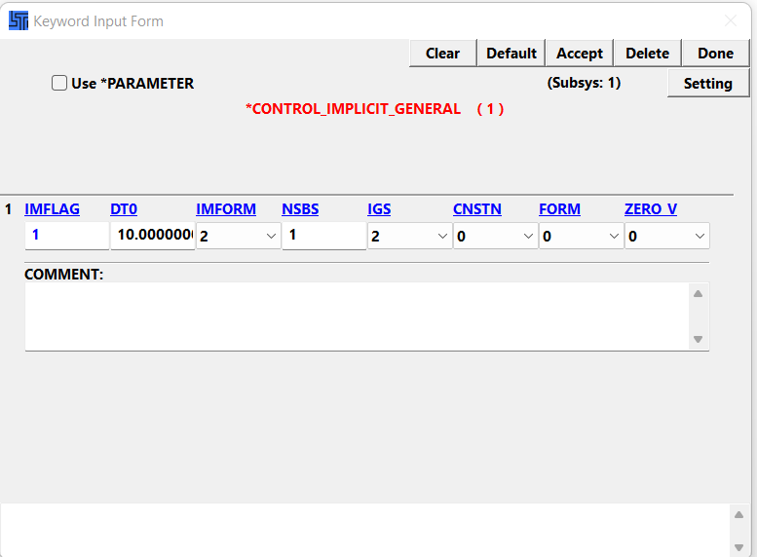

**Fig 2.13 *Control – IMPLICIT_GENERAL - Keyword Input Form**

1. click on “**IMPLICIT_AUTO”** and click on **Accept 🡪 Done.**
2. click on “**IMPLICIT_SOLUTION”** and click on **Accept 🡪 Done.**
3. click on “**IMLICIT_DYNAMICS”** andenter the **IMASS** value as 1,click on **Accept 🡪 Done.**

Under **\*Dbase** interface, do the following.

1. click on “**ASCII_option”,** select the data needed**,** enter the data point valuesand click on **Accept 🡪 Done** asshown in fig 2.14**.**

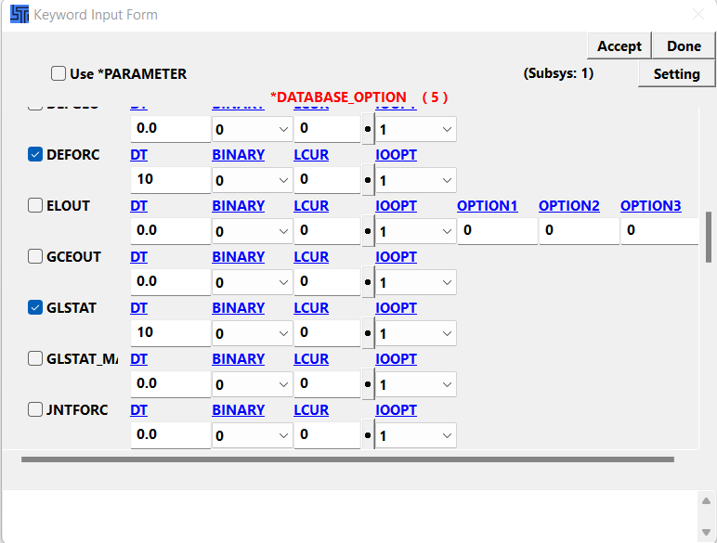

**Fig 2.14 *Control – ASCII_option - Keyword Input Form**

1. click on “**BINARY_D3PLOT”,** enter the valuesand click on **Accept 🡪 Done** asshown in fig 2.15**.**

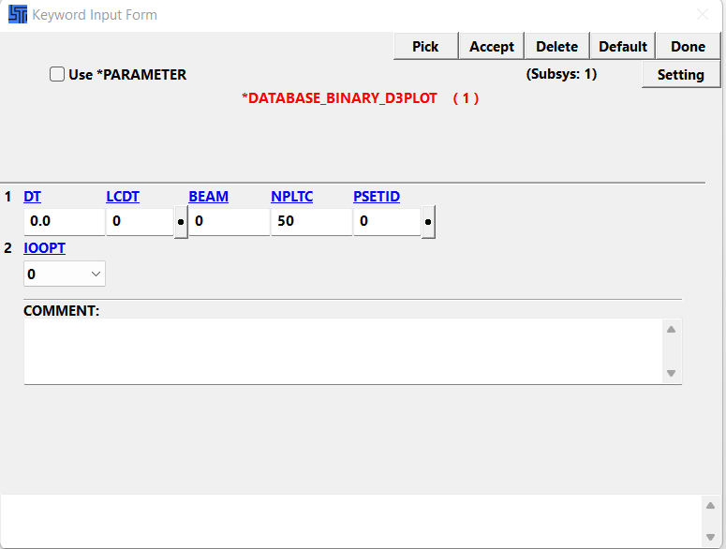

**Fig 2.15 *Control – BINARY_D3PLOT - Keyword Input Form**

1. **HISTORY_NODE** is one of the main keyword to be used when the system is discrete.

click on “**HISTORY_NODE”,** enter the node valuesand click on **Accept 🡪 Done** asshown in fig 2.16**.**

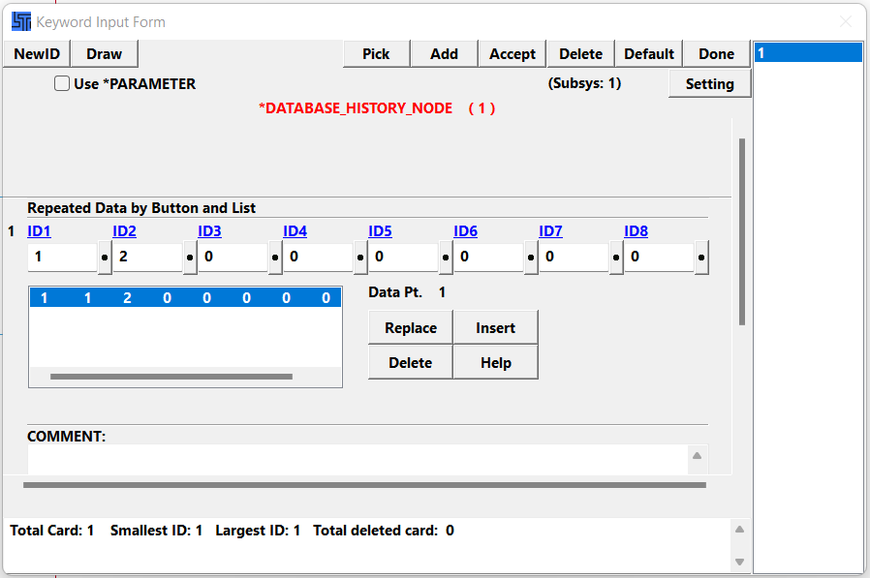

**Fig 2.16 *Control – BINARY_D3PLOT - Keyword Input Form**

**STEP 10:** Save the keyword file and Run the file in LS-DYNA.

**STEP 11:** After execution of the file open the “**d3plot**” binary file. Click on **ASCII 🡪 nodout* 🡪 Load 🡪 Select 1: and 2: , also select the type of graph (Y-displacement) 🡪 Plot.** The graph will appear. Refer fig Fig 2.17.

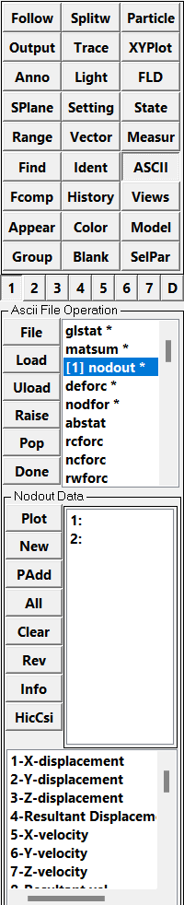

**Fig 2.17 Graph plotting method**

### Methodology for Spring and Damper analysis by Explicit solution

For explicit solution repeat step 1 to step 6 as in implicit function. To define curve, go to **\*Define🡪 CURVE 🡪 NewID 🡪 Enter the values (Insert two values for A1 and O1 (0,1) and (1,1), SFA – 40000, SFO - 10)** 🡪 **Accept 🡪 Done** as done in Fig 2.18.

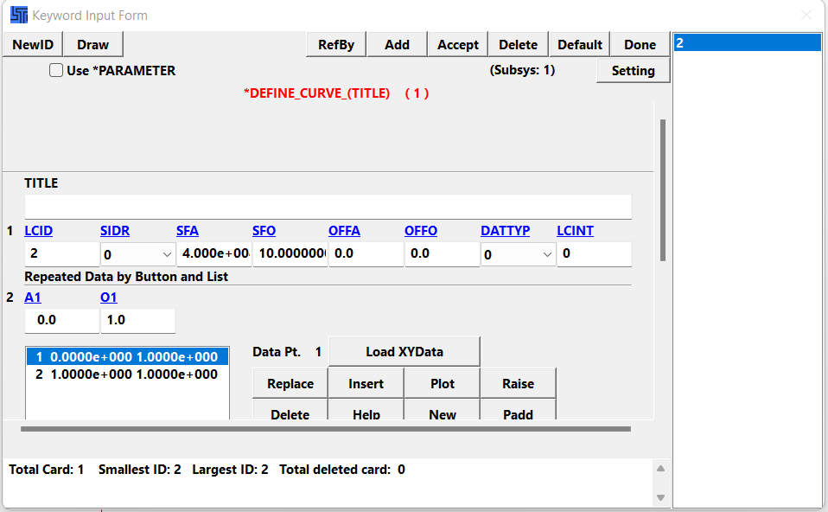

**Fig 2.18 *Define – CURVE - Keyword Input Form**

Under **\*Control** interface, do the following.

1. click on “**TERMINATION”** andenter the time value in millisecond. Click on “**Accept”** and “**Done”.**
2. click on “**TIMESTEP”** andenter the value (DT2MS – 10, LCTM – 1 (Curve that is defined)). Click on “**Accept”** and “**Done”.** Refer fig 2.19.

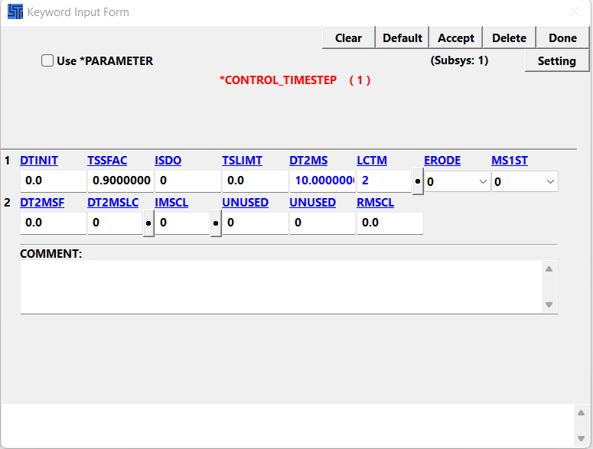

**Fig 2.19 *Control – TIMESTEP - Keyword Input Form**

Follow the same steps from step 9 to step 11 as Implicit solution.

## Discussion of Implicit and Explicit Analysis of Spring and Damper:

### Displacement Graph:

Both the implicit and explicit analyses of the spring and damper displacement graph show the same results. The displacement graph of implicit and explicit analysis is shown in Fig 2.20 and Fig 2.21 respectively.

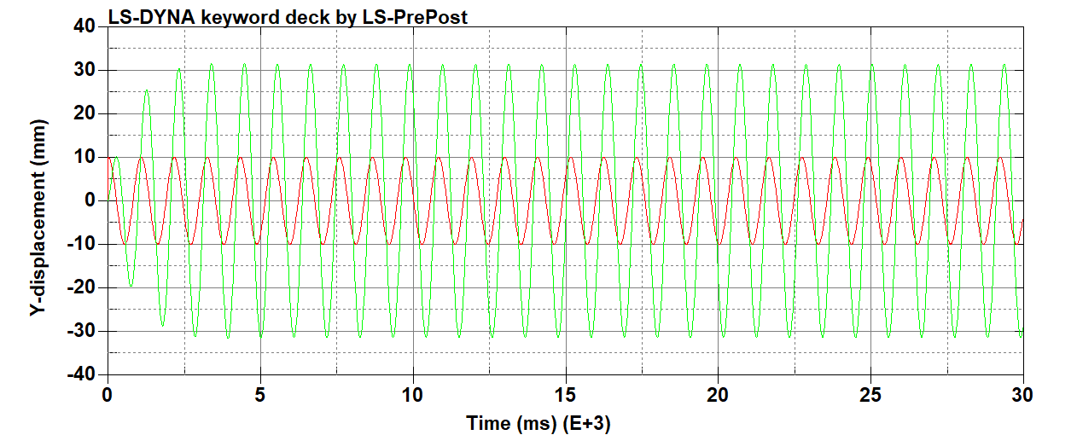

**Fig 2.20 Displacement Graph – Implicit**

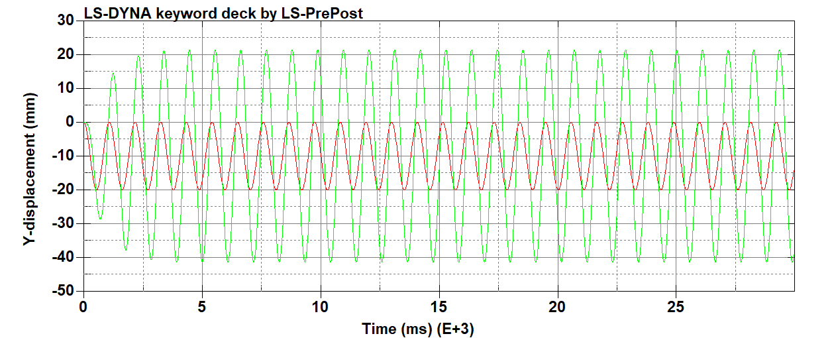

**Fig 2.21 Displacement Graph – Explicit**

### Velocity Graph:

The spring and damper velocity graph's implicit and explicit analysis provide the same conclusions. Both the implicit and explicit analysis velocity graphs are displayed in Figures 2.22 and 2.23, respectively.

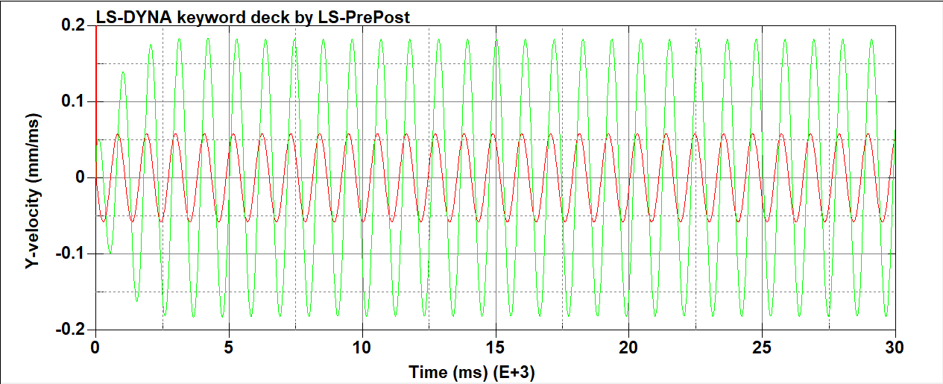

**Fig 2.22 Velocity Graph – Implicit**

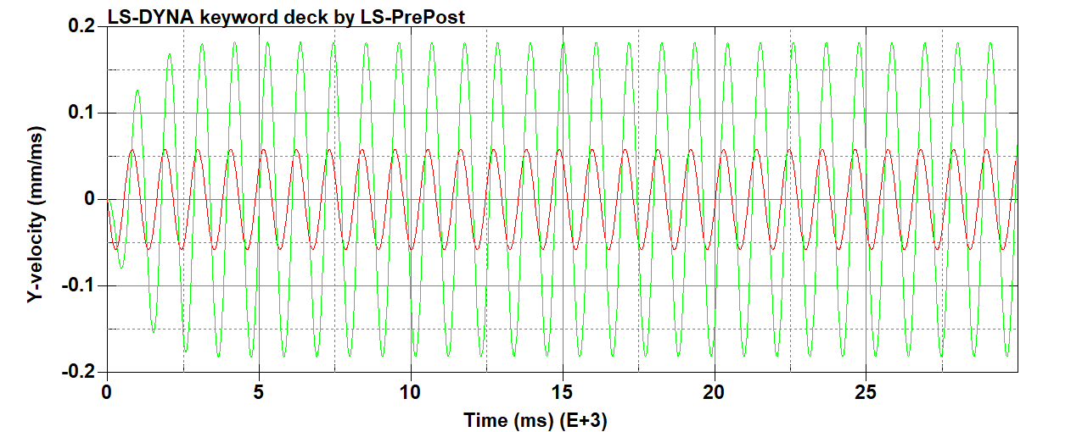

**Fig 2.23 Velocity Graph - Explicit**

### Acceleration Graph:

The spring and damper acceleration graph's implicit and explicit analysis provide the same conclusions. Both the implicit and explicit analysis acceleration graphs are displayed in Figures 2.24 and 2.25, respectively.

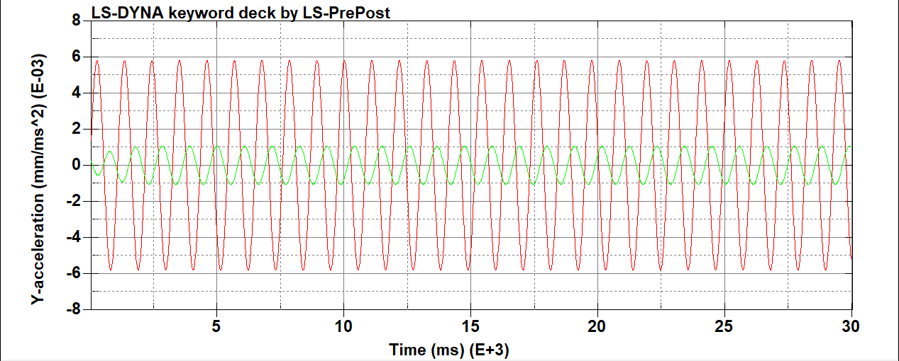

**Fig 2.24 Acceleration Graph – Implicit**

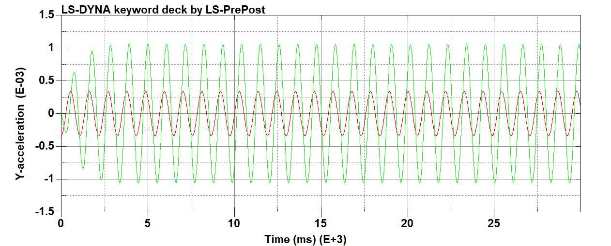

**Fig 2.25 Acceleration Graph – Explicit**

### Force Graph

Both the implicit and explicit analyses of the spring and damper force graph yield the same results. The analysis, both implicit and explicit Figures 2.26 and 2.27, respectively, show force graphs.

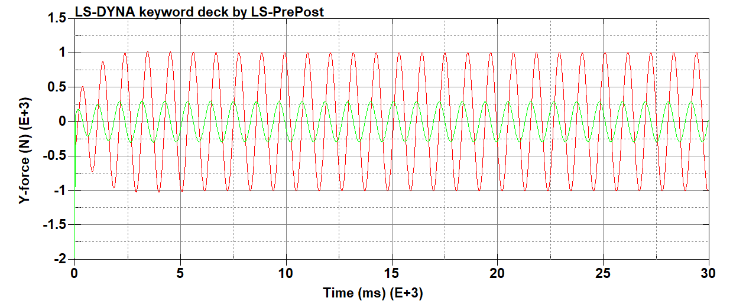

**Fig 2.26 Force Graph – Implicit**

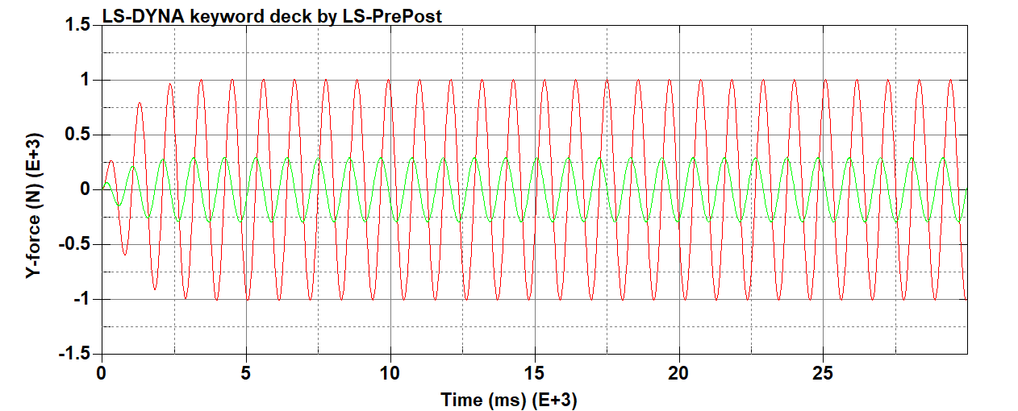

**Fig 2.27 Force Graph – Explicit**

# Analysis of Square plate with hole in center having different number of elements

## Methodology for creation of square plate with hole in center

### Geometry 1 and 2:

A 2D (2-dimensional) sketch of the quarter plate with the hole is created using the **2DMesh 🡪 Sketch** command. The basic sketch is created using lines and circles for the given dimensions. The edges are created by selecting the **Create/Delete Edges** command under **Sketch** as shown in fig 3.1.

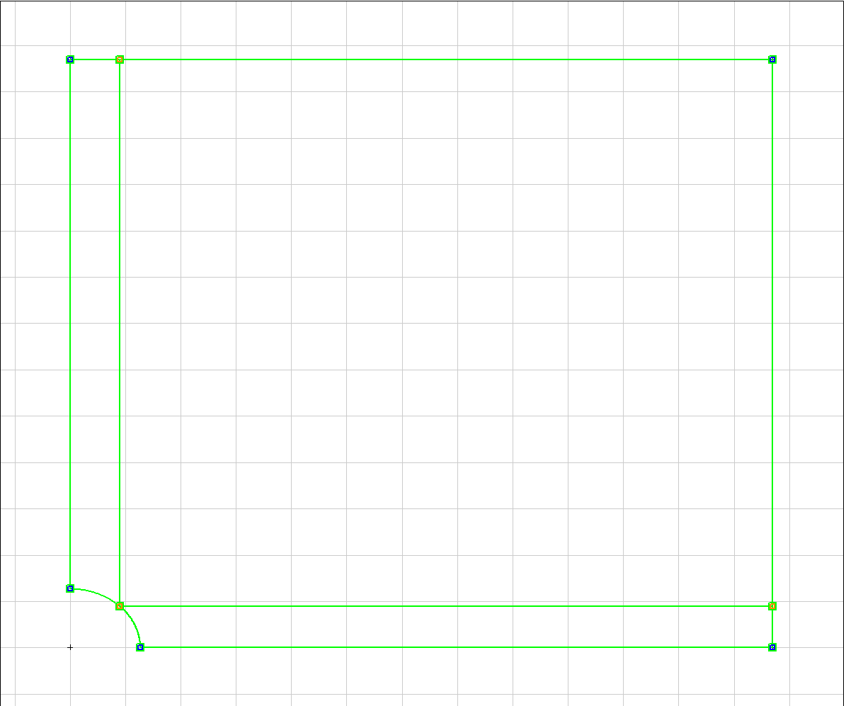

**Fig 3.1 Created edges for 2D sketch of quarter plate with hole.**

Once the edges are created, the number of elements is mentioned to create a mesh. The number of elements to be created on the quarter circle is mentioned to be 4, 6, 8, and 12 for four plates respectively. Once the number of elements is determined, the mesh is created using the **Create/Delete mesh** command. Mesh for quarter plate is shown in fig 3.2.

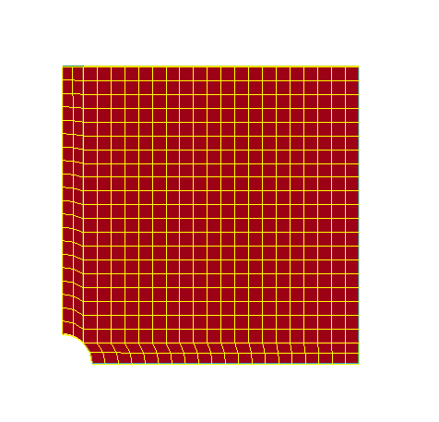

**Fig 3.2 Created mesh for 2D sketch of quarter plate with hole.**

The meshed part is then reflected with respect to the X-axis and Y-axis using the **Reflect** interface to create a full plate with a hole in the centre. The part is shown in fig 3.3.

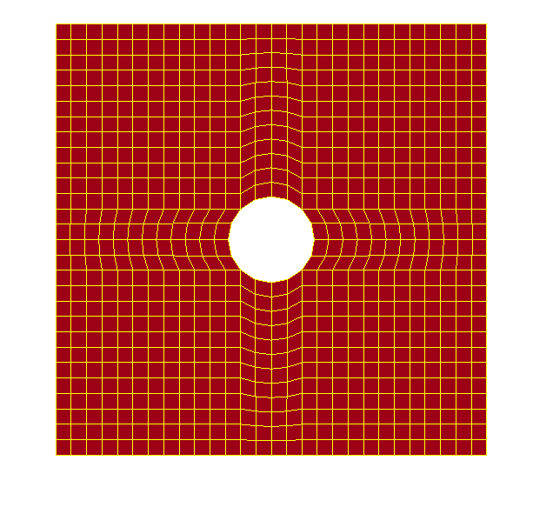

**Fig 3.3 Plate with hole in centre and meshed**

When part is reflected, the two edges combine and create duplicate nodes. Using the **DupNodes** interface, the duplicate nodes created are merged. Use **the Translt** interface to translate the mesh part and create other parts with different numbers of elements as mentioned in the question. See Figure 3.4.

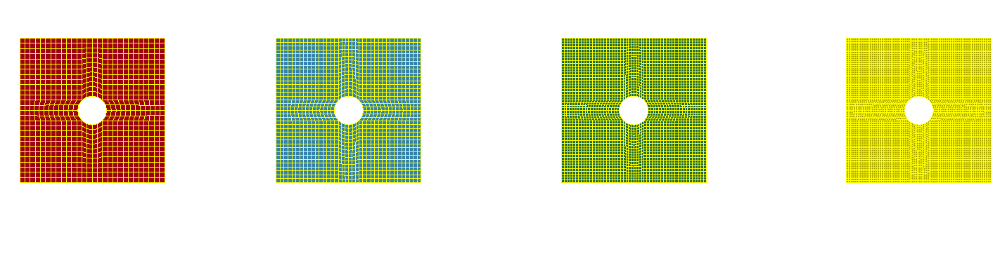

**Fig 3.4 Four different parts with four different number of elements.**

In the **SPC** interface, select the edge and propagate option. Select the edge to be fixed and constrain the edge by checking all the direction checkboxes. Under the **SetD** interface, select the edge and propagate option. Select the edge and enter a name for the nodes. As a result, the nodes to which force will be applied are determined. Repeat the same steps for the other plates.

Define the load curve function. The curve function increases from zero to the specific load and then remains stable there. The curve function is defined under the **"*Define"** interface. The load curve is shown in fig. 3.5.

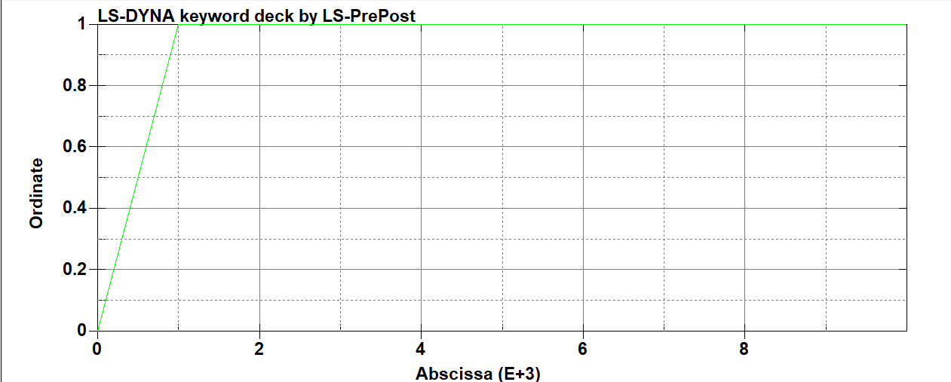

**Fig 3.5. Load’s curve graph**

Define the implicit values and termination values under the **"*Control"** interface. The termination value is the total time value till which the software runs. The **"ASCII"** and **"BINARY D3PLOT"** options are chosen under the **"Dbase"** interface to obtain the output.

## Analysis:

### Geometry 1 (d = 25.4 mm, W = 127 mm, t = 6.35 mm) Manual Calculation:

**𝐾𝑡,𝑖𝑛𝑓 = 3 - (3.14 * (𝑑 / 𝑊)) + (3.667 * (𝑑 / 𝑊) ^ 2) - (1.527 * (𝑑 / 𝑊) ^ 3)**

𝐾𝑡,𝑖𝑛𝑓 = 3 - (3.14 * (25.4 / 127)) + (3.667 * (25.4 / 127) ^ 2) - (1.527 * (25.4 / 127) ^ 3)

𝐾𝑡,𝑖𝑛𝑓 = 3 - (3.14 * (0.2)) + (3.667 * (0.2) ^ 2) - (1.527 * (0.2) ^ 3)

𝐾𝑡,𝑖𝑛𝑓 = 3 - (3.14 * (0.2)) + (3.667 * 0.04) - (1.527 * 0.008)

𝐾𝑡,𝑖𝑛𝑓 = 3 - (0.628) + (0.14668) - (0.012216)

**𝐾𝑡,𝑖𝑛𝑓 = 2.5064**

**𝜎𝑛𝑜m = 𝜎∞ * ((𝑊 – 𝑑) / 𝑊) = 𝐹𝑎𝑝𝑝𝑙𝑖𝑒𝑑 / (𝑡* (𝑊 − 𝑑))**

**𝜎𝑛𝑜m =** 𝜎∞ * ((127 – 25.4) / 127) **=** 7500 / (6.35 * (127 – 25.4))

**𝜎𝑛𝑜m = 11.6250** **N/mm^2**

**𝐾𝑡 = 𝜎𝑚𝑎𝑥 / 𝜎𝑛𝑜m**

𝜎𝑚𝑎𝑥 = 𝜎𝑛𝑜m * 𝐾𝑡

𝜎𝑚𝑎𝑥= 11.6250 * 2.5064

**𝜎𝑚𝑎𝑥 = 29.1369 N/ mm^2**

### Geometry 2 (d = 12.7 mm, W = 127 mm, t = 6.35 mm) Manual Calculation:

**𝐾𝑡,𝑖𝑛𝑓 = 3 - (3.14 * (𝑑 / 𝑊)) + (3.667 * (𝑑 / 𝑊) ^ 2) - (1.527 * (𝑑 / 𝑊) ^ 3)**

𝐾𝑡,𝑖𝑛𝑓 = 3 - (3.14 * (12.7 / 127)) + (3.667 * (12.7 / 127) ^ 2) - (1.527 * (12.7 / 127) ^ 3)

𝐾𝑡,𝑖𝑛𝑓 = 3 - (3.14 * (0.1)) + (3.667 * (0.1) ^ 2) - (1.527 * (0.1) ^ 3)

𝐾𝑡,𝑖𝑛𝑓 = 3 - (3.14 * (0.1)) + (3.667 * 0.01) - (1.527 * 0.001)

𝐾𝑡,𝑖𝑛𝑓 = 3 - (0.314) + (0.03667) - (0.001527)

**𝐾𝑡,𝑖𝑛𝑓 = 2.7211**

**𝜎𝑛𝑜m = 𝜎∞ * ((𝑊 – 𝑑) / 𝑊) = 𝐹𝑎𝑝𝑝𝑙𝑖𝑒𝑑 / (𝑡* (𝑊 − 𝑑))**

**𝜎𝑛𝑜m =** 𝜎∞ * ((127 – 12.7) / 127) **=** 7500 / (6.35 * (127 – 12.7))

**𝜎𝑛𝑜m = 10.3333** **N/mm2**

**𝐾𝑡 = 𝜎𝑚𝑎𝑥 / 𝜎𝑛𝑜m**

𝜎𝑚𝑎𝑥 = 𝜎𝑛𝑜m * 𝐾𝑡

𝜎𝑚𝑎𝑥= 10.3333 * 2.7211

**𝜎𝑚𝑎𝑥 = 28.1179 N/ mm2**

## LS- DYNA result and discussion:

#### Geometry 1:

A value known as the von Mises stress is used to predict whether a certain material will yield or fracture [1]. Fig 3.6 provides the von Mises stress analysis of a plate having 4 number of elements or having less mesh sensitivity in LS-Dyna Software. From the analysis, the maximum stress obtained is 20.81 N/mm2 at the top and bottom surfaces (red area) of the hole, and the minimum stress is 3.324 N/mm2 on the left and right surfaces (blue area) of the hole.

The relative error is calculated by the following formula,

Relative Error = ((**𝐾𝑡h** - **𝐾𝑡) / 𝐾𝑡h**) *100

**𝐾𝑡h** -stress concentration factor (theoretical) – 2.5064

**𝐾𝑡** -stress concentration factor obtained from the software analysis

**𝐾𝑡 = 𝜎𝑚𝑎𝑥 / 𝜎𝑛𝑜m**

𝐾𝑡 = 20.8092 / 11.6250

**𝐾𝑡 = 1.7894 (no unit)**

Relative Error = ((2.5064-1.7894)/ (2.5064)) *100 = 28.60%

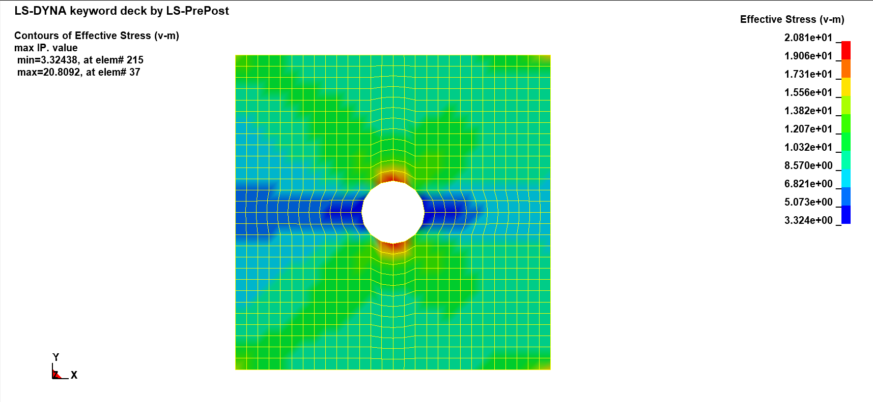

**Fig 3.6 Von mises stress with number of elements of mesh as 4.**

Fig 3.7 provides the von Mises stress analysis of a plate with a 6-element number on the quarter circle of the hole. This analysis almost provides the same result as a plate having the same number of elements as 4. The maximum stress is at the top and bottom surface of the hole, and the minimum stress is at the sides of the hole, but the value increases with the mesh becoming finer. The maximum stress obtained is 22.97 N/mm2 and the minimum stress is 2.435 N/mm2.

**𝐾𝑡 = 𝜎𝑚𝑎𝑥 / 𝜎𝑛𝑜m**

𝐾𝑡 = 22.9703 / 11.6250

**𝐾𝑡 = 1.9759 (no unit)**

Relative Error = ((2.5064-1.9759)/ (2.5064)) *100 = 21.16%

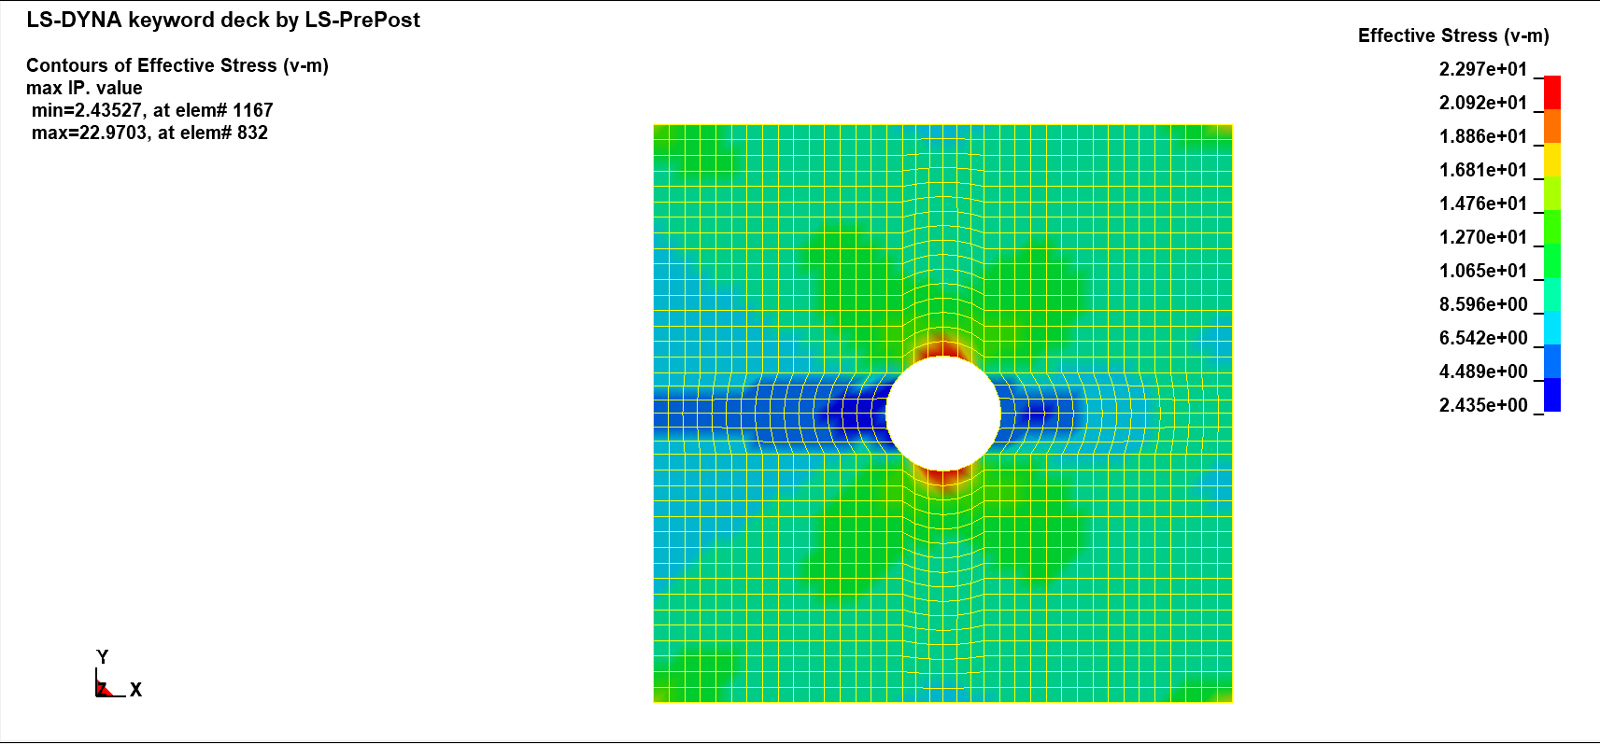

**Fig 3.7 Von mises stress with number of elements of mesh as 6.**

As the mesh becomes even more finer with number of elements to be 8 on quarter circle, the maximum stress increases to 24.49 N/mm2 and the minimum stress is reduced to 2.181 N/mm2. The von mises stress analysis of plate is shown in fig 3.8.

**𝐾𝑡 = 𝜎𝑚𝑎𝑥 / 𝜎𝑛𝑜m**

𝐾𝑡 = 24.49 / 11.6250

**𝐾𝑡 = 2.1066 (no unit)**

Relative Error = ((2.5064-2.1066)/ (2.5064)) *100 = 13.58%

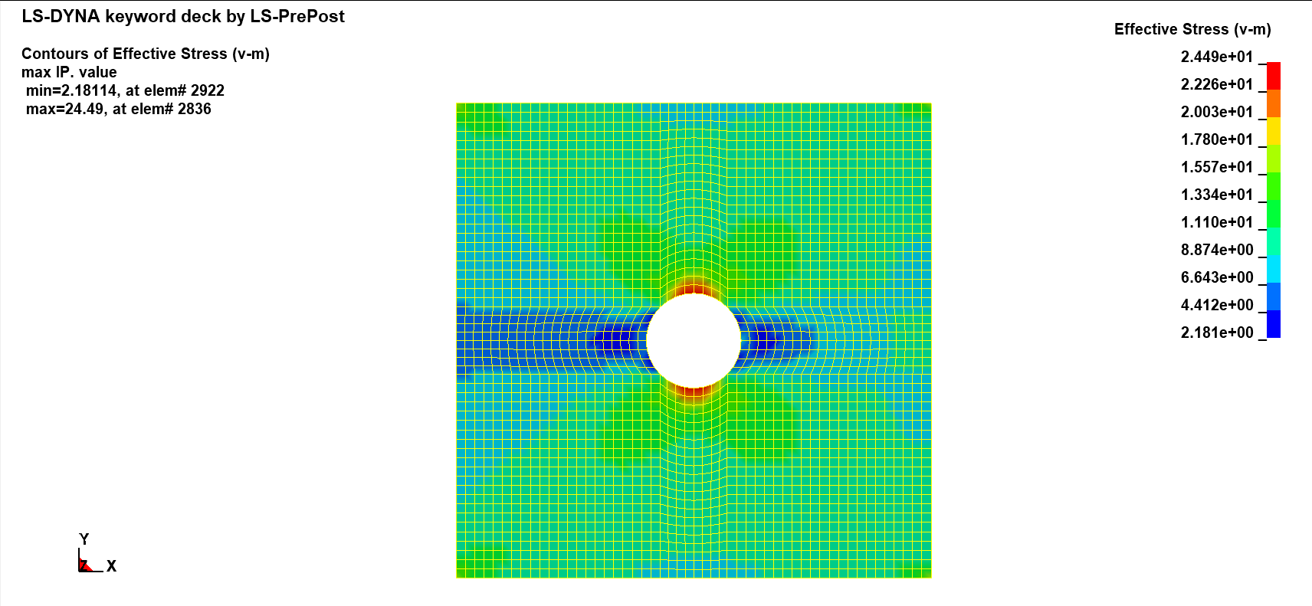

**Fig 3.8 Von mises stress with number of elements of mesh as 8.**

The von Mises stress analysis of a plate with 12 number of elements on quarter circle or with high mesh sensitivity is shown in Fig. 3.9 below. The analysis yielded maximum and minimum stresses of 26.11 N/mm2 and 1.993 N/mm2, respectively.

**𝐾𝑡 = 𝜎𝑚𝑎𝑥 / 𝜎𝑛𝑜m**

𝐾𝑡 = 26.1148 / 11.6250

**𝐾𝑡 = 2.2464 (no unit)**

Relative Error = ((2.5064-2.2464)/ (2.5064)) *100 = 10.37%

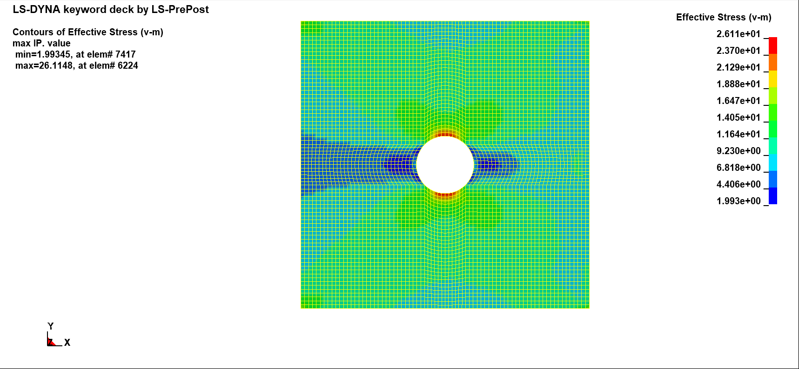

**Fig 3.9 Von mises stress with number of elements of mesh as 12.**

### Relative Error Graph:

Fig 3.10. represents the graph between the number of elements and relative error. The number of elements is marked along the X-axis and the relative error % is marked along the Y-axis. From the graph it is found that, as number of elements of the mesh increases, the relative error decreases.

**Fig 3.10 Number of elements vs Relative error**

### Geometry 2:

There are not many differences between the study of geometry 1 and geometry 2. The tension on the plate has changed because of the altered hole size, but it still greatly impacts the hole’s top and bottom surfaces, leaving the side under less stress in its path. The von Mises stress analysis of a plate with 16 number of elements on circle or with low mesh sensitivity is shown in Fig. 3.11 below. The investigation yielded maximum and minimum stresses of 19.02 N/mm2 and 3.791 N/mm2, respectively.

**𝐾𝑡 = 𝜎𝑚𝑎𝑥 / 𝜎𝑛𝑜m**

𝐾𝑡 = 19.0157 / 10.3333

**𝐾𝑡 = 1.8402 (no unit)**

Relative Error = ((2.7211-1.8402)/ (2.7211)) *100 = 32.37 %

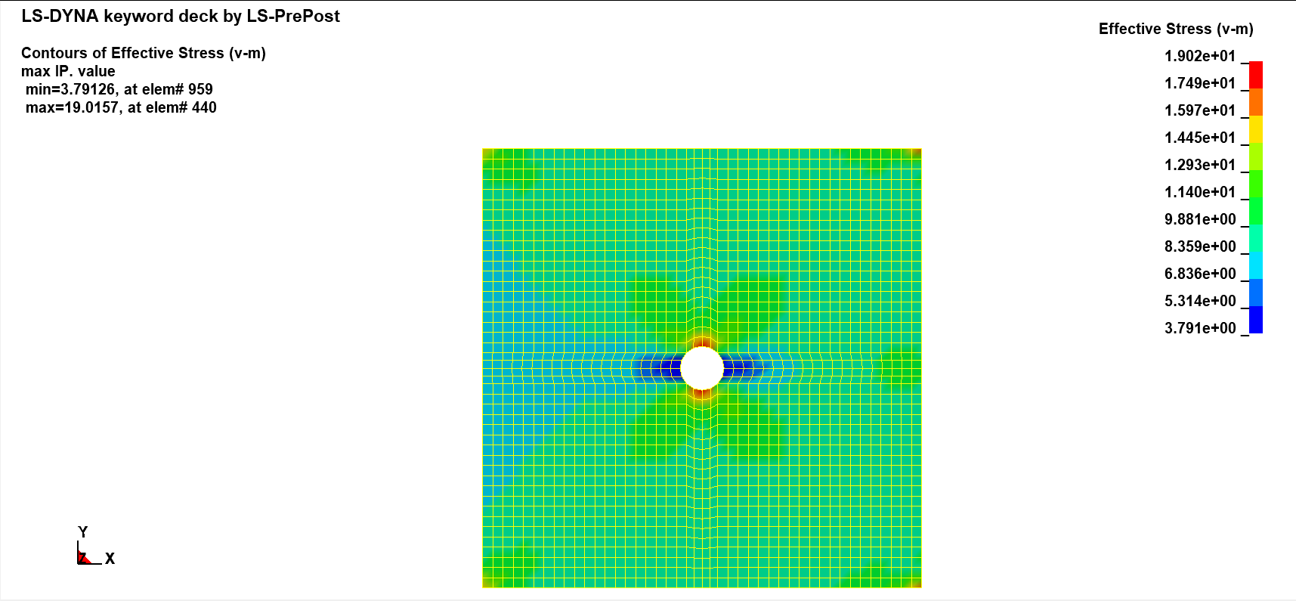

**Fig 3.11 Von mises stress with number of elements of mesh as 4.**

The below fig 3.12 shows the von mises stress analysis of plate having 6 number of elements in quarter circle has been deformed by a force of 7500 N on one end while the other is held fixed. From the analysis the maximum stress obtained is 21.30 N/mm2 and the minimum stress is 2.526 N/mm2.

**𝐾𝑡 = 𝜎𝑚𝑎𝑥 / 𝜎𝑛𝑜m**

𝐾𝑡 = 21.3 / 10.3333

**𝐾𝑡 = 2.0612 (no unit)**

Relative Error = ((2.7211-2.0612)/ (2.7211)) *100 = 24.25 %

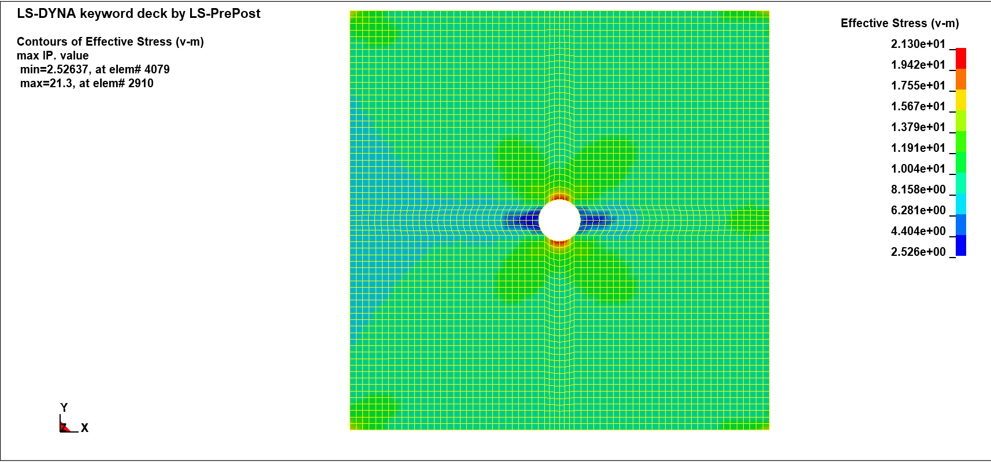

**Fig 3.12 Von mises stress with number of elements of mesh as 6.**

When the mesh becomes more finer that is when the number of nodes in the part is increased the analysis is done even more finer and there is change in values with the maximum stress obtained is 23.24 N/mm2 and the minimum stress is 2.338 N/mm2. The von mises stress analysis of plate with 8 number of elements in quarter circle is shown in fig 3.13.

**𝐾𝑡 = 𝜎𝑚𝑎𝑥 / 𝜎𝑛𝑜m**

𝐾𝑡 = 23.2362 / 10.3333

**𝐾𝑡 = 2.2486 (no unit)**

Relative Error = ((2.7211-2.2486)/ (2.7211)) *100 = 17.36 %

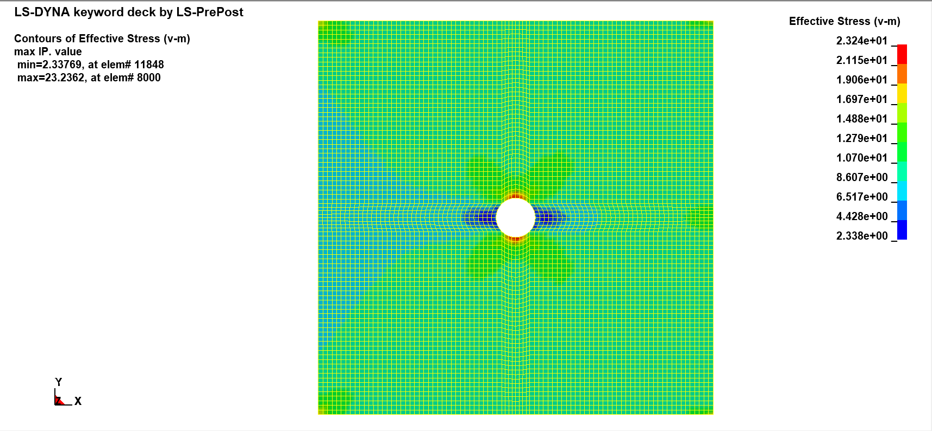

**Fig 3.13 Von mises stress with number of elements of mesh as 8.**

As the relative error decreases with increase in mesh value the number of elements of the plate is furthermore increased and the analysis is done with number of elements on the circle to be 48. This is the highest mesh sensitivity done in this assignment. The analysis shows that the maximum stress obtained is 24.39 N/mm2 and the minimum stress is 2.056 N/mm2. The von mises stress analysis of plate is shown in Fig 3.14.

**𝐾𝑡 = 𝜎𝑚𝑎𝑥 / 𝜎𝑛𝑜m**

𝐾𝑡 = 24.3877 / 10.3333

**𝐾𝑡 = 2.3601 (no unit)**

Relative Error = ((2.7211-2.3601)/ (2.7211)) *100 = 13.26 %

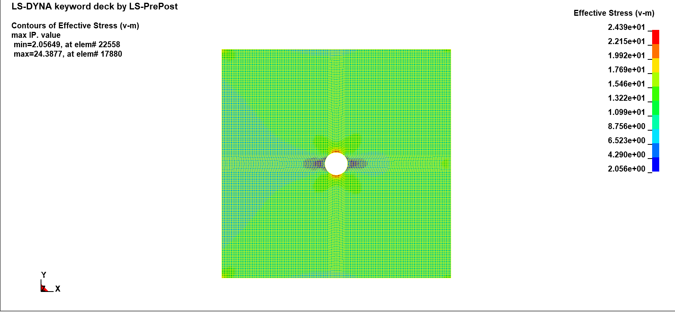

**Fig 3.14 Von mises stress with number of elements of mesh as 12.**

### Relative Error graph:

The graph between the number of elements and the relative error is shown in Figure 3.15. The relative error% is indicated along the Y-axis, while the number of elements is indicated along the X-axis. The graph demonstrates that the relative inaccuracy lowers as the mesh's element count rises. i.e., the error diminishes as the mesh sensitivity increases.

**Fig 3.15 Number of elements vs Relative error**

# Solid vs. Shell Comparison

## Methodology:

A 2D (2-dimensional) sketch of the structure is created using the **2DMesh 🡪 Sketch** command. The basic sketch is created using lines under sketch. For 2D sketch of the shell the midplane of the element is considered, hence the dimensions are calculated based on the thickness of the shell. The edges are created by selecting the **Create/Delete Edges** command under **Sketch** as shown in fig 4.1.

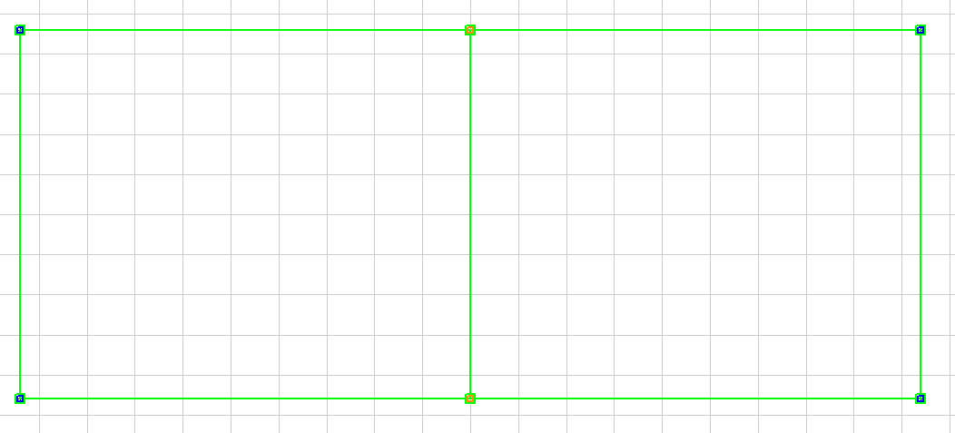

**Fig 4.1 Created edges for 2D sketch of Shell structure.**

For the solid the 2D sketch is created as shown on fig 4.2

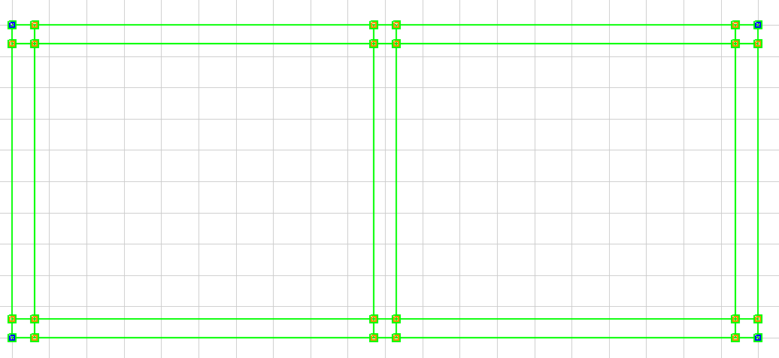

**Fig 4.2 Created edges for 2D sketch of Solid structure.**

Once the edges are created, the number of elements is mentioned to create a mesh. Once the number of elements is determined, the mesh is created using the **Create/Delete mesh** command. Mesh is shown in fig 4.3.

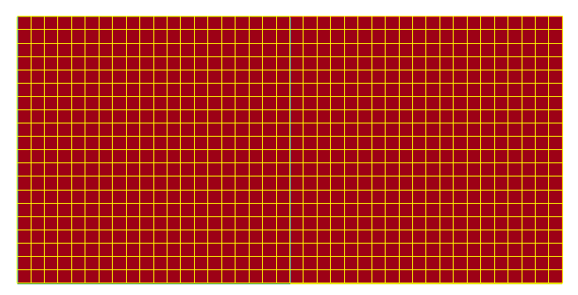

**Fig 4.3 Created mesh for 2D sketch of shell structure.**

Similarly, the mesh for solid is also created which is shown below in fig 4.4.

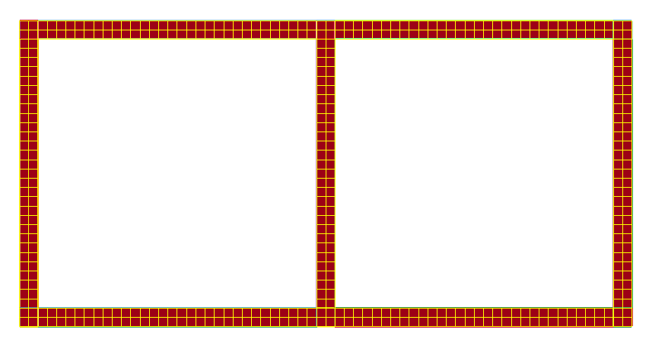

**Fig 4.4 Created mesh for 2D sketch of Solid structure**

Using **EIGen 🡪 Shell 🡪 Edge_Drag** the shell element is created. Two parts are created one for steel material and another for aluminium. The shell element is shown in fig 4.5.

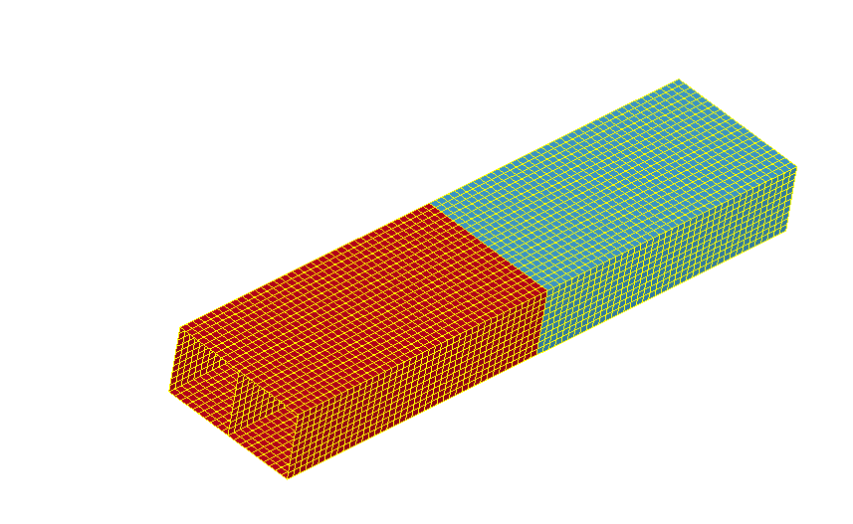

**Fig 4.5 Element generated for Shell Element.**

Using **EIGen 🡪 Solid 🡪 Solid_Face_Drag** the solid element is created. The solid element is shown in fig 4.6.

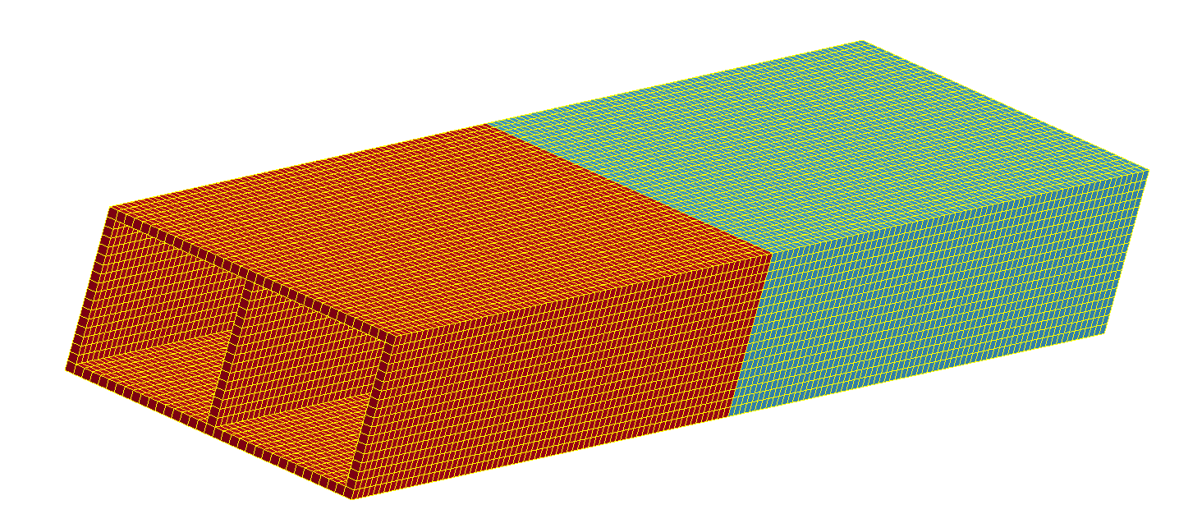

**Fig 4.6 Element generated for Solid Element.**

In the **SPC** interface, select the edge and propagate option. Select the edge to be fixed and constrain the edge by checking all the direction checkboxes. Under the **SetD** interface, select the edge and propagate option. Select the edge and enter a name for the segment set. As a result, the nodes to which force will be applied are determined.

The load curve is defined under the **"*Define"** interface. The curve remains stable or also called as constant velocity.. The load curve is shown in fig. 4.7.

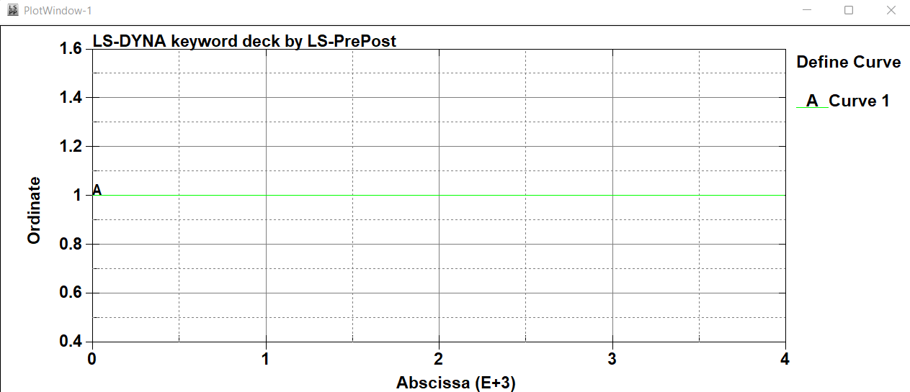

**Fig 4.7. Load’s curve graph**

The implicit and termination values is defined under the **"*Control"** interface. The **"ASCII"** and **"BINARY D3PLOT"** are provided under **"Dbase"** interface to obtain the output.

## LS- DYNA result and discussion:

### SHELL: Steel end to be fixed and Aluminium end to be loaded

The von mises stress of the structure at time 1000ms is maximum at the corners of the fixed steel material. The maximum stress obtained at this point of time is 47.2043 N/mm2. The von mises stress of the structure is shown in fig 4.8.

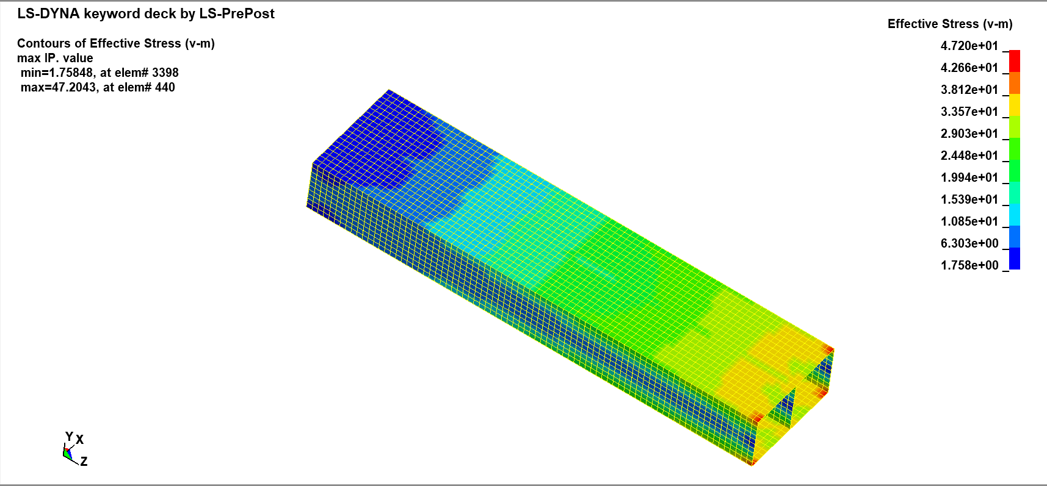

**Fig 4.8 Von mises stress of shell element with steel end fixed for 1000ms.**

With the constant velocity applied to the structured it is found that the deformation at end of aluminium structure is maximum and it is 0.5mm. The Y-displacement is shown in fig 4.9.

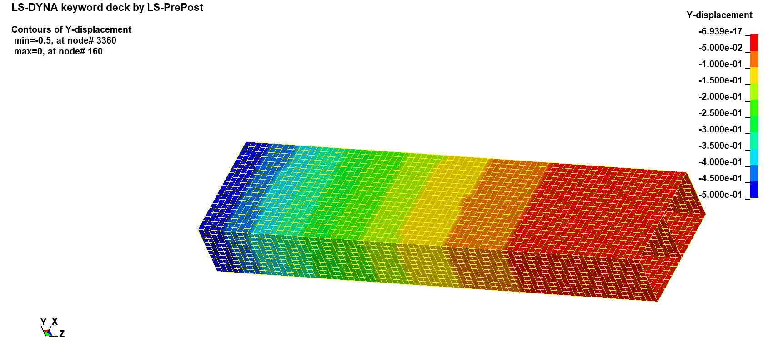

**Fig 4.9 Y-Displacement of shell element with steel end fixed for 1000ms.**

At time 2000ms, the structure's von Mises stress is greatest at the corners of the fixed steel material. At this moment, the highest stress measured was 86.4649 N/mm2. Figure 4.10 depicts the structure's von Mises stress.

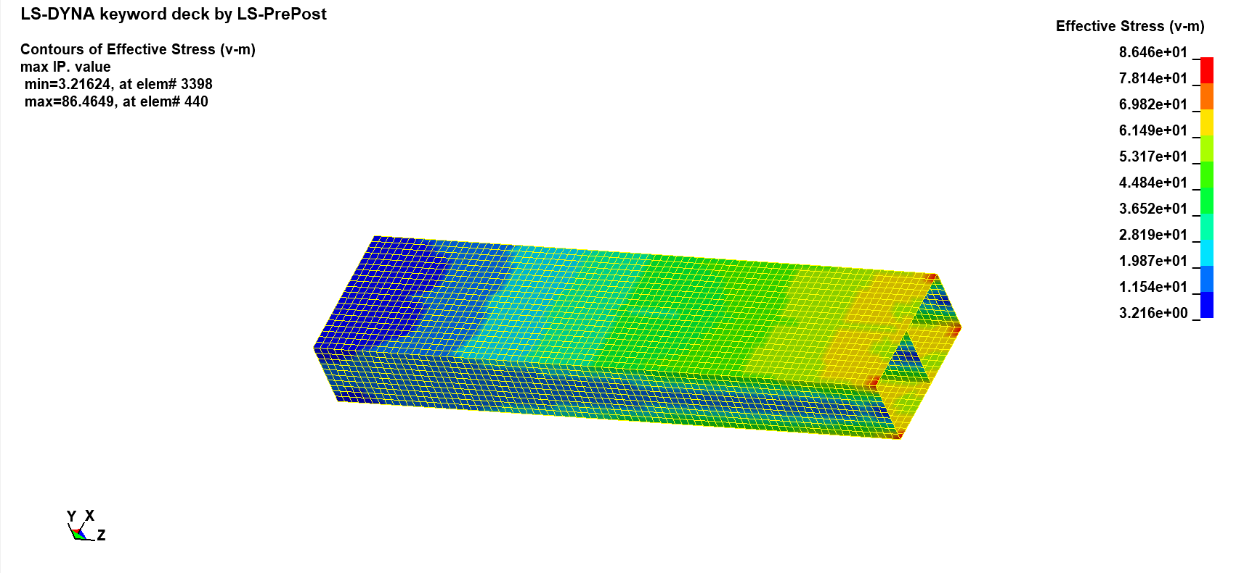**Fig 4.10 Von mises stress of shell element with steel end fixed for 2000ms.**

It is discovered that the end of aluminium structure deforms by 1mm at this point when the constant velocity is applied. The Y-displacement is shown in fig 4.11.

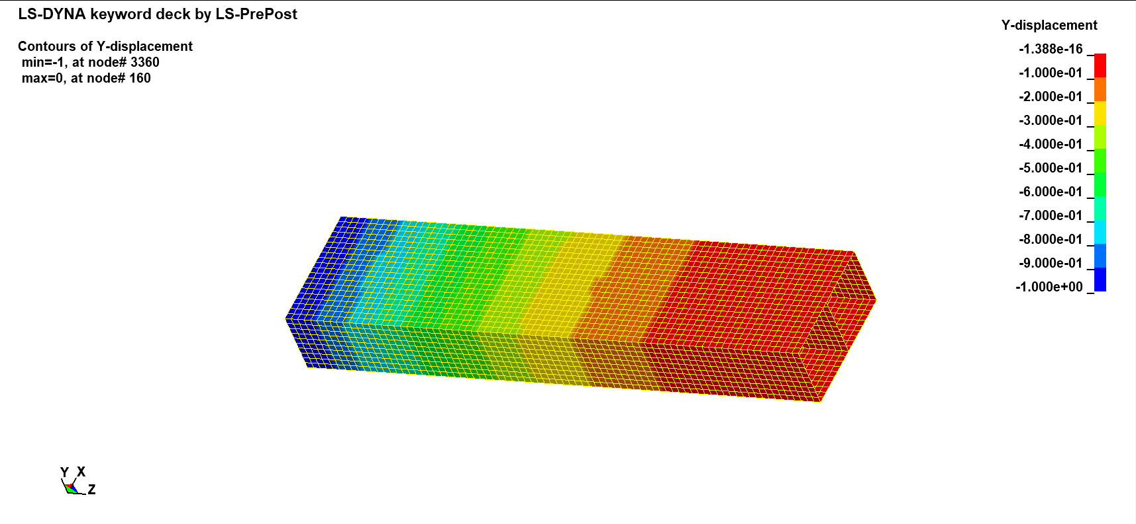

**Fig 4.11 Y-Displacement of shell element with steel end fixed for 2000ms.**

At time 3000ms the maximum stress is recorded at the corners of the steel. The maximum stress recorded was 129.714 N/mm2 and the minimum stress of 4.8170 N/mm2 acts on the aluminium. The von Mises stress of the structure is shown in Figure 4.12.

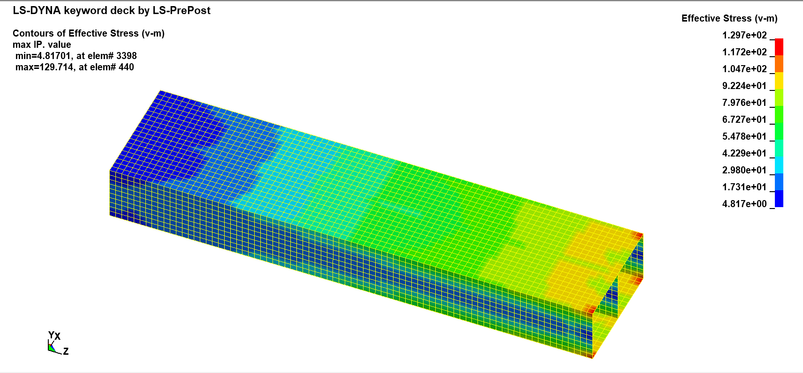

**Fig 4.12 Von mises stress of shell element with steel end fixed for 3000ms.**

When the constant velocity is maintained till 3000ms the end of aluminium structure deforms by 1.5 mm at this location. The deformation is shown in fig 4.13.

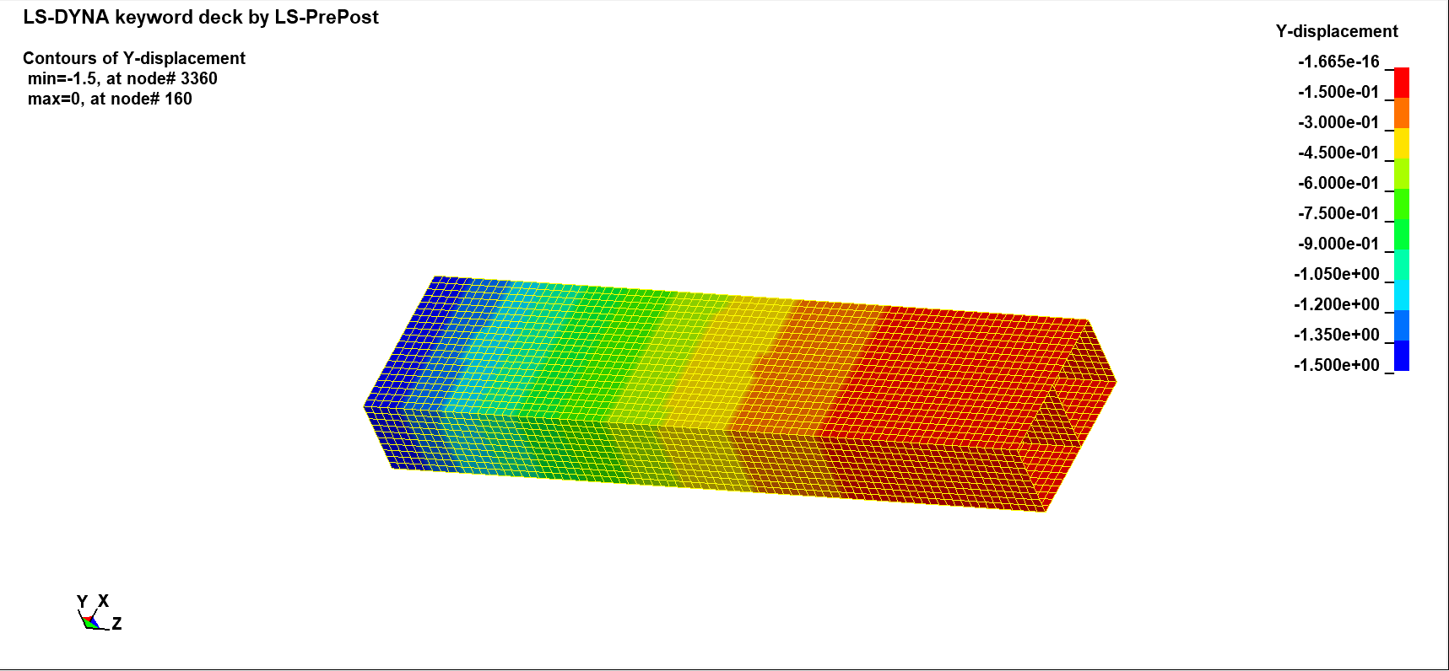

**Fig 4.13 Y-Displacement of shell element with steel end fixed for 3000ms.**

When plotted the stress against the time period the stress increases as the time increases or when more deformation is applied on the ends of the structure. The graph is plotted and is shown in fig 4.14.

**Fig 4.14 Time in millisecond vs Max Effective Stress (N/mm2).**

### SHELL: Aluminium end to be fixed and Steel end to be loaded

At time 1000ms, the structure's von Mises stress is greatest at the corners of the fixed structural aluminium. The maximum stress measured as of this moment is 21.866 N/mm2. Fig. 4.15 illustrates the structure's von Mises stress.

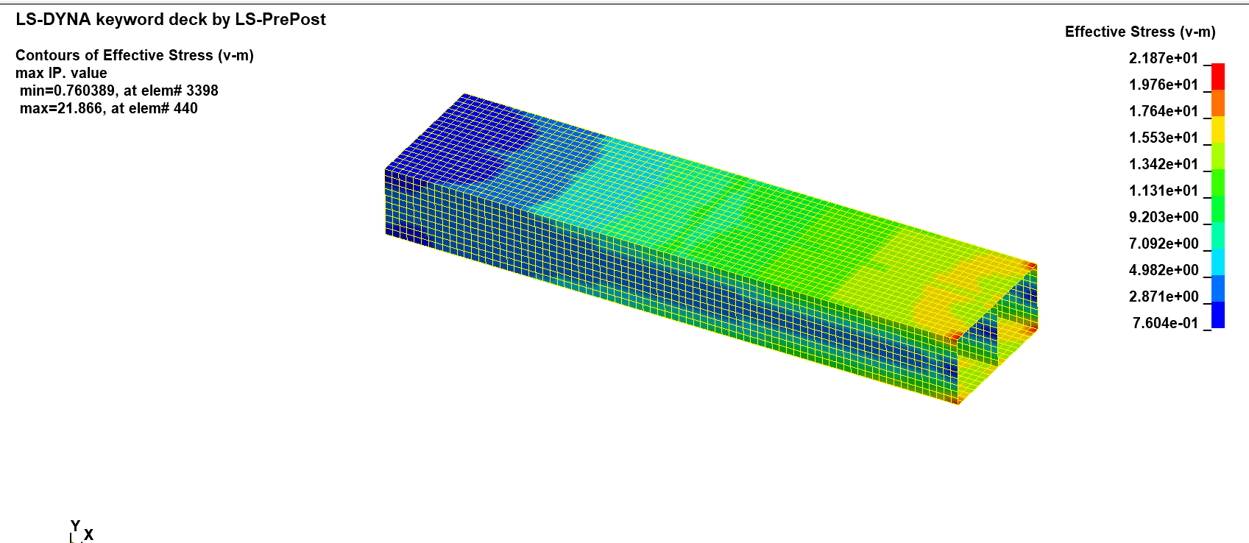

**Fig 4.15 Von mises stress of shell element with aluminium end fixed at 1000ms.**

The deflection of the shell element at time 1000 millisecond is shown in fig 4.16. The edges of the steel experience the most deflection, while the edges of aluminium experience zero deflection.

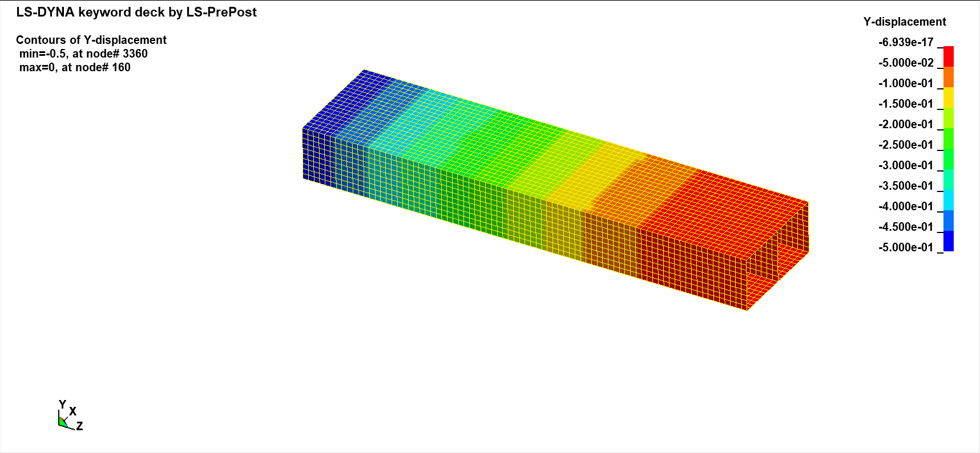

**Fig 4.16 Y-Displacement of shell element with aluminium end fixed for 1000ms.**

The corners of the fixed aluminium mateial are where the von Mises stress is greatest at time 2000ms. The maximum stress recorded at this time was 43.74 N/mm2. The von Mises stress of the structure is shown in Figure 4.17.

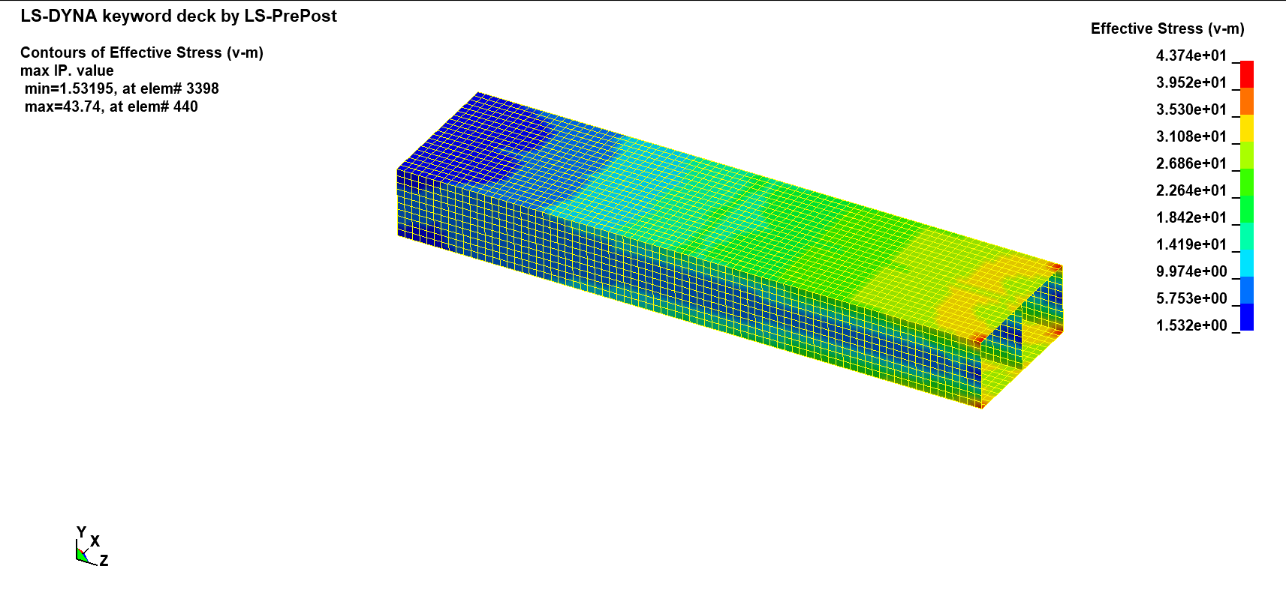

**Fig 4.17 Von mises stress of shell element with aluminium end fixed at 2000ms.**

Fig 4.18 depicts the deflection of the shell element at time 2000 ms. While the edges of aluminium experience zero deflection, the edges of steel experience the greatest deflection of 1mm.

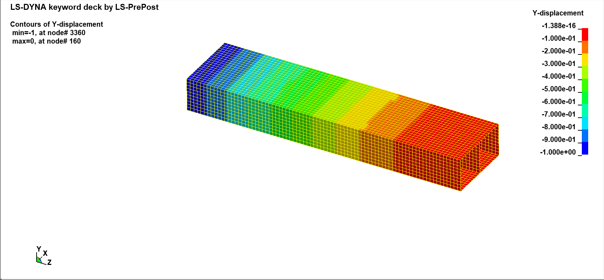

**Fig 4.18 Y-Displacement of shell element with aluminium end fixed for 2000ms.**

The von Mises stress is highest at 3000ms in the corners of the steel material. 65.6219 N/mm2 was the highest stress recorded at this moment. The lowest stress recorded is 2.3431 N/mm2. Fig 4.19 displays the structure's von Mises stress.

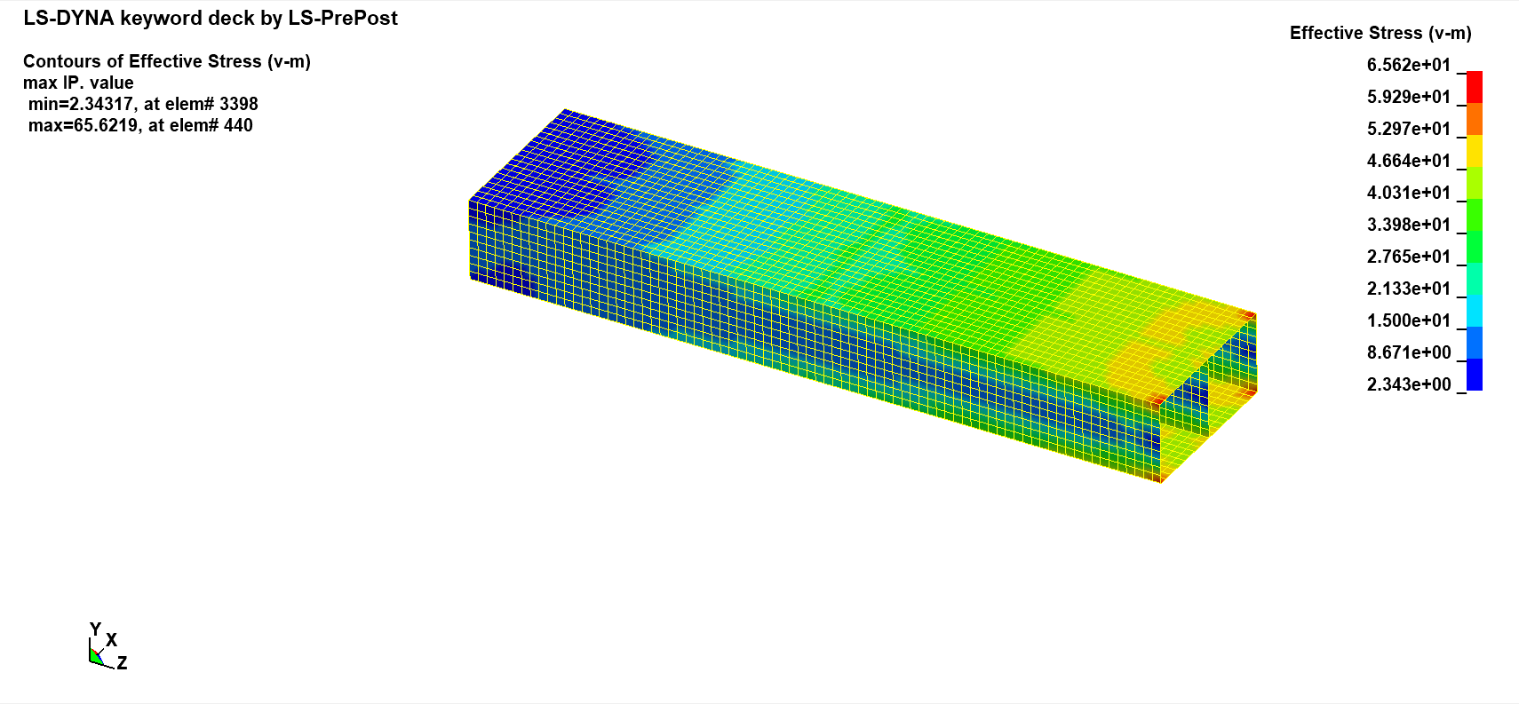

**Fig 4.19 Von mises stress of shell element with aluminium end fixed at 3000ms.**

The deflection of the shell element at time 3000 ms is shown in Fig. 4.20. The edges of steel experience the largest deflection of 1.5mm, while the edges of aluminium experience zero deflection.

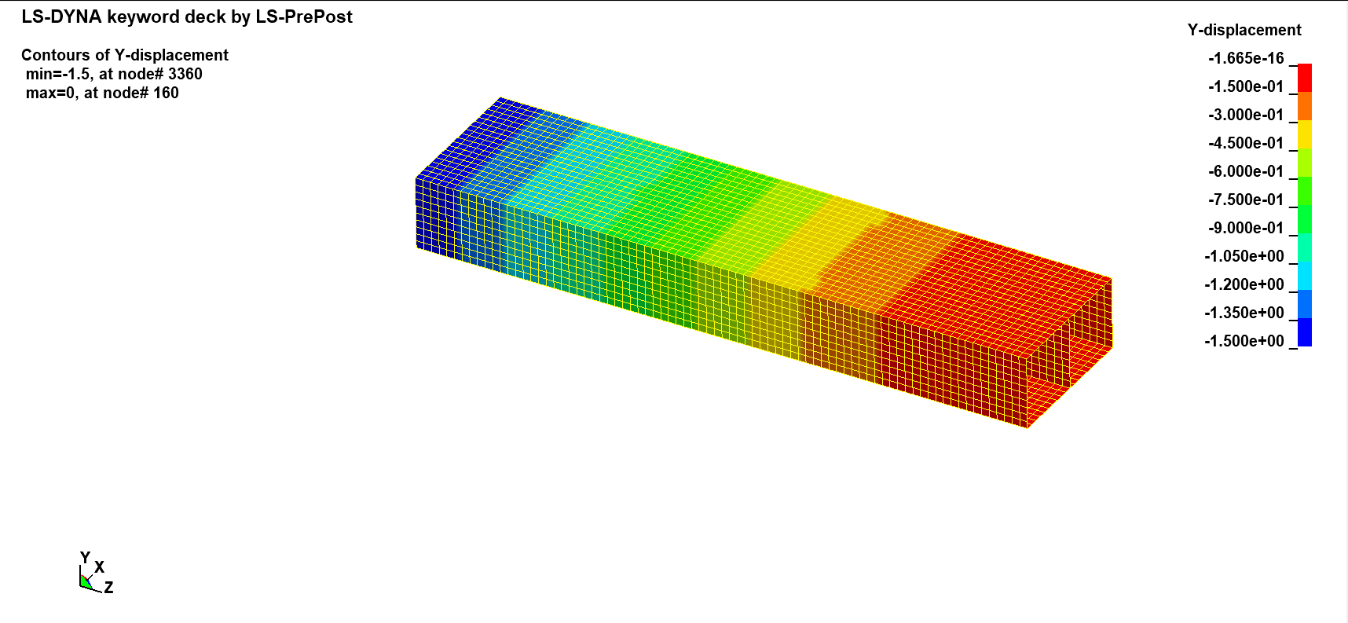

**Fig 4.20 Y-Displacement of shell element with aluminium end fixed for 3000ms.**

Plotting the stress vs time reveals that the stress rises as the time passes or as the structure's ends are subjected to additional deformation. The plotted graph is displayed in fig. 4.21.

**Fig 4.21 Time in millisecond vs Max Effective Stress (N/mm2).**

### SOLID: Steel end to be fixed and Aluminium end to be loaded

At time 1000ms, the corners of the fixed steel material are where the von Mises stress of the solid structure is greatest. The highest stress measured as of this moment is 50.3718 N/mm2. Fig 4.22 displays the structure's von Mises stress.

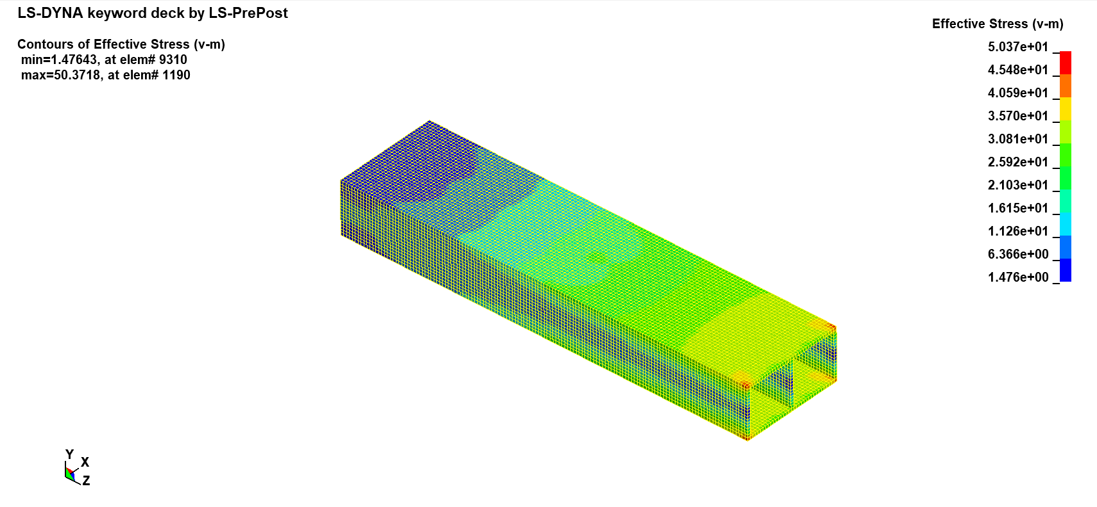

**Fig 4.22 Von mises stress of solid element with steel end fixed at 1000ms.**

Fig. 4.23 depicts the deflection of the shell element at time 1000 ms. The edges of steel receive little or no deflection, whereas the aluminium end experiences the highest deflection of 0.5mm.

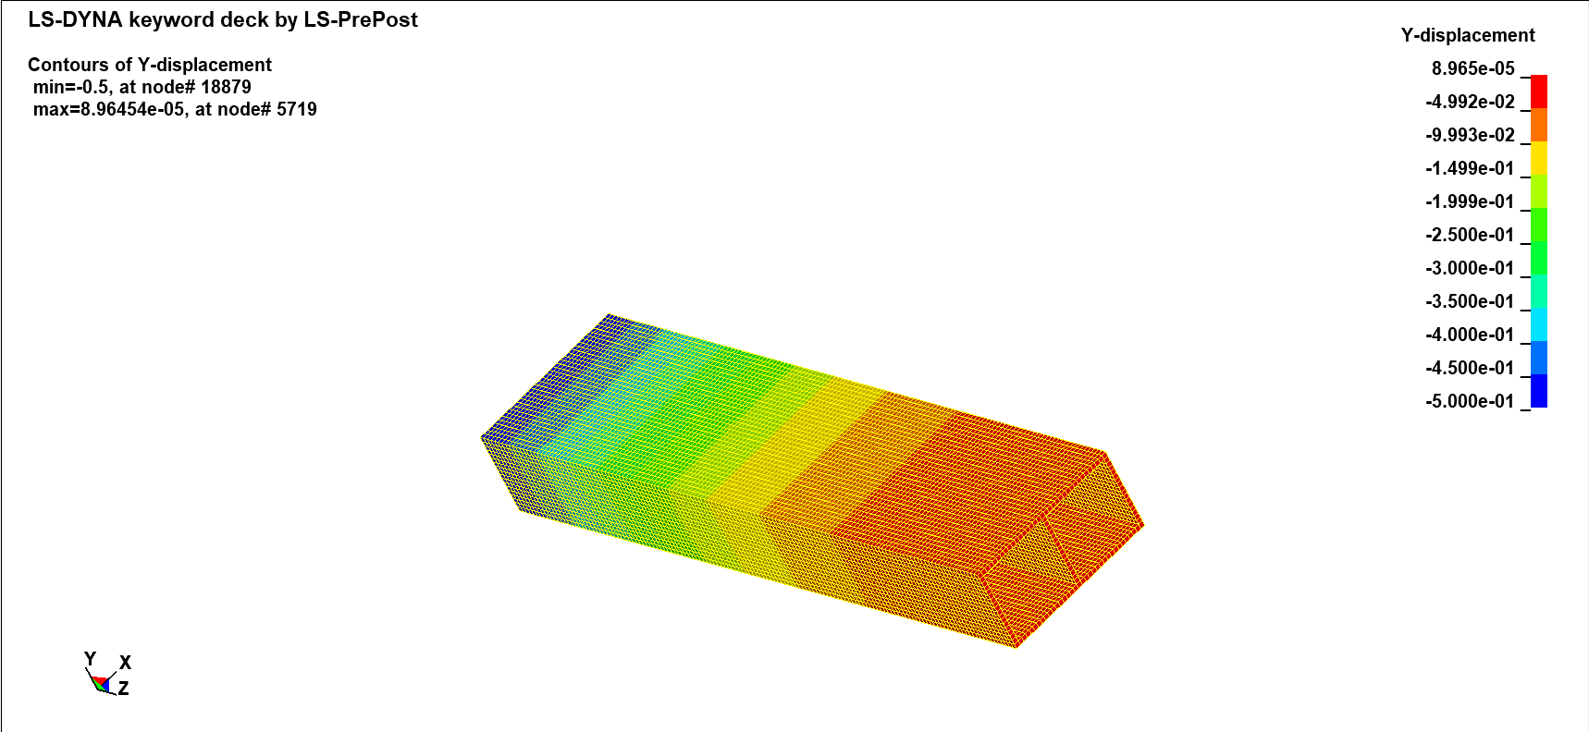

**Fig 4.23 Y-Displacement of solid element with steel end fixed for 1000ms.**

The von Mises stress of the solid construction is highest at time 2000ms at the corners of the fixed steel material. At this time, a 92.257 N/mm2 stress has been recorded as the maximum. The structure's von Mises stress is shown in Fig. 4.24.

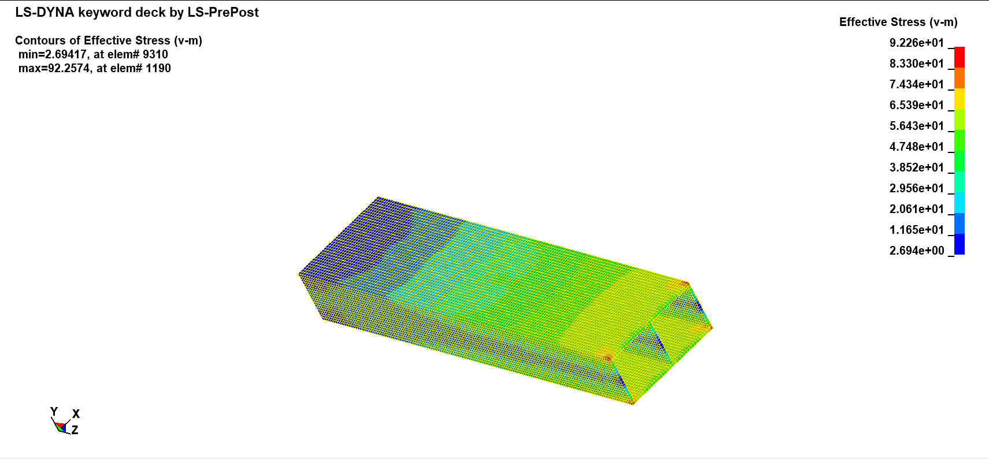

**Fig 4.24 Von mises stress of solid element with steel end fixed at 2000ms.**

The deflection of the shell element at time 2000 ms is shown in Fig. 4.25. While the aluminium end receives the largest deflection of 1mm, the steel edges experience almost no deflection.

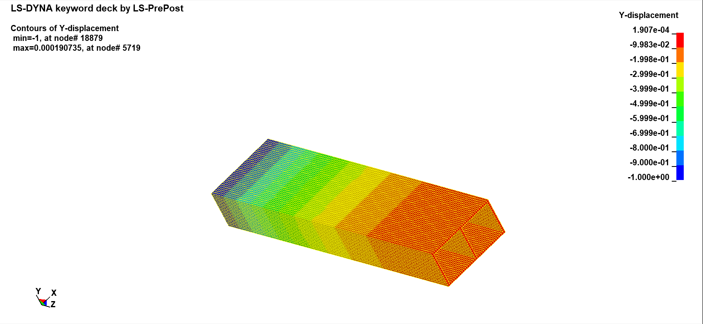

**Fig 4.25 Y-Displacement of solid element with steel end fixed for 2000ms.**

The edges of the steel material have a significant von Mises stress at 3000 ms. The peak stress at this time was 138.387 N/mm2. The stress with the lowest value was 4.02591 N/mm2. The structure's von Mises stress is illustrated in Fig. 4.26.

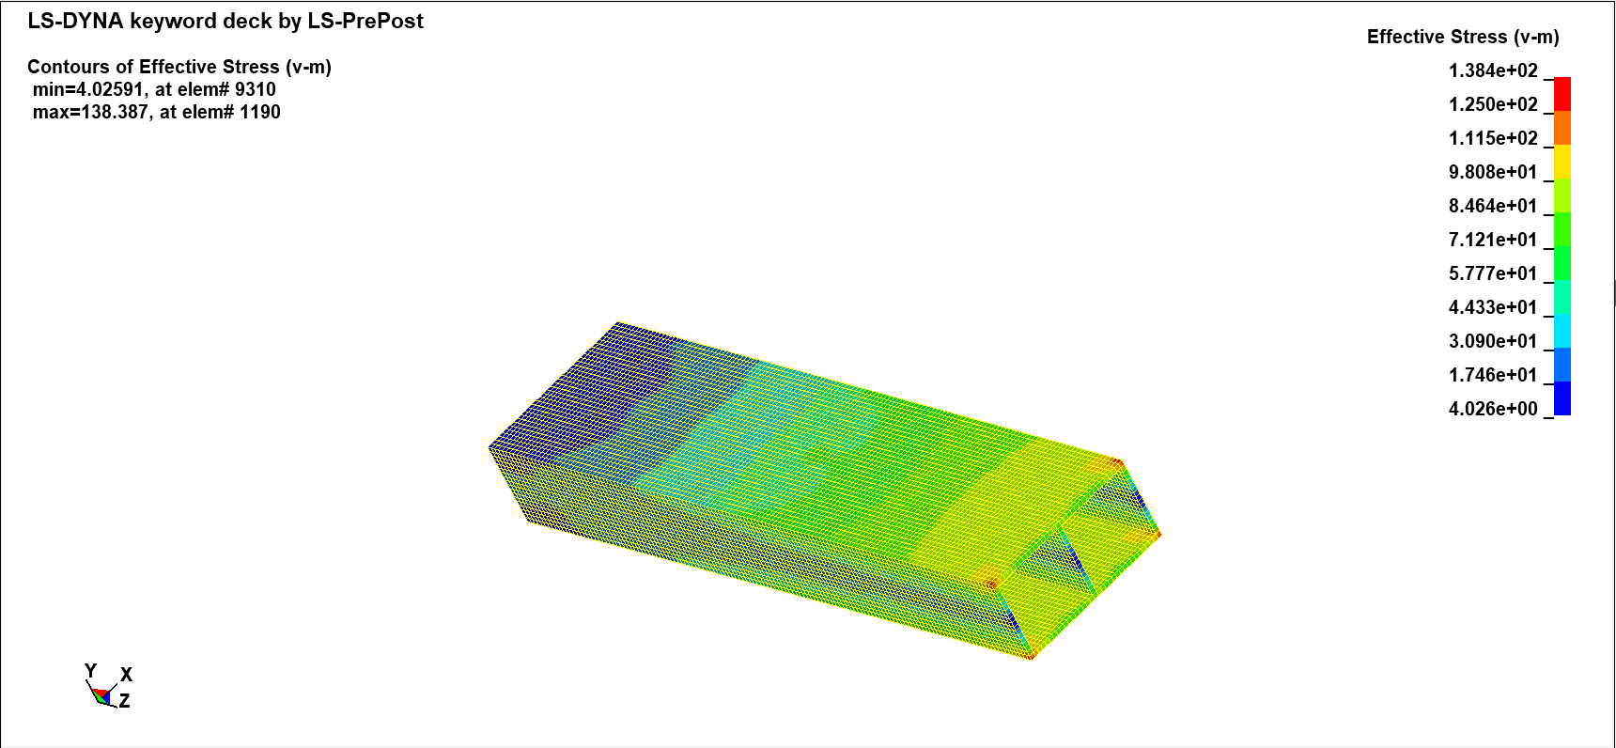

**Fig 4.26 Von mises stress of solid element with steel end fixed at 3000ms.**

Fig. 4.27 displays the deflection of the shell element at time 3000 ms. The steel edges barely deflect at all, whereas the aluminium end experiences the maximum deflection of 1.5 mm.

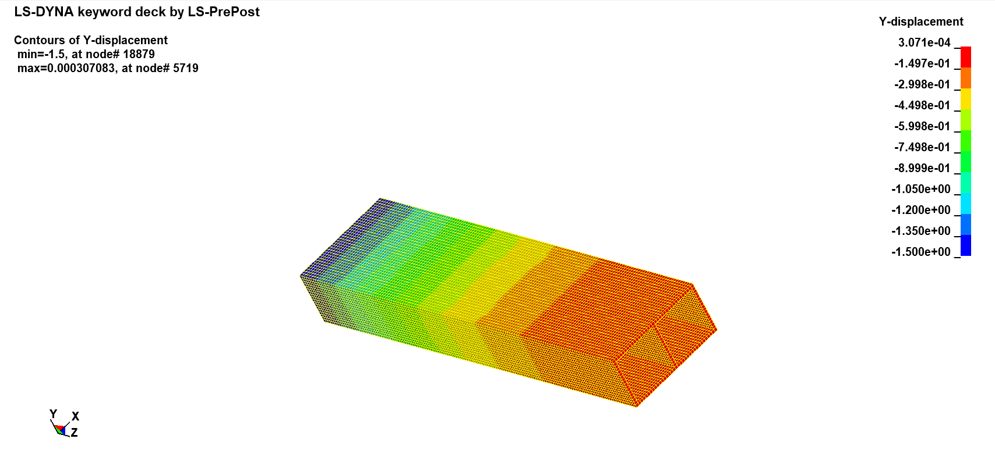

**Fig 4.27 Y-Displacement of solid element with steel end fixed at 3000ms.**

Plotting the stress vs. time illustrates that the stress increases over time or in response to further deformation of the structure's ends. Fig. 4.28 shows the plotted graph.

**Fig 4.28 Time in millisecond vs Max Effective Stress (N/mm2).**

### SOLID: Aluminium end to be fixed and Steel end to be loaded

At time 1000ms, the corners of the fixed aluminium material are where the von Mises stress of the solid structure is greatest. The highest stress measured as of this moment is 22.39 N/mm2. Fig 4.29 displays the structure's von Mises stress.

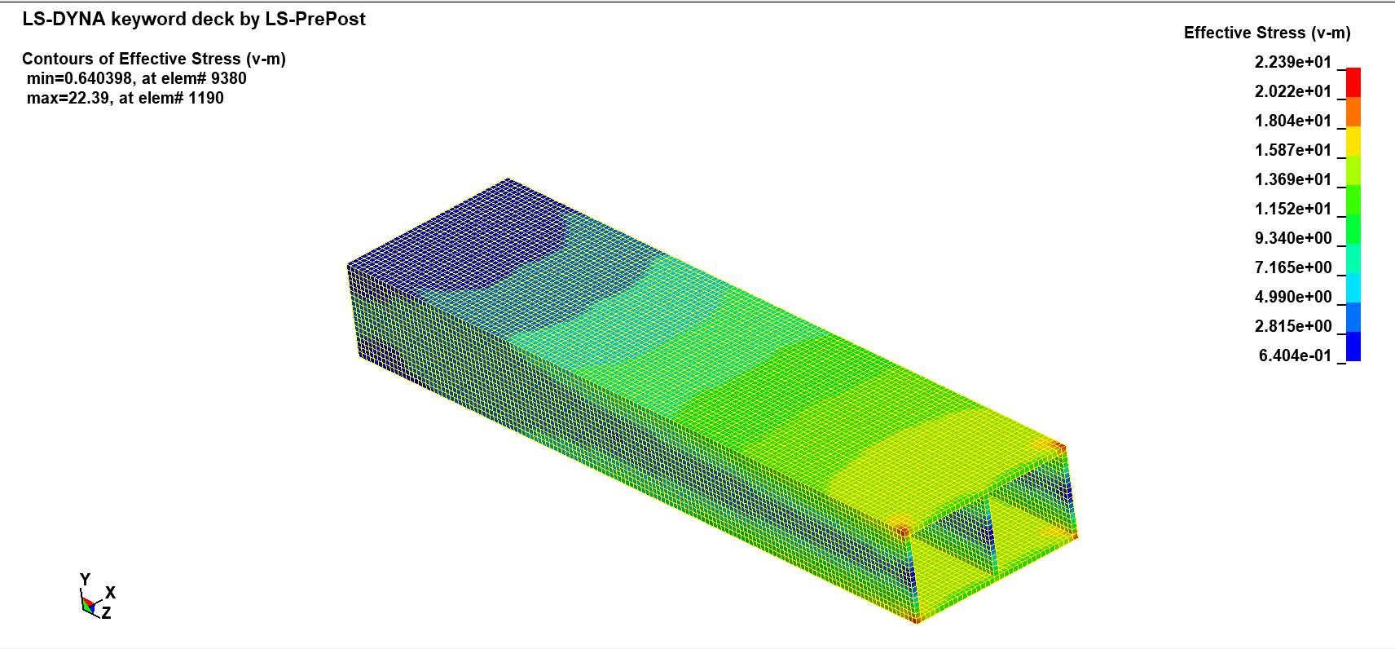

**Fig 4.29 Von mises stress of solid element with aluminium end fixed at 1000ms.**

Fig. 4.30 displays the deflection of the shell element at time 1000 ms. The steel edges never deflect at all, but the aluminium end experiences the maximum deflection of 0.5mm.

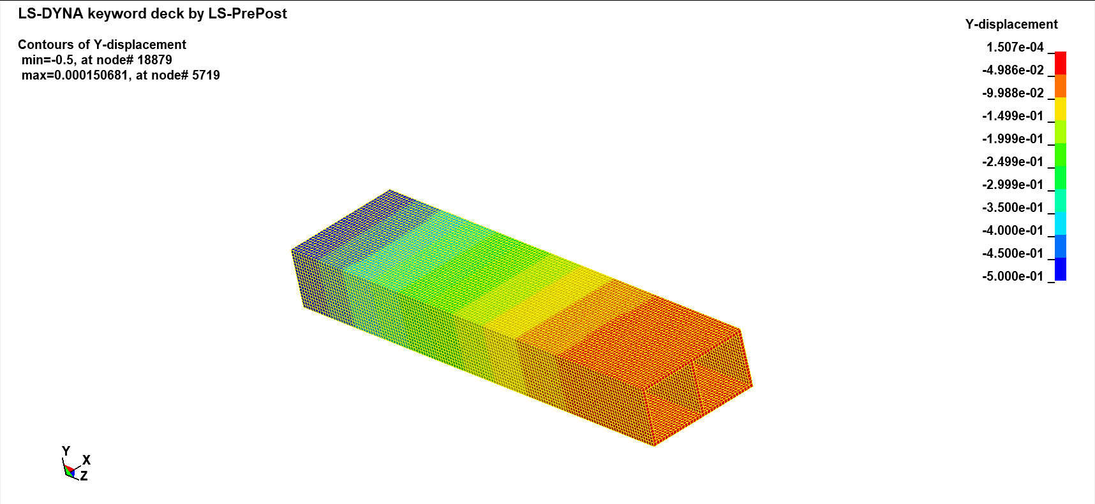

**Fig 4.30 Y-Displacement of solid element with aluminium end fixed at 1000ms.**

At 2000 ms, the steel material's edges exhibit a sizable von Mises stress. At this point, the highest stress was 45.9297 N/mm2. 1.20253 N/mm2 was the stress with the lowest value. Fig. 4.31 shows the structure's von Mises stress.

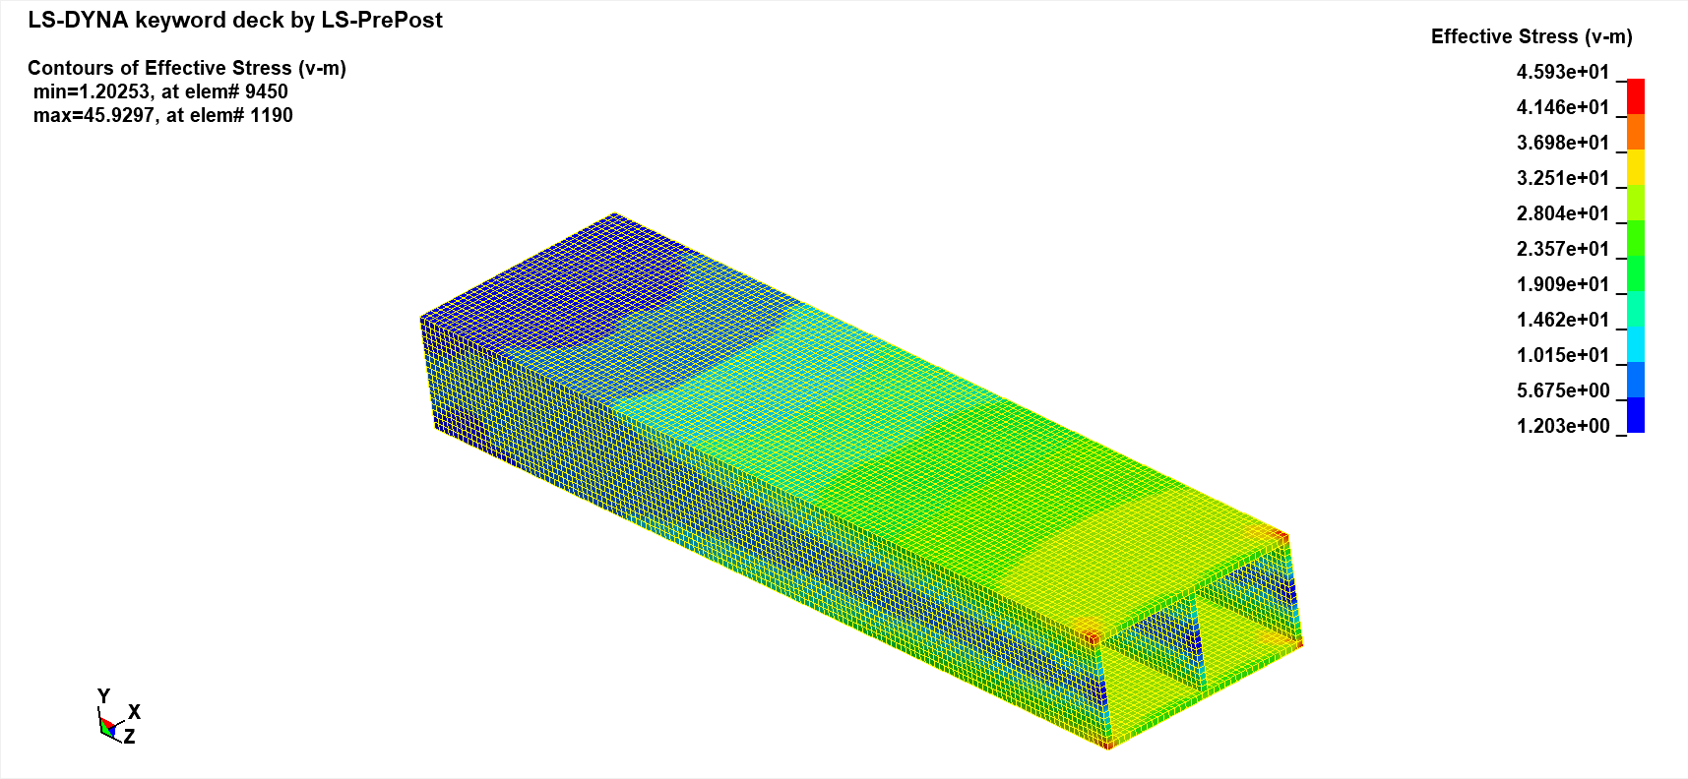

**Fig 4.31 Von mises stress of solid element with aluminium end fixed at 2000ms.**

Figure 4.32 depicts how the steel deflects by 1mm in the y direction when a constant load is applied.

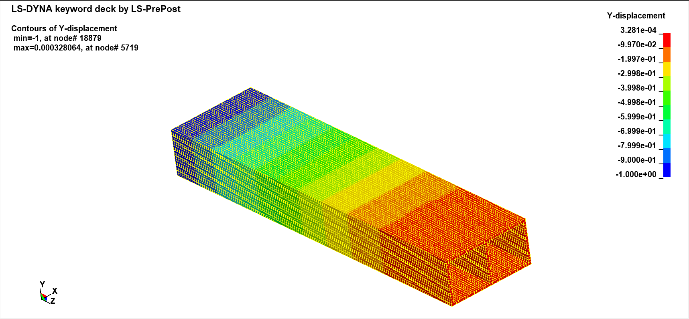

**Fig 4.32 Y-Displacement of solid element with aluminium end fixed at 2000ms.**

The steel material's edges have a substantial von Mises stress value at 3000 ms. 68.8955 N/mm2 was the maximum stress at this point. The least amount of tension was 1.553 N/mm2. Fig. 4.33 shows the von Mises stress of the structure.

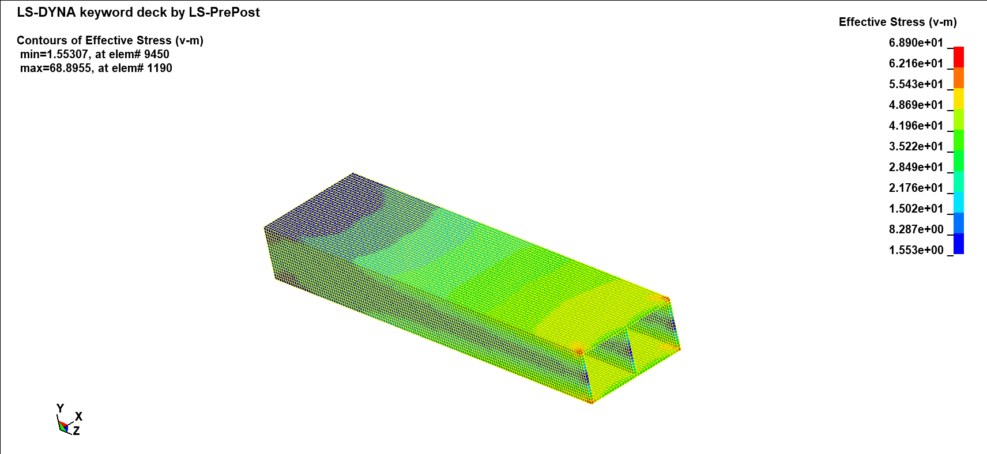

**Fig 4.33 Von mises stress of solid element with aluminium end fixed at 3000ms.**

Figure 4.34 shows how a constant load causes the steel to sag by 1.5mm in the y direction at 3000ms.

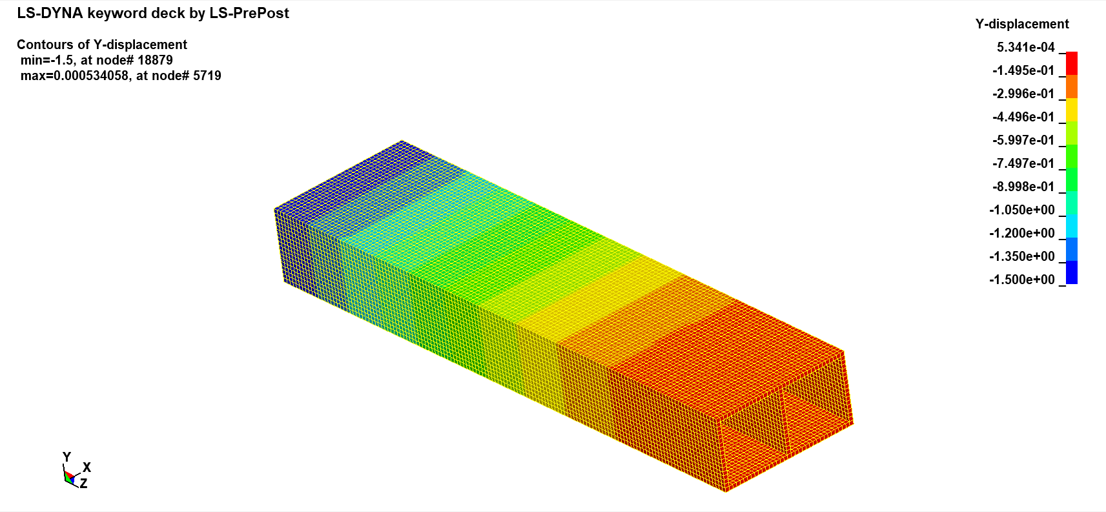

**Fig 4.34 Y-Displacement of solid element with aluminium end fixed at 3000ms.**

The stress grows with time or in reaction to increased deformation of the structure's ends, as shown by the stress vs. time plot. The plotted graph is displayed in Fig. 4.35.

**Fig 4.35 Time in millisecond vs Max Effective Stress (N/mm2).**

A graph is drawn to compare the Solid and Shell models. The stress on the shell construction is explained in Fig. 4.36 along with the solid structure's fixed steel end and constant load on the aluminium. It is clear from the stress values that they increase for both shell and solid as the load increases, although the solid's stress value is slightly higher than the shell values.

**Fig 4.36 Stress Analysis between solid and shell element with steel end as fixed.**

To compare the Solid and Shell models, a graph is created. Fig. 4.37 explains the stress on the shell construction as well as the fixed aluminium end of the solid structure and the constant load on the steel. Although the solid's stress value is marginally larger than the shell values, it is obvious from the stress values that they rise as the load rises for both shell and solid.

**Fig 4.37 Stress Analysis between solid and shell element with aluminium end as fixed.**

# Vibrational Analysis and Axisymmetric analysis of Structures

## Methodology for creation of Z beam:

The **2DMesh 🡪 Sketch** command is used to produce a 2D (2-dimensional) sketch of the structure. The given dimensions are in inches which are converted into millimeter. Lines under the sketch are used to form the fundamental sketch. By choosing the **Create/Delete Edges** command under **Sketch**, as seen in fig. 5.1, the edges are produced.

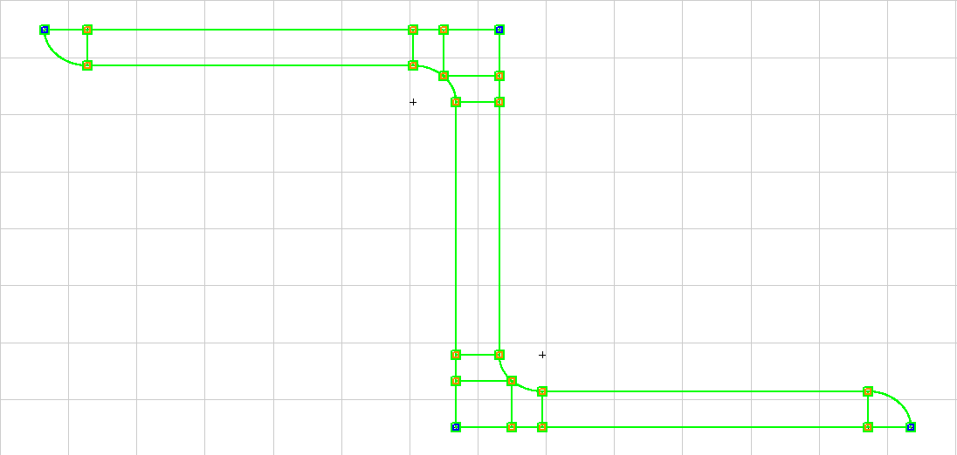

**Fig 5.1 Created edges for 2D sketch of structural member.**

The number of elements required to construct a mesh is stated after the edges have been created. The **Create/Delete mesh** command is used to create the mesh after the number of elements has been specified. Figure 5.2 depicts the mesh.

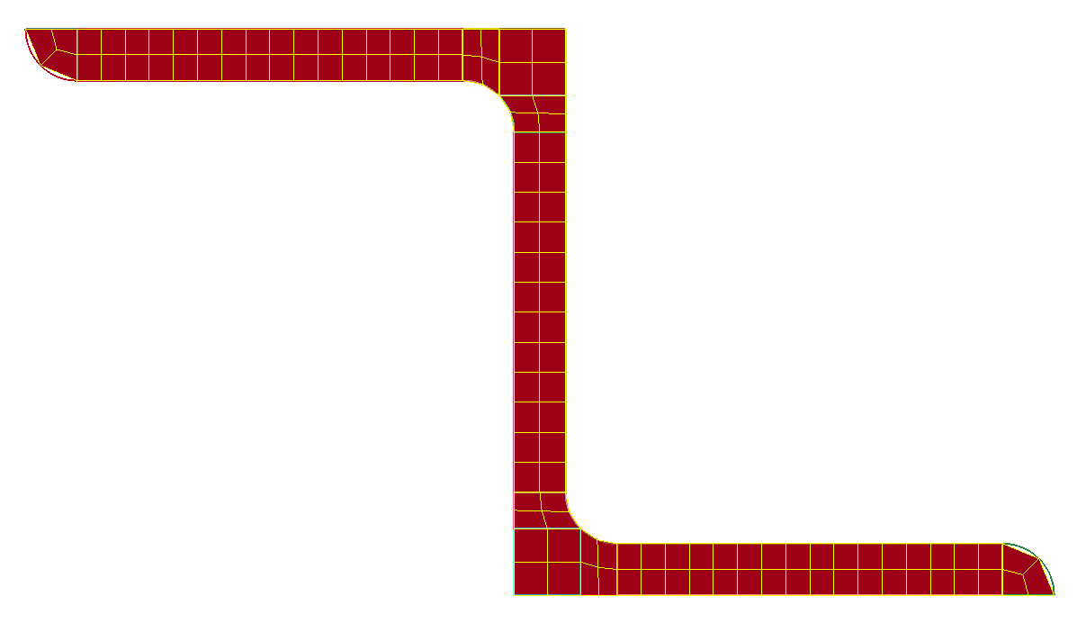

**Fig 5.2 Created mesh for 2D sketch of structural member**

The solid element is constructed by using the **EIGen 🡪Solid 🡪 Solid_Face_Drag** command for 100mm, 75mm and 50mm. The components are made of 425 copper structures and Section has been designated as solid. In Fig. 5.3, Fig. 5.4 and Fig. 5.5, the structural elements are depicted.

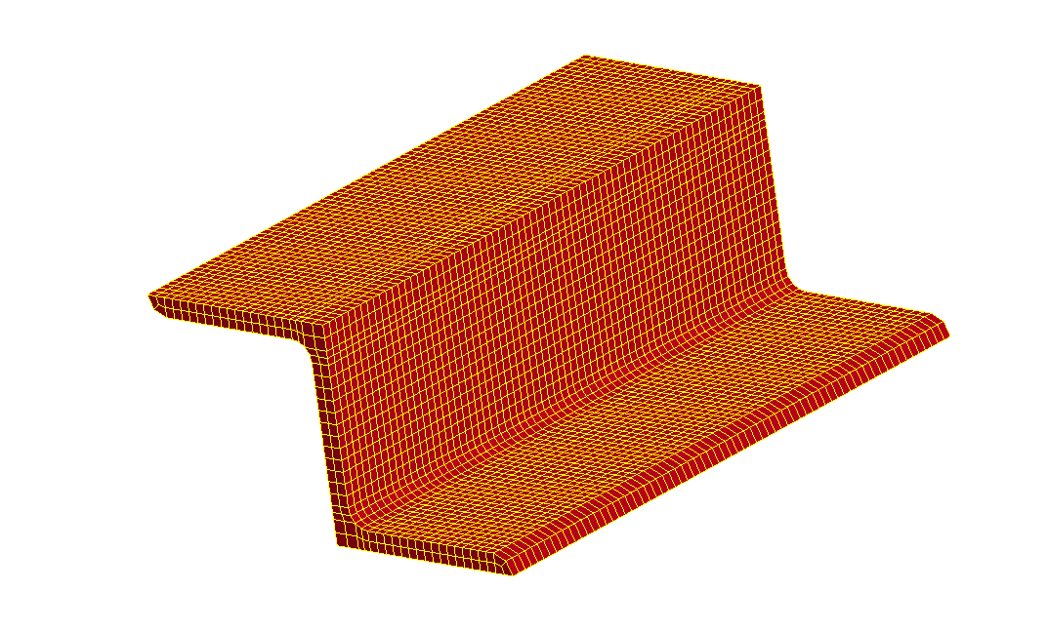

**Fig 5.3 Element generated for structural member for length 100mm.**

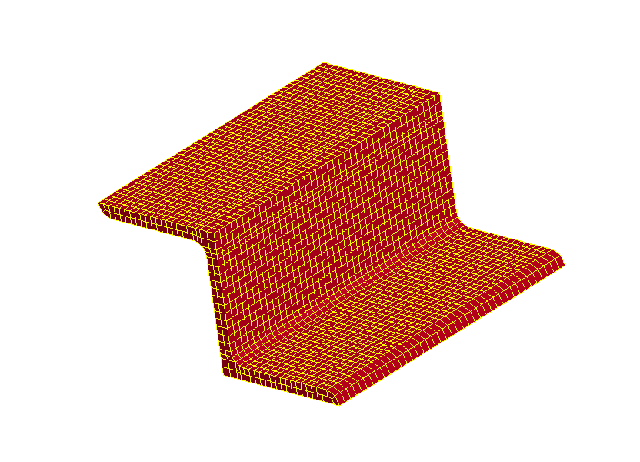

**Fig 5.4 Element generated for structural member for length 75 mm.**

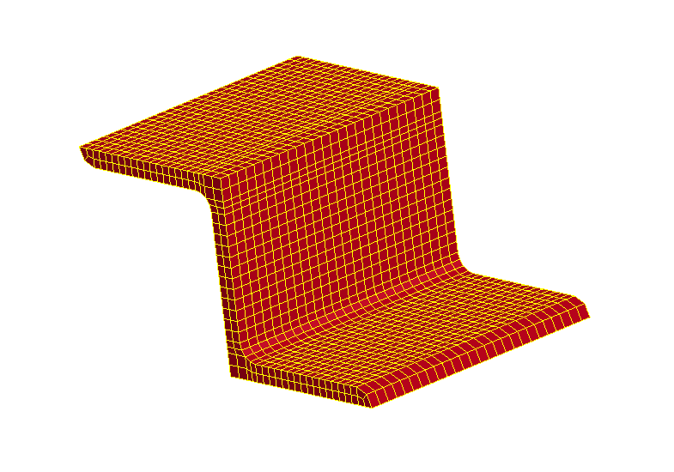

**Fig 5.5 Element generated for structural member for length 50mm.**

Select the entire component, then use the **DupNodes** command to merge every duplicate node. Select the element and propagate option in the **SPC** interface. Choose the Z structural element's left and right-side faces, then limit the faces by selecting all the direction checkboxes.

Under **\*Controls** interfacethe following input details are added.

**IMPLICIT_AUTO**

**IMPLICIT_EIGEN_VALUE**

**IMPLICIT_GENERAL**

**TERMINATION**

The **IMPLICIT_EIGEN_VALUE** is used to extract number of eigenvalues. With a termination time of 3000ms, the simulation is conducted implicitly.

## LS- DYNA result and discussion:

### Vibrational analysis at first natural period for length 50,75 and 100mm:

The frequency discovered for the structural element's first natural period with a length of 50 mm is 4.93 kHz. The displacement as a result is 0.4304 mm. The frequency and resulting displacement of the system in the first natural period is shown in Fig. 5.6.

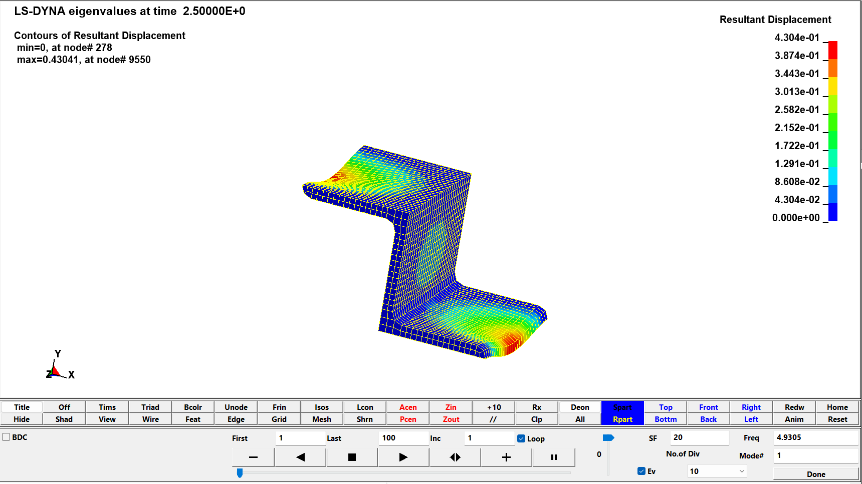

**Fig 5.6 Resultant Displacement and frequency of structural member for length 50mm.**

The frequency discovered for the structural element's first natural period with a length of 75 mm is 2.77 kHz. The displacement as a result is 4.620 mm. The frequency and resulting displacement of the system in the first natural period is shown in Fig. 5.7.

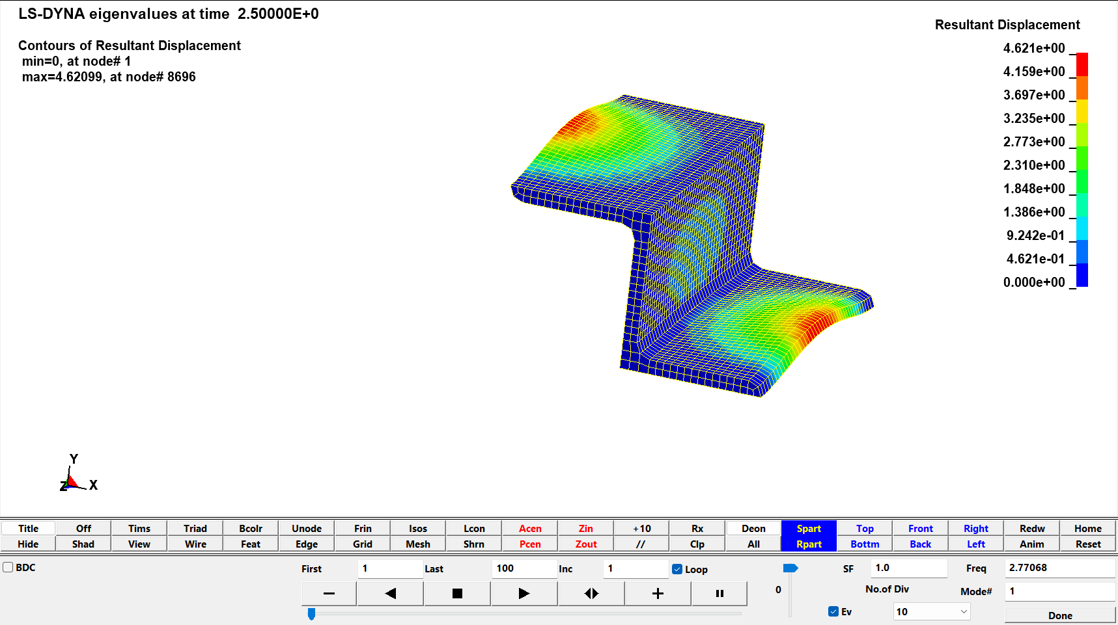

**Fig 5.7 Resultant Displacement and frequency of structural member for length 75mm.**

The first natural period of the structural element with a length of 100 mm has a frequency of 2.02 kHz. As a result, there is a displacement of 5.50 mm. Fig. 5.8 displays the system's frequency and displacement as a result in the first natural period.

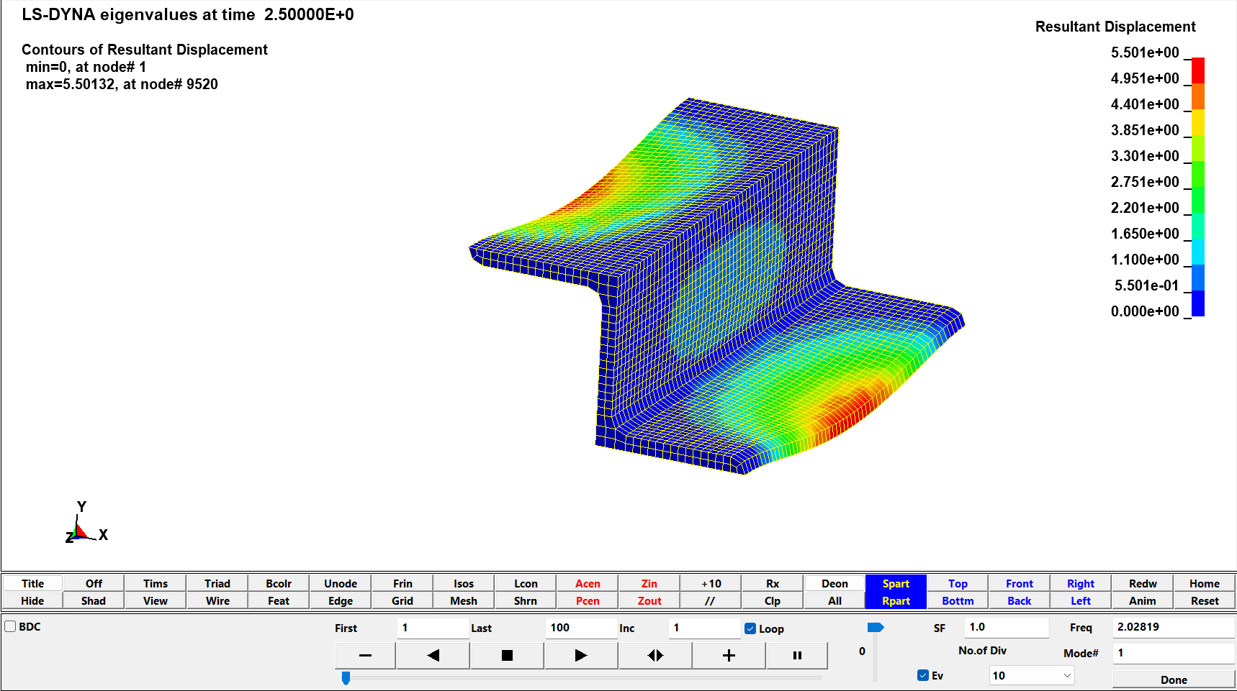

**Fig 5.8 Resultant Displacement and frequency of structural member for length 100mm.**

### Vibrational analysis at fifth natural period for length 50,75 and 100mm:

The structural element's fifth natural period, which has a length of 50 mm, has a frequency of 11.92 kHz. There is a displacement of 3.45 mm as a result. The frequency and displacement of the system because of the fifth natural period are shown in Fig. 5.9.

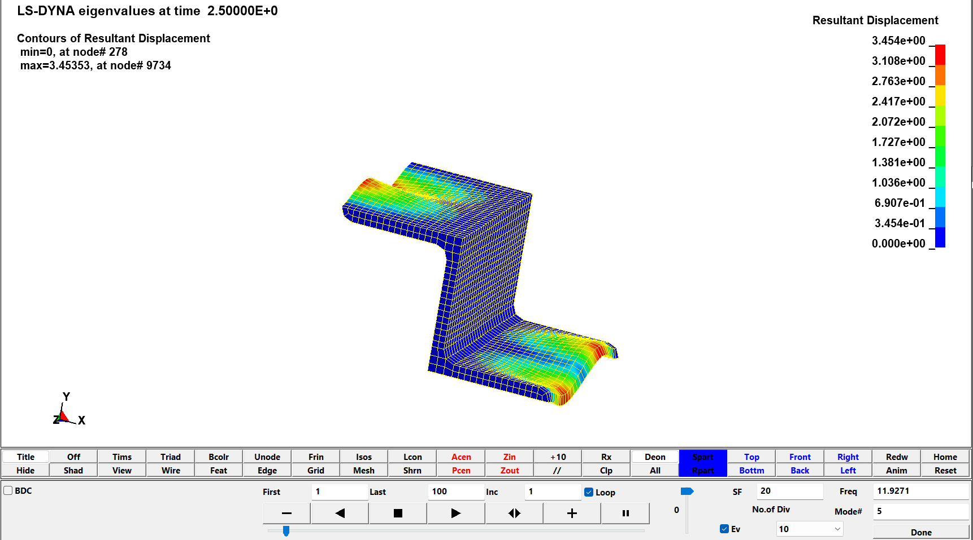

**Fig 5.9 Frequency of structural member for 5th natural period for length 50mm.**

The structural element's fifth natural period, which has a length of 75 mm, has a frequency of 7.44 kHz. There is a 4.6389 mm displacement as a result. The frequency and displacement of the system as a result during the fifth natural period are shown in Fig. 5.10.

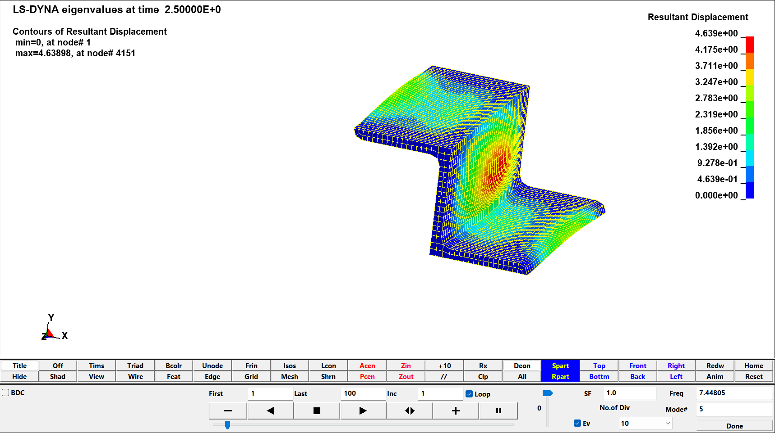

**Fig 5.10 Frequency of structural member for 5th natural period for length 75mm.**

The structural element's fifth natural period, which has a length of 100 mm, has a frequency of 5.64 kHz. There is a 5.91 mm displacement as a result. The frequency and displacement of the system as a result during the fifth natural period are shown in Fig. 5.11.

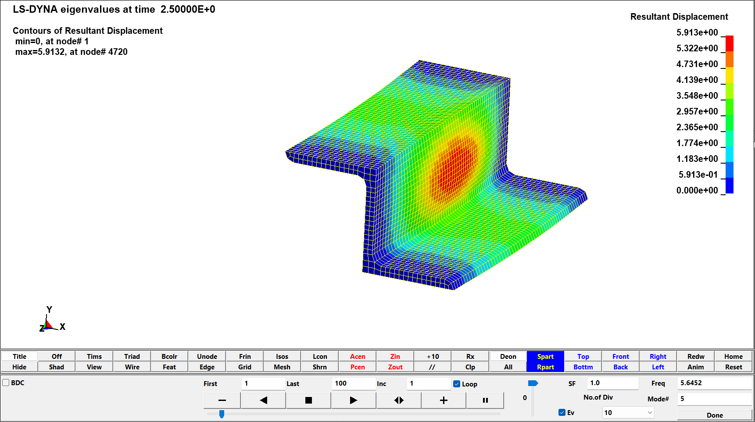

**Fig 5.11 Frequency of structural member for 5th natural period for length 100mm.**

### Vibrational analysis at tenth natural period for length 50,75 and 100mm:

The tenth natural period of the structural element is of length 50 mm and frequency 19.7646 kHz. As a result, there is a displacement of 5.33185 mm. Fig. 5.12 depicts the system's frequency and displacement because of the tenth natural cycle.

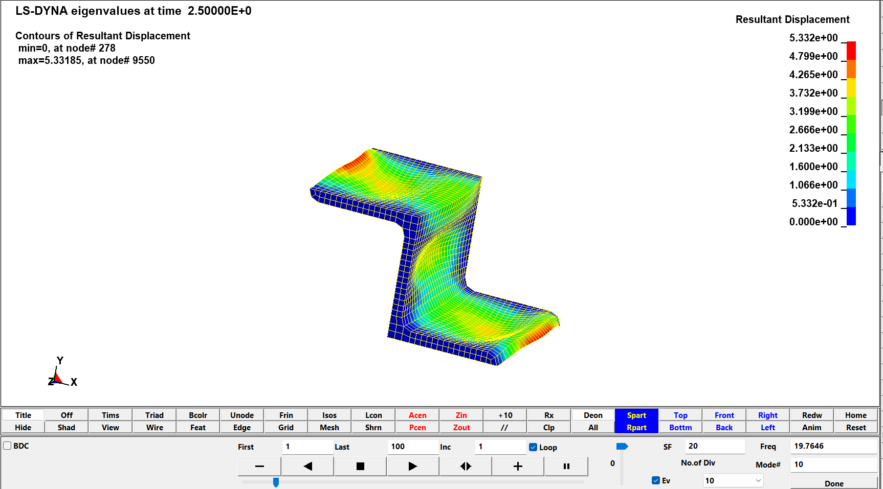

**Fig 5.12 Frequency of structural member for 10th natural period for length 50mm.**

The frequency of the 75 mm long structure is 11.15 kHz during tenth natural period. The resultant displacement is 4.610 mm. According to the tenth natural period, the system's frequency and displacement are depicted in Fig. 5.13.

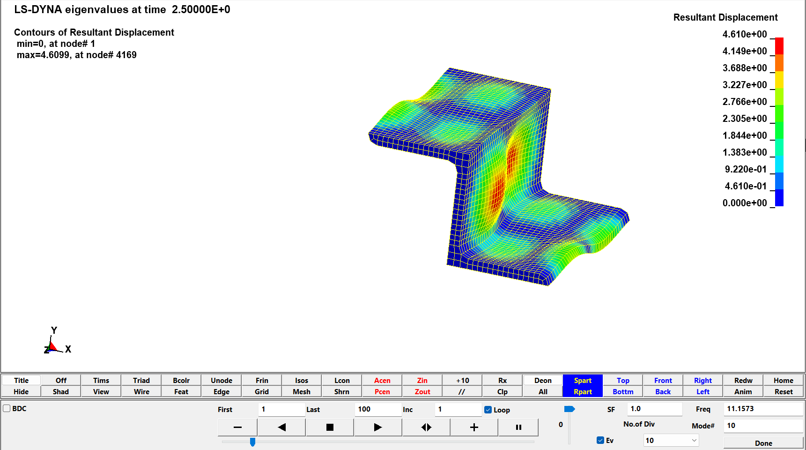

**Fig 5.13 Frequency of structural member for 10th natural period for length 75mm.**

The tenth natural period of the structural element of length 100 mm has frequency of 9.02045 kHz. As a result, there is a displacement of 5.49 mm. Figure 5.14 depicts the system's frequency and displacement as a result during the tenth natural period.

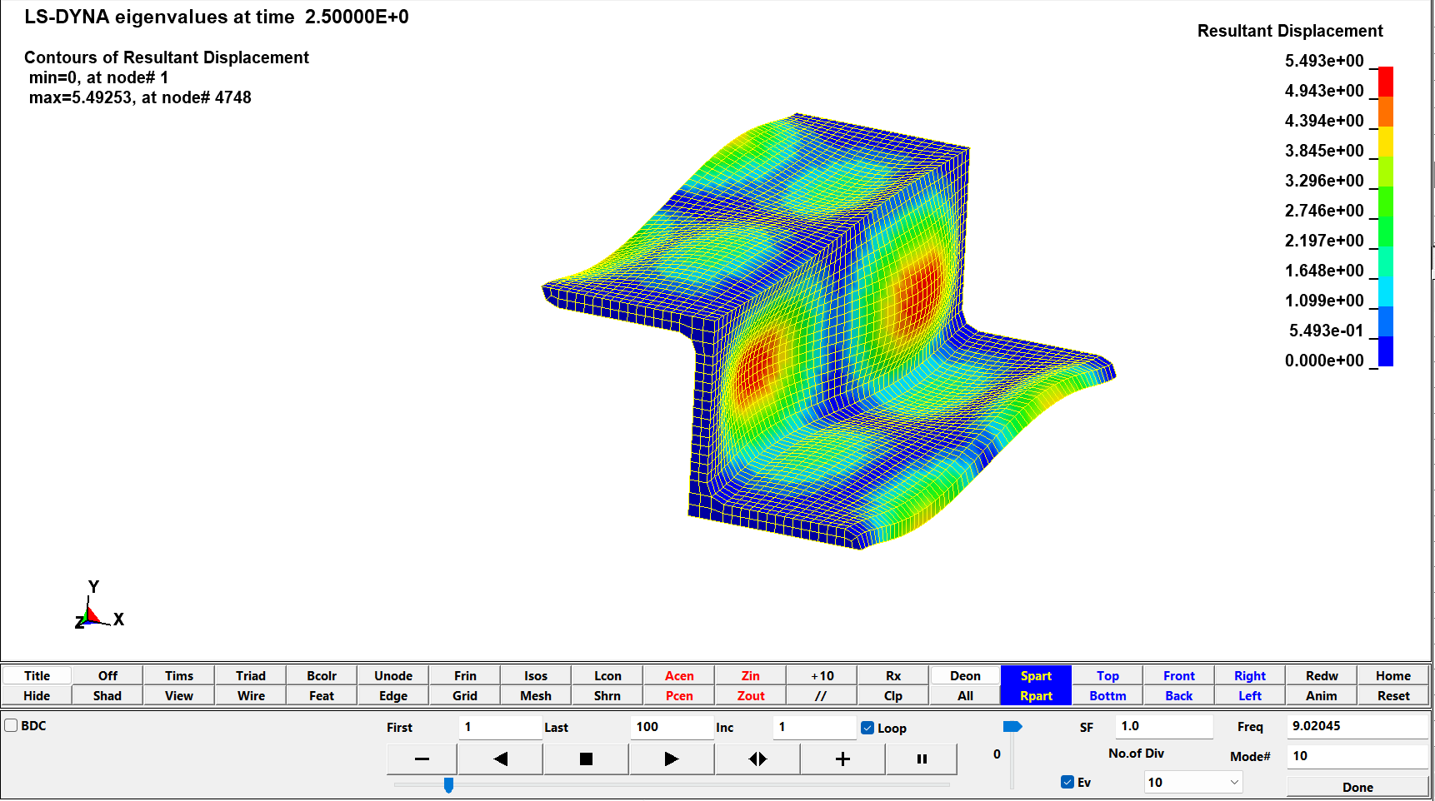

**Fig 5.14 Frequency of structural member for 10th natural period for length 100mm.**

### Vibrational analysis at twentieth natural period for length 50,75 and 100mm:

The natural frequency of the Z element at twentieth natural element for 50mm is 30.549kHz. Fig 5.15 shows the frequency data of Z element at each mode.

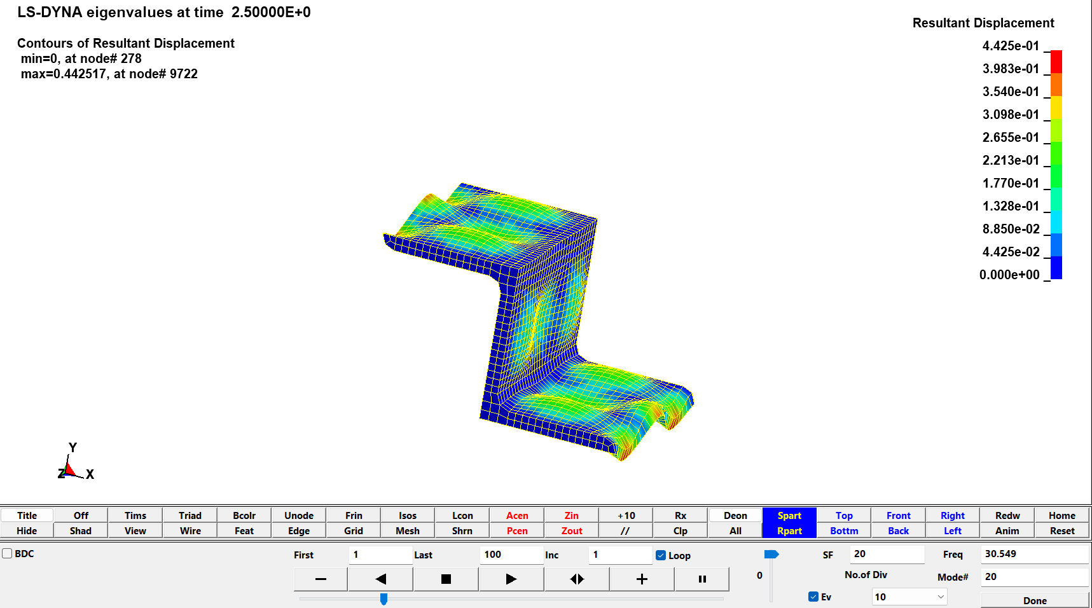

**Fig 5.15 Frequency of structural member for 20th natural period for length 50mm.**

The Z element's natural frequency at its twentieth position for a 75mm length is 20.6457 kHz. The frequency statistics for Z elements in each mode are displayed in Fig. 5.16.

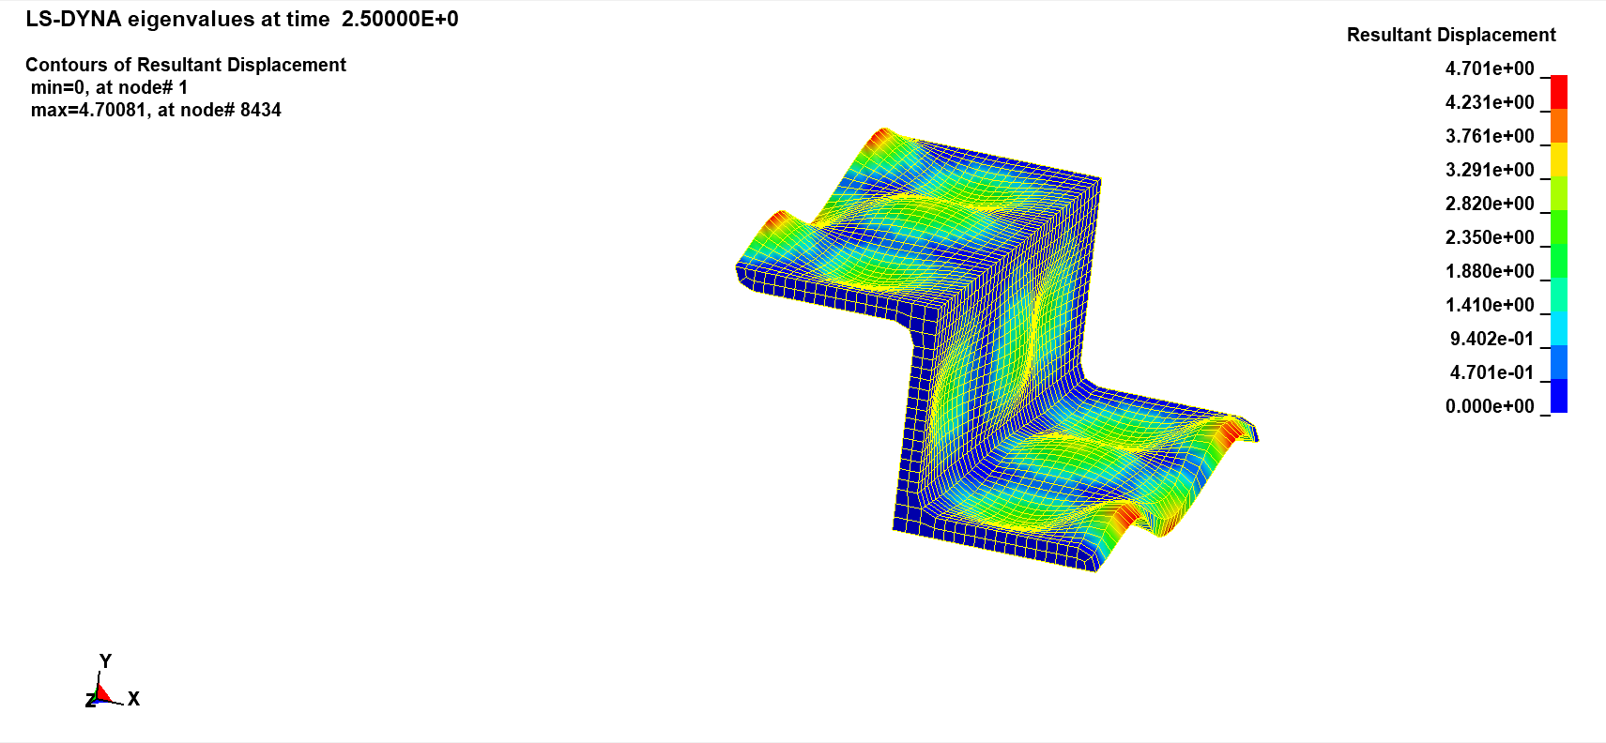

**Fig 5.16 Frequency of structural member for 20th natural period for length 75mm.**

For a 100mm lens, the Z element's natural frequency at the twentieth natural element is 15.4047 kHz. The frequency information for each mode of the Z element is shown in Fig. 5.17.

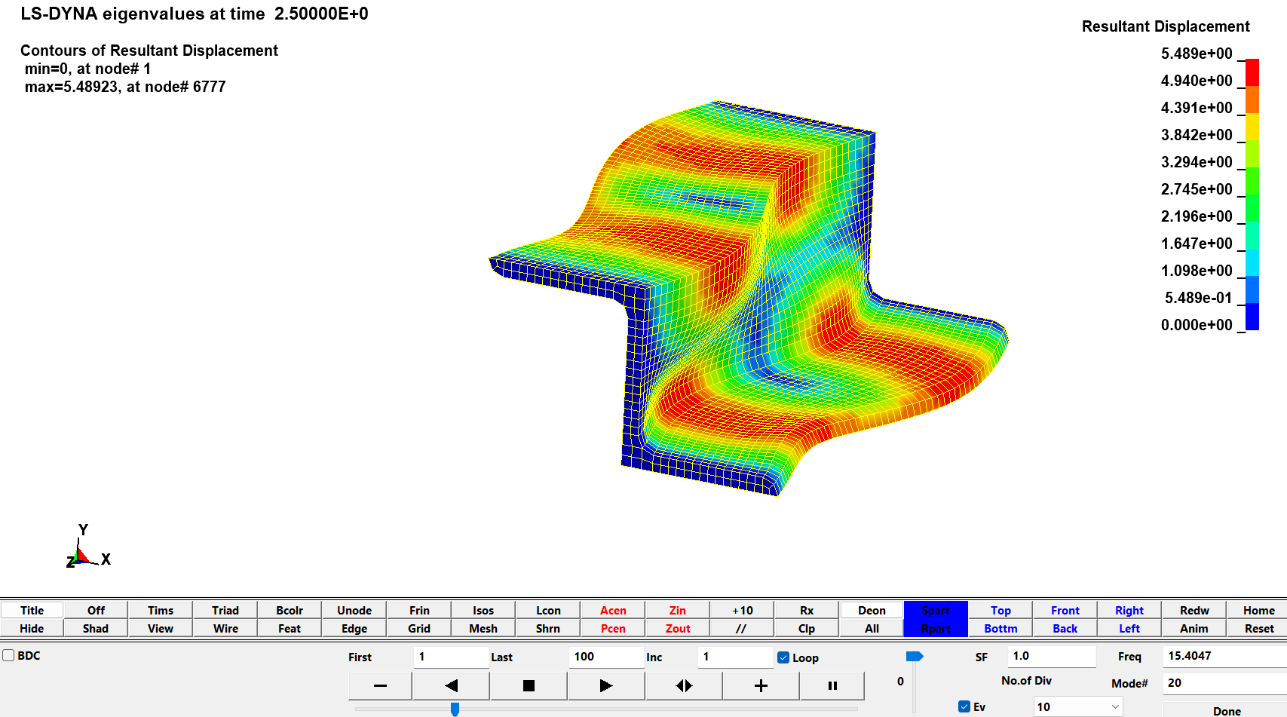

**Fig 5.17 Frequency of structural member for 20th natural period for length 100mm.**

### Frequency vs Natural Period for 50, 75 and 100mm

The below fig 5.18 shows the frequency vs natural period distribution for 50mm, 75mm and 100mm element over the periods of first, fifth, tenth and twentieth. As the size of the element decreases the vibrational frequency increases. The maximum vibrational frequency is 30.54 kHz for the 50mm structure during twentieth period and during the same period the frequency of 100 structure is 15.4 kHz. The minimum frequency is found to be 2.02 kHz obtained from the 100 structures during the first period, the 50mm structure provides 4.93 kHz and 75mm provides 2.77 kHz during the same period.

**Fig 5.18 Frequency vs Natural Period.**

## Methodology for Axisymmetric beam:

Figures 5.19 and 5.20 depict the given full structure and the converted half structure, respectively. The **EIEdit** interface transforms the whole mesh structure into a half structure. Half of the structure is selected and erased in the **EIEdit** interface's elements deletion option.

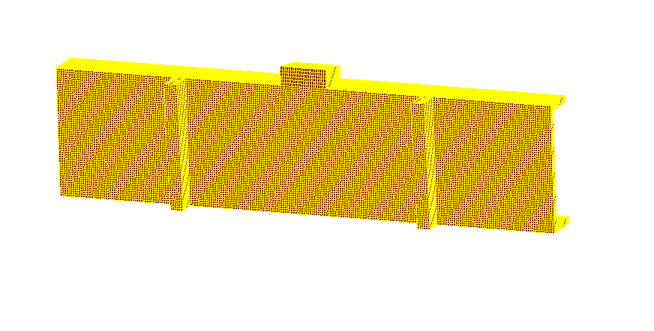

**Fig 5.19 Full mesh symmetry of the structure**

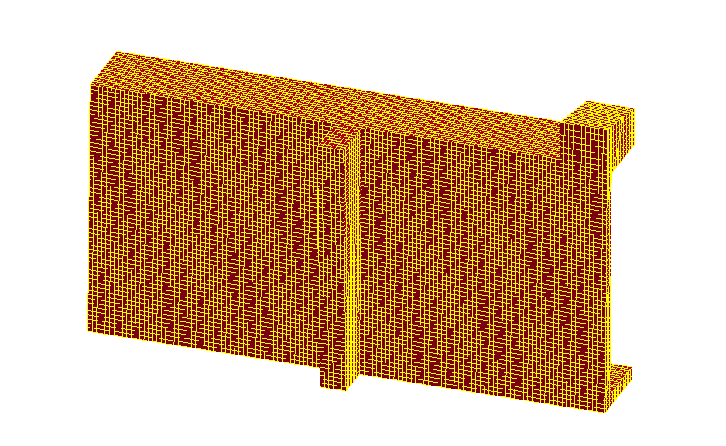

**Fig 5.20 Half symmetry of the structure**

For both the structure the copper material is applied. The properties of 425 copper are

Density = 0.0078300 g/mm3,

Youngs modulus= 2.070e+005 N/mm2

Poisson ratio = 0.3000000

Section provided for both the symmetry is solid. In the **SPC** interface, choose the element and propagate option. For the full symmetry, both the end is constrained across all the direction or to be fixed. In case of half symmetry the one end of the symmetry is fixed whereas other end of the symmetry can move in x and y direction and can also rotate normal to Z, and other movements are restricted. The full symmetry and half symmetry constrain are shown in fig 5.21 and fig 5.22 respectively.

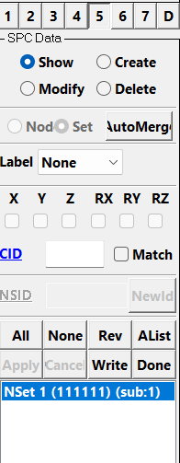

**Fig 5.21 SPC interface for full symmetry**

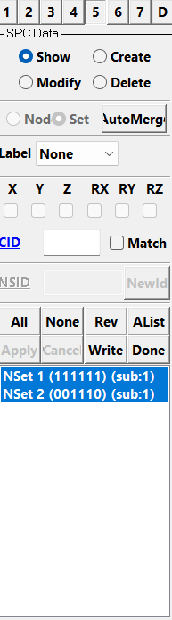

**Fig 5.22 SPC interface for half symmetry**

The **SetD** interface is used to create the node set. The nodes in which the load is to be applied is selected and the node set is created for both the symmetries. Under the **"*Define"** interface, the load curve is defined. Under the **Load** interface the load is scaled according to the number of nodes and the load direction is mentioned. For the half symmetry model the load action on the top surface of the element (15 KN) is reduced to half as the structure is also half. Thus the load of 15KN is assumed to be 7.5KN and scaled accordingly to the number of nodes.

The implicit and termination values is defined under the **"*Control"** interface. The **"ASCII"** ,**"BINARY D3PLOT" and “HISTORY_NODE”**  are provided under **"Dbase"** interface to obtain the output.

## LS- DYNA result and discussion:

The von mises stress for the full structure is shown below in fig 5.23. The maximum stress obtained is 861.051 N/mm2.

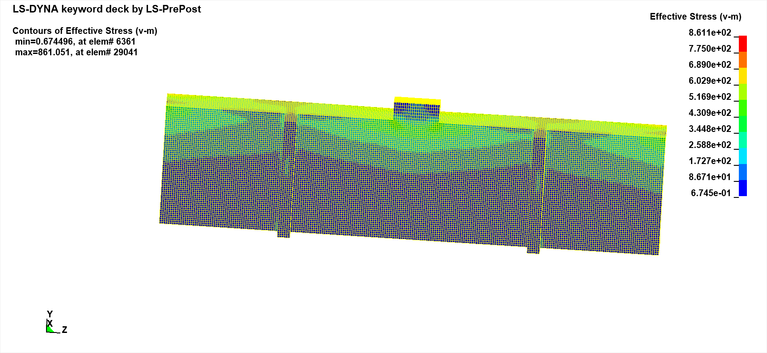

**Fig 5.23 Von mises stress for full symmetry**

Similarly, the fig 5.24 shows the von mises stress for the half structure. The maximum value obtained is 861.087 N/mm2.

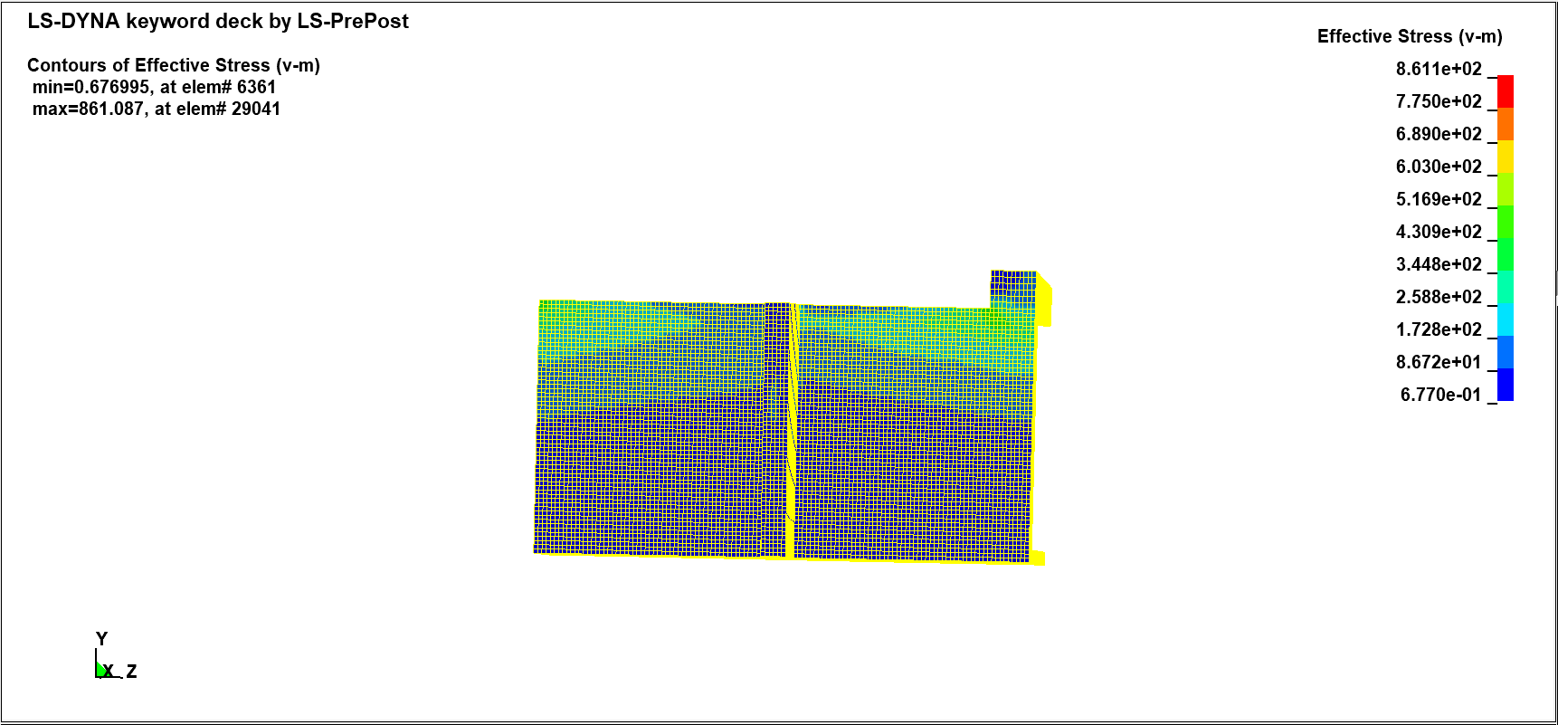

**Fig 5.24 Von mises stress for half symmetry**

When compared the von mises stress for the elements the value obtained for full symmetry and half symmetry is the same.

### X Displacement at node 87730:

At the node 87730 the maximum stress is found for both the symmetry. Then for the node 87730 the X displacement is found for both the full and half symmetry. The X Displacement for the node 87730 for full mesh and half symmetry is shown in fig 5.25 and fig 5.26 respectively. From the analysis it is found that X Displacement is same for the full and half symmetry.

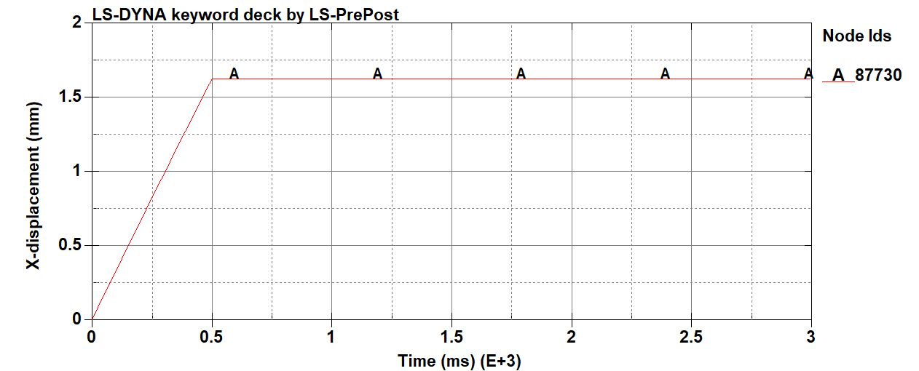

**Fig 5.25 X-Displacement stress for full symmetry**

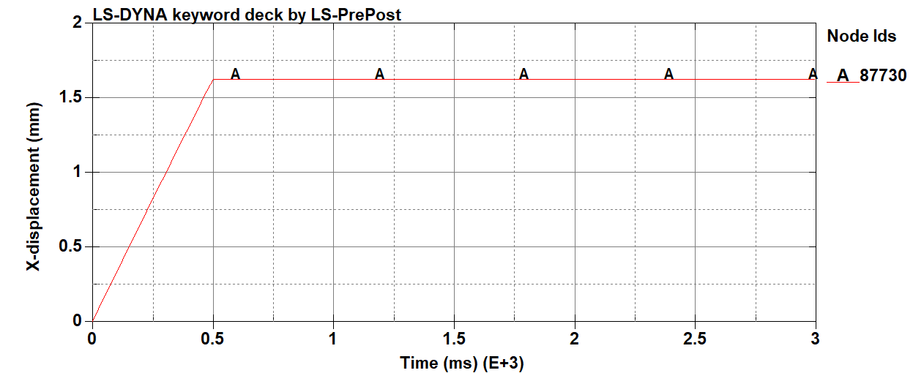

**Fig 5.26 X-Displacement for half symmetry**

### Y Displacement at node 87730:

The greatest stress is discovered at node 87730 for both the symmetry. The Y displacement is then determined for the node 87730 for both the full and half symmetry. Figures 5.27 and 5.28, which represent the Y Displacement for the node 87730 for full mesh and half symmetry, respectively. According to the investigation, the Y-Displacement is the same for both complete and half symmetry.

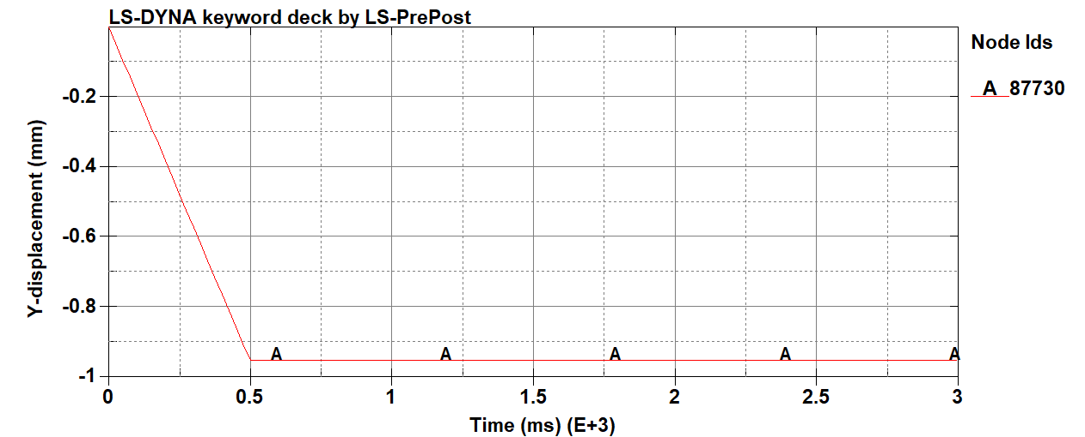

**Fig 5.27 Y-Displacement for half symmetry**



**Fig 5.28 Y-Displacement for half symmetry**

# Calculating the cumulative error and validation metrics between software and theoretical values

## Formula Used:

𝑃𝐿3

Deformation, 𝛿 =

3𝐸𝐼

Validation metric, 𝑉 = 1 – (1 /𝛿𝑇) * 0∫𝛿𝑇 tanh | (𝐹(𝑥) − 𝑓(𝑥)) /𝑓(𝑥) | dx

Cumulative error, 𝐶 = (1/𝛿𝑇) * 0∫𝛿𝑇 | (𝐹(𝑥) − 𝑓(𝑥))/ 𝑓(𝑥) | dx

|  |  |
| --- | --- |
| δ | Deflection |
| υ | Poisson Ratio |
| ρ | Density |
| E | Young’s Modulus |
| I | Moment of Inertia |
| P | Load |
| L | Length |
| V | Validation Metric |
| C | Cumulative Error |

## Methodology:

By selecting the **2DMesh—>Sketch** command, the structure's sketch can be created. The measurements provided are in millimetres. The length of structure is 150 mm, the cross section of the structure is 30mm and the thickness is 3mm. The basic sketch is made up of the lines underneath. The edges are created by selecting the **Create/Delete Edges** command under Sketch, as seen in fig. 6.1.

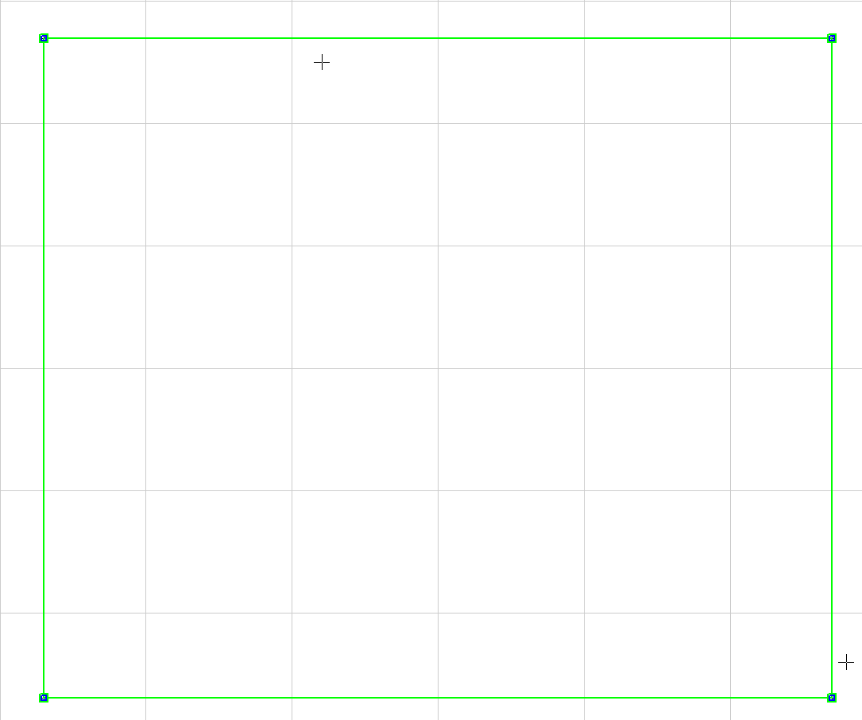

**Fig 6.1 Created edges for 2D sketch of hollow structural member.**

By the similar method the 2D structure for the other geometry are created. The fig 6.2, fig 6.3 and fig 6.4 represents the 2D sketch of the geometry I, geometry II and geometry III respectively.

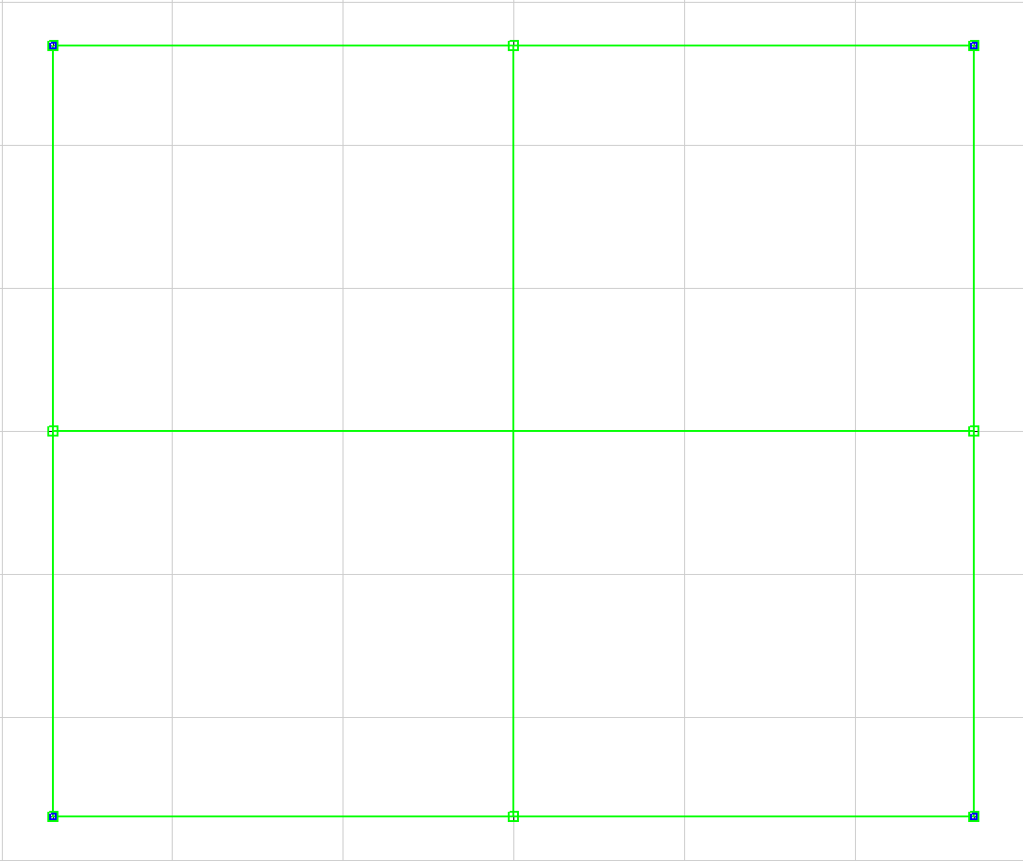

**Fig 6.2 Created edges for 2D sketch of geometry 1.**

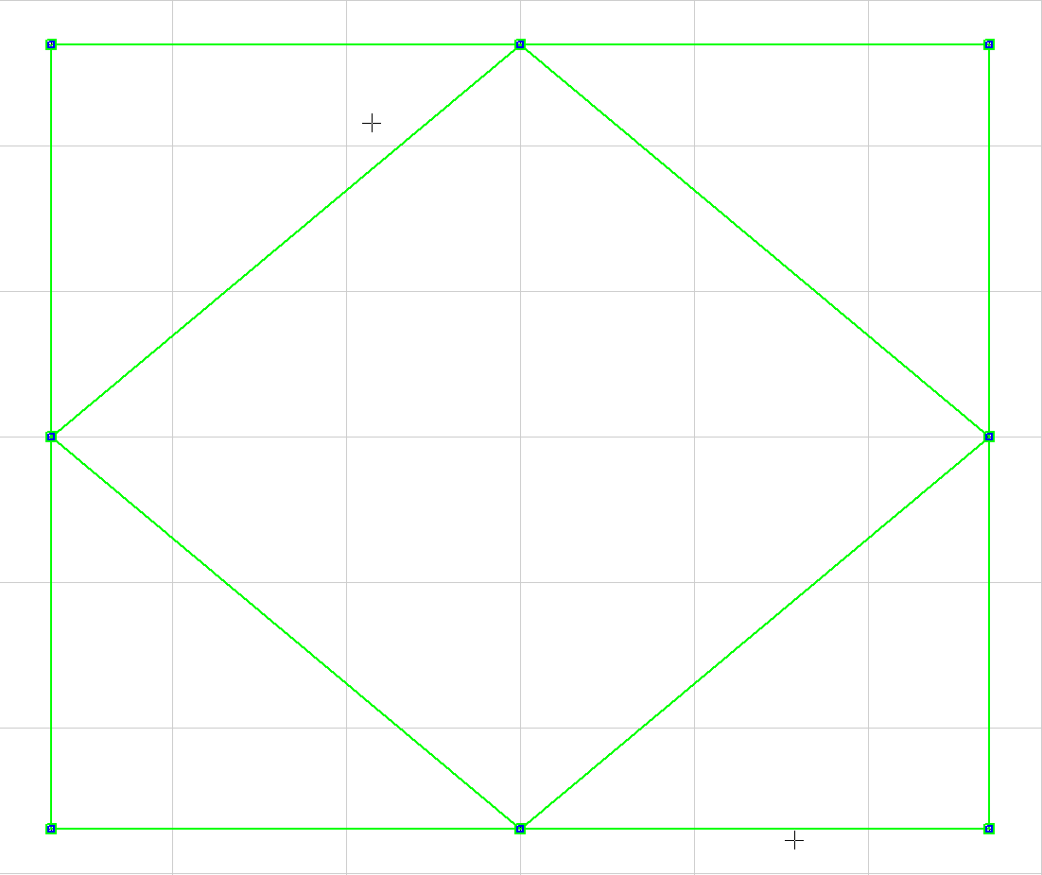

**Fig 6.3 Created edges for 2D sketch of geometry 2.**

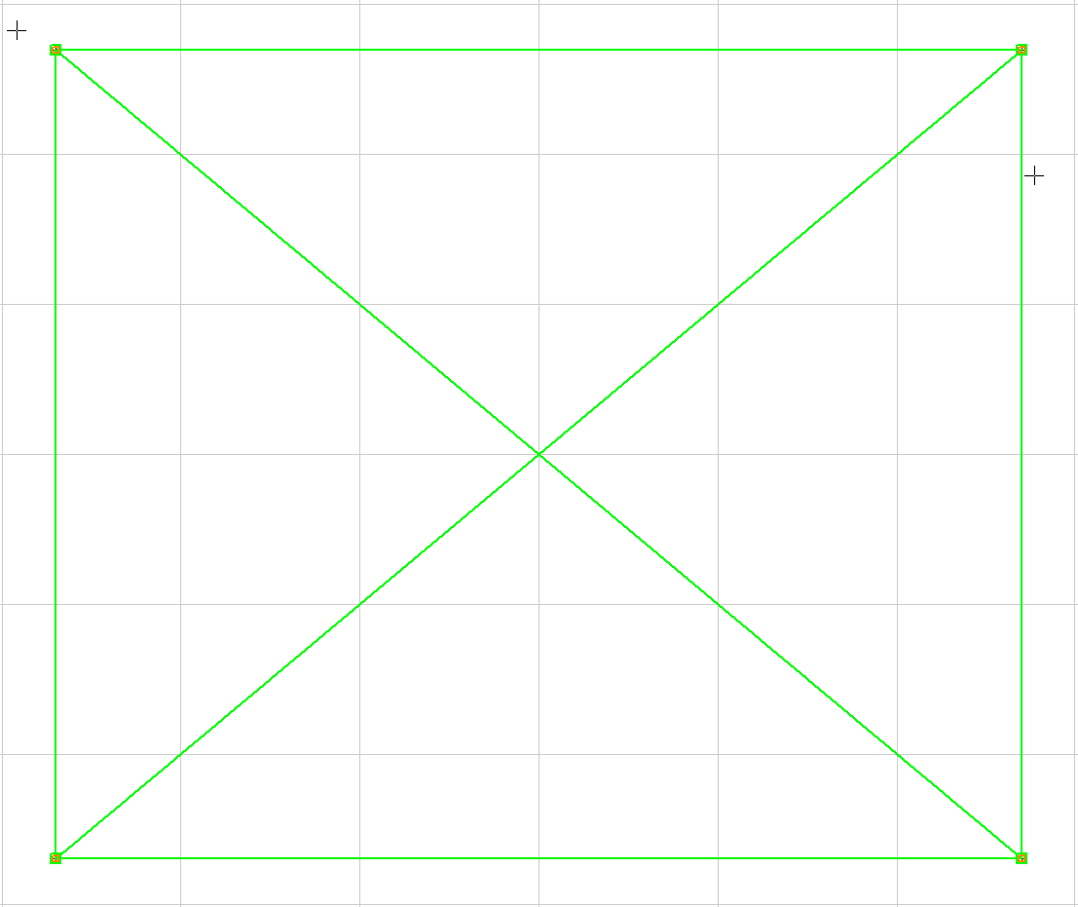

**Fig 6.4 Created edges for 2D sketch of geometry 3.**

After the edges have been formed, the number of elements is mentioned. The Create/Delete mesh command is used to create the mesh after the element count has been determined. The shell element is constructed by using the EIGen🡪Shell🡪Edge Drag command for 150mm. Aluminum 7075-T7 structures are used to make the components, and the section has been given the shell designation. The structural components are shown in Figs. 6.5, 6.6, 6.7 and 6.8.

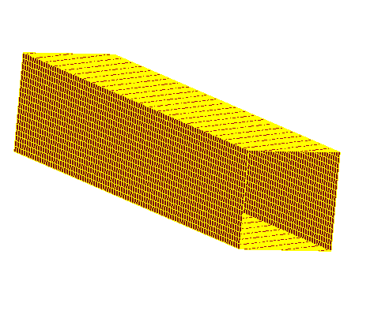

**Fig 6.5 Element generated for hollow structural member for length 150mm.**

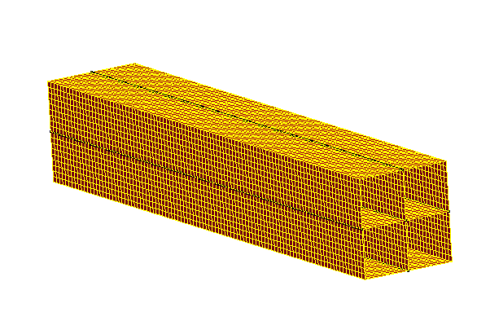

**Fig 6.6 Element generated for geometry 1 for length 150mm.**

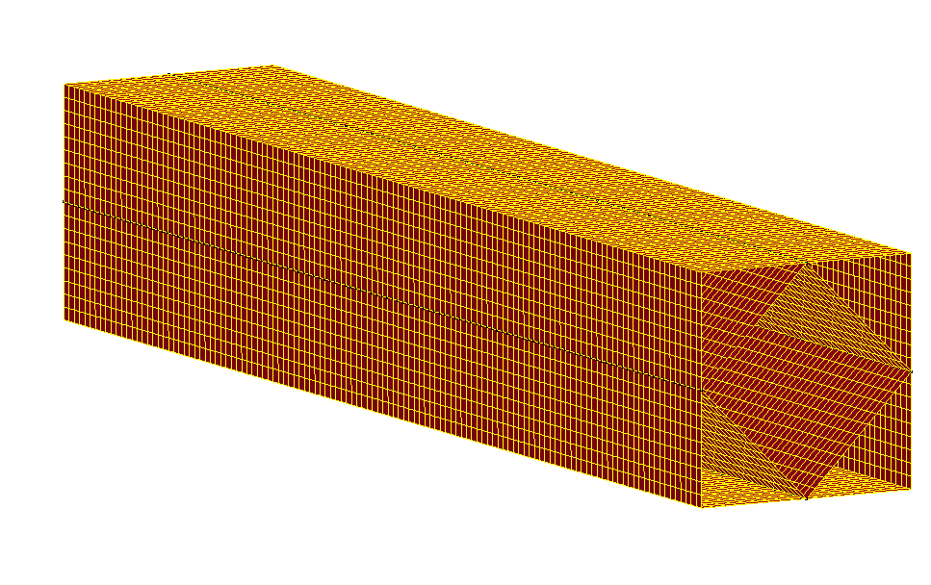

**Fig 6.7 Element generated for geometry 2 for length 150mm**

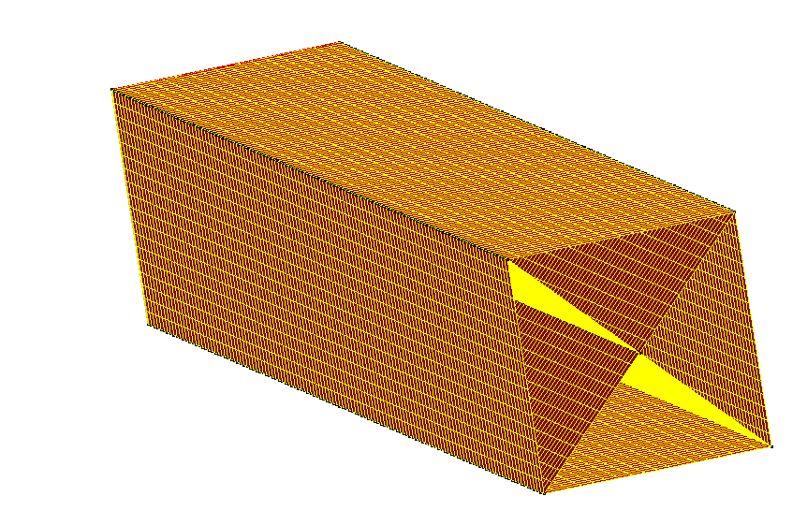

**Fig 6.8 Element generated for geometry 3 for length 150mm.**

Use the **DupNodes** command to merge all duplicate nodes after selecting the full component. In the **SPC** interface, choose the element and propagate option. By selecting every checkbox in the SPC command window, one end of the structure can be fixed. The segment set is generated via **SetD** interface by choosing the other end of the structure.

As given in the question a lateral load curve for 250ms is defined under the **\*Define** interface. The load curve is shown in Fig 6.9.

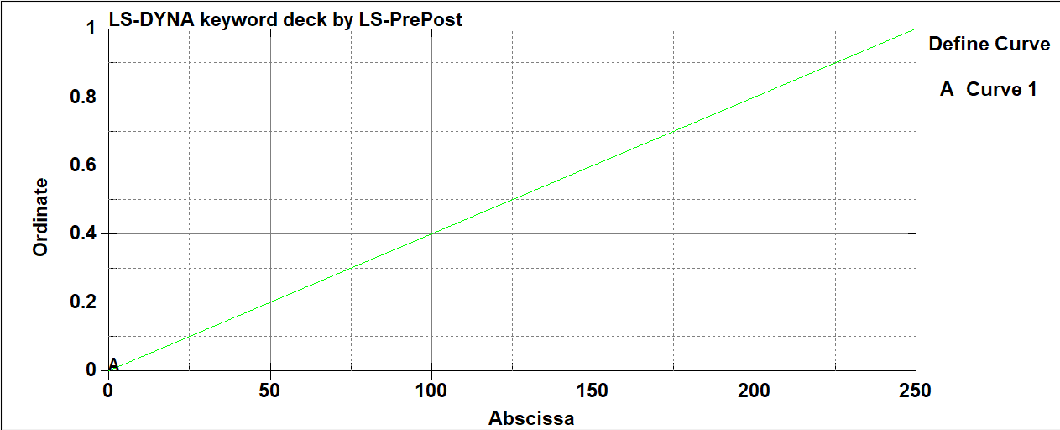

**Fig 6.9 Load Curve**

Under the **LOAD** interface, the load value is scaled and supplied according to the load's direction. Under **\*Controls** interface the following input details are added.

**IMPLICIT_AUTO**

**IMPLICIT_DYNAMICS**

**IMPLICIT_GENERAL**

**TERMINATION**

The total termination time is 250 milliseconds. The datapoints mentioned is 1 to get 250 data values. Under **\*Dbase** the **ASCII Option**, **Binary D3Plot** is mentioned. A random node is selected from the structure and mentioned under the **History Node**.

## LS- DYNA result and discussion:

### Lateral Displacement:

The hollow structure's maximum displacement under a 10KN force is -4.579 mm. The negative sign indicates that the structure bends downwards. At the cantilever end, the displacement had reached its maximum. Fig 6.10 shows the displacement of structure under 10kN load.

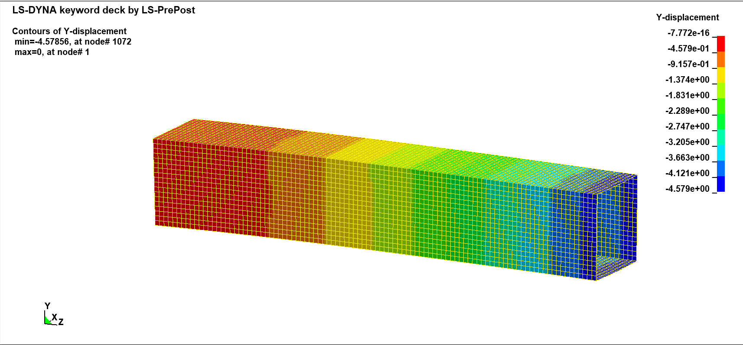

**Fig 6.10 Displacement of Hollow structure under 10kN load.**

The maximum displacement of geometry 1 under a 10KN force is -3.764 mm. The displacement had reached its maximum at the cantilever end. The structure's displacement under a 10 kN load is shown in Fig. 6.11.

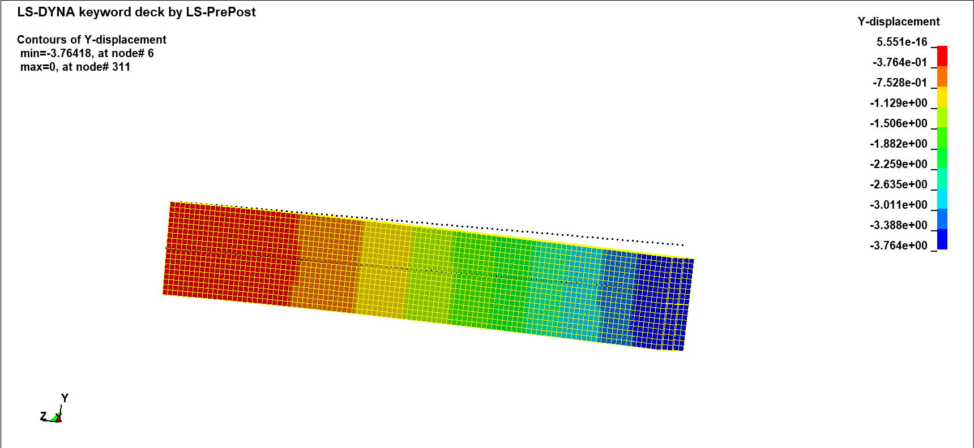

**Fig 6.11 Displacement of geometry 1 under 10kN load.**

The displacement of geometry 2 at the end of analysis for 10KN force is -3.172 mm. The displacement is maximum at the cantilever end and minimum at the fixed end. Fig. 6.12 shows the displacement of geometry 2.

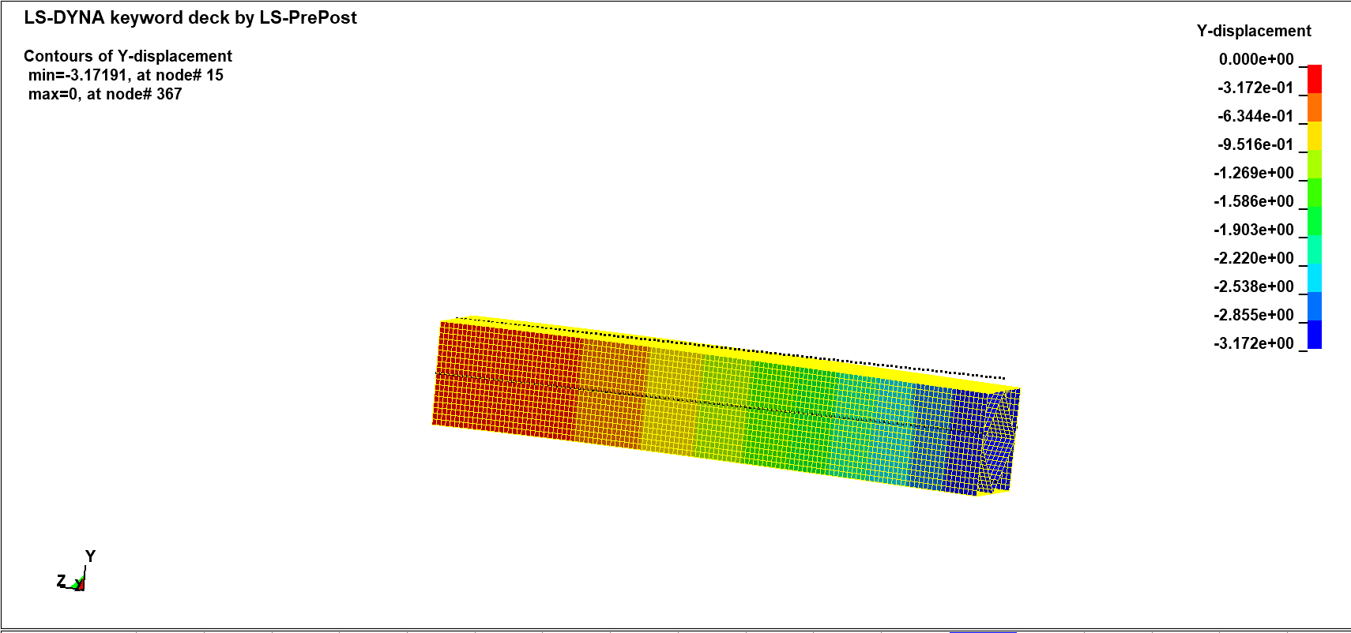

**Fig 6.12 Displacement of geometry 2 under 10kN load.**

At the completion of the analysis, geometry 3 has moved -3.23 mm under a 10KN force. Maximum displacement is at the cantilever end, while minimum displacement is at the fixed end. The displacement of geometry 3 is depicted in Fig. 6.13.

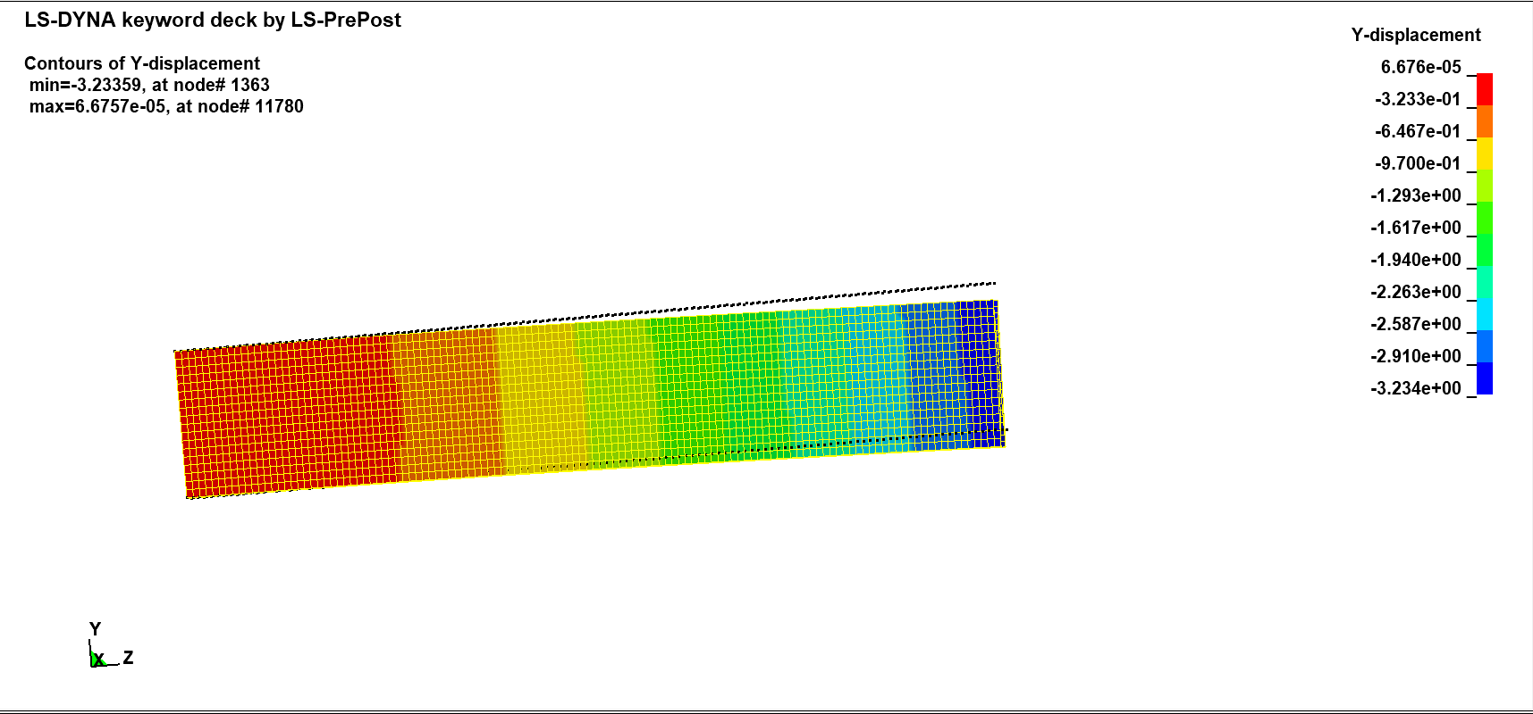

**Fig 6.13 Displacement of geometry 3 under 10kN load.**

When exposed to the same load of 10kN, LS-Dyna analysis reveals that geometry 2 exhibits less displacement while hollow structure exhibits more displacement. As a result, it can be claimed that geometry 2 is more resistant to lateral deformation. The displacement of each structure is shown in fig 6.14.

**Fig 6.14 Displacement of Structures.**

### Theoretical Calculation:

Under the From Simulation section are the results from LS Dyna. The load values for the analytical x variables were calculated by dividing the total load by 250 data points. The deformation formula is used to determine the Y variable.

𝑃𝐿3

Deformation, 𝛿 = (1)

3𝐸𝐼

P, L and E values are known values. The I represent moment of inertial is found either using cad software or through the formula if known. The validation metric V and cumulative error are computed using the provided validation metric and cumulative error formulas.

Validation metric, 𝑉 = 1 – (1 /𝛿𝑇) * 0∫𝛿𝑇 tanh | (𝐹(𝑥) − 𝑓(𝑥)) /𝑓(𝑥) | dx

Cumulative error, 𝐶 = (1/𝛿𝑇) * 0∫𝛿𝑇 | (𝐹(𝑥) − 𝑓(𝑥))/ 𝑓(𝑥) | dx

The validation metric for the hollow structure is 0.8353 and the cumulative error is 0.1662. Fig 6.15 shows the calculations of validation metric and cumulative error.

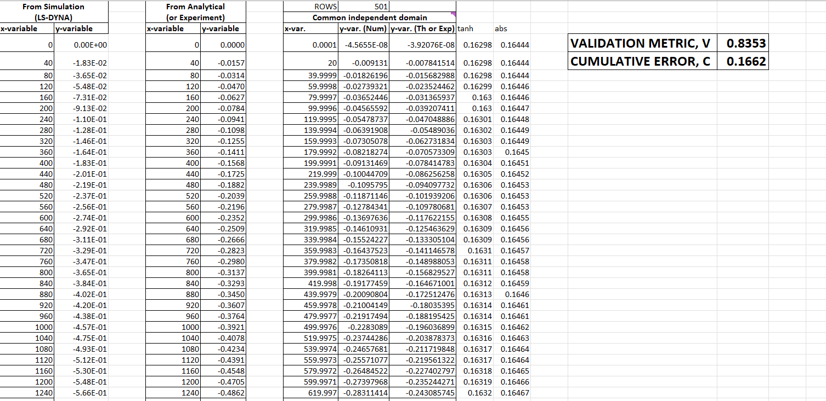

**Fig 6.15 Excel calculation for Validation metric and cumulative error for hollow structure.**

The x variable and y variable received from the calculation using the excel sheet are plotted for analytical vs. numerical value. The numerical vs. analytical displacement is depicted in Figure 6.16. It is discovered that the hollow model has a higher difference between calculated and the LS Dyna value.

**Fig 6.16 Numerical vs Analytical Displacement Graph for Hollow structure**

The validation metric for geometry 1 is 0.9636 and the cumulative error is 0.0.0365. Fig 6.17 shows the calculations of validation metric and cumulative error.

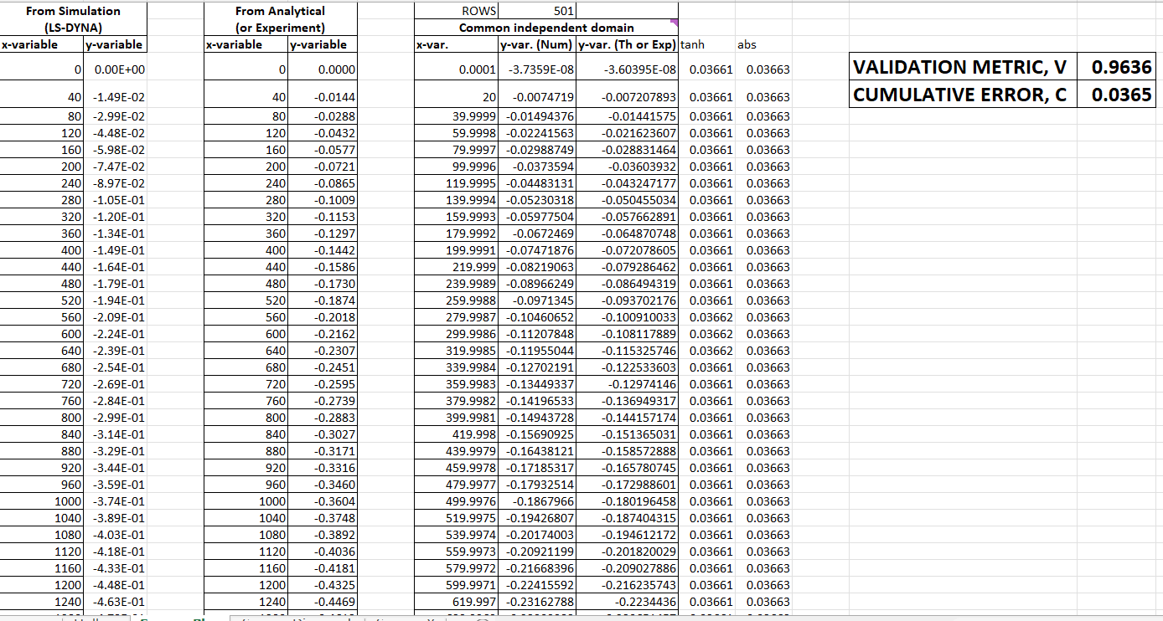

**Fig 6.17 Excel calculation for Validation metric and cumulative error for Geometry 1.**

The numerical and analytical approach of geometry 1's values for the x and y variables are plotted similarly, and it is discovered that geometry 1 has a lower errorpercentage compared to hollow structure. The plot is shown on fig 6.18.

**Fig 6.18 Excel calculation for Validation metric and cumulative error for hollow structure.**

The cumulative error is 0.02 and the validation metric for geometry 2 is 0.98. The validation metre and cumulative error computations are displayed in Fig. 6.19.

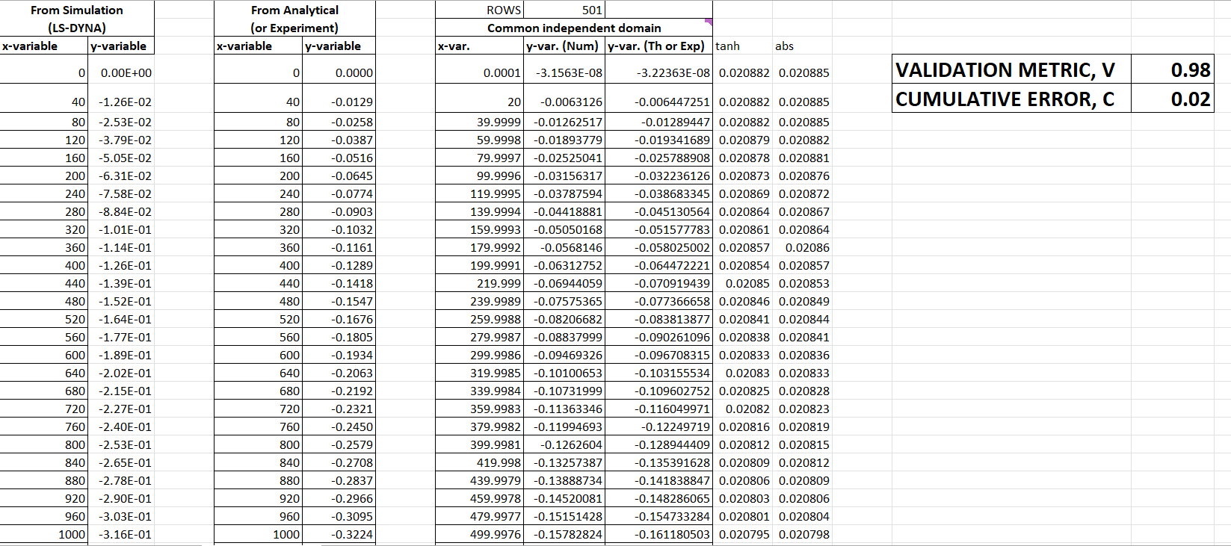

**Fig 6.19 Excel calculation for Validation metric and cumulative error for Geometry 2.**

According to the study, geometry 2 has a higher validation metric and a lower error. Therefore, the LS Dyna analysis is accurate and appropriate for this geometry. The numerical and analytical displacement is plotted for geometry 2 and is depicted in Fig 6.20.

**Fig 6.20 Numerical vs Analytical Displacement Graph for Geometry 2.**

The validation metric for geometry 3 is 0.9615, and the overall error is 0.0385. Fig. 6.21 shows the computations for the cumulative error and the validation metric.

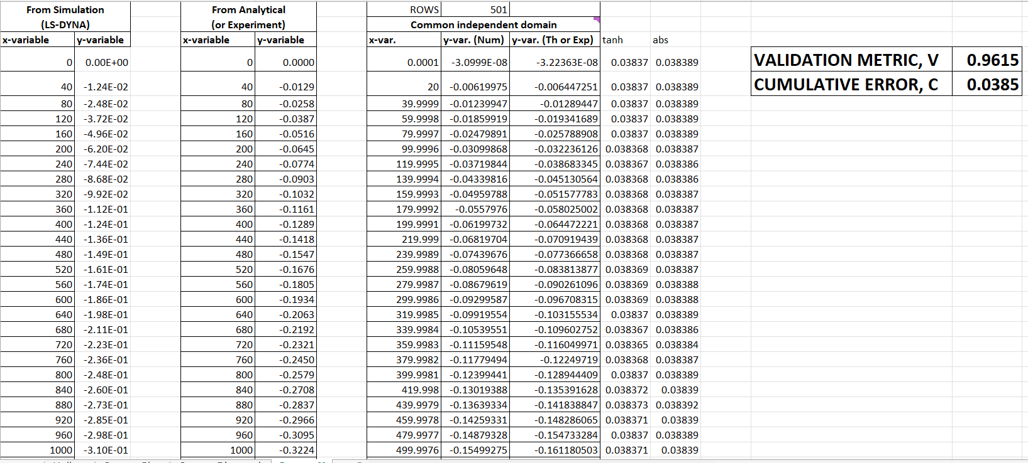

**Fig 6.21 Excel calculation for Validation metric and cumulative error for Geometry 3.**

Geometry 3 has a stronger validation metric and a lower error, according to the study. The LS Dyna analysis is therefore correct and suitable for this shape. Fig. 6.22 shows the numerical and analytical displacement plotted for geometry 3.

**Fig 6.22 Numerical vs Analytical Displacement Graph for Geometry 3.**

# Conclusions

One of the most important concepts from this course is the generation of finite elements, which is also utilised to analyse numerous models. Fig. 7.1 shows the solid composed of finite elements.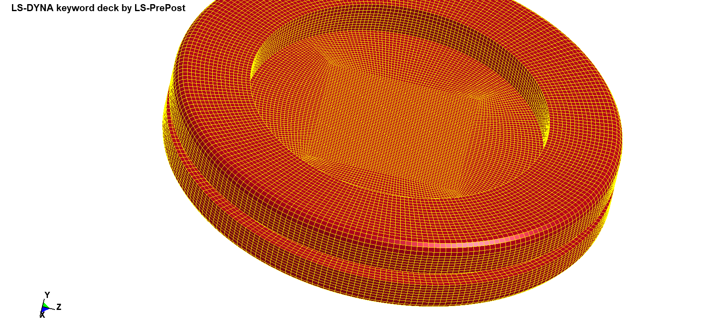

**Fig 7.1 3D part**

The analysis's findings supported the course's instruction, which said that plates with more elements or higher mesh sensitivity produce better results than those with fewer elements or lower sensitivity. The formula and software numbers are used to calculate the stress concentration factor, which is then used to determine how much the theoretical stress concentration and the value acquired from the program diverge. The plate with a high mesh sensitivity is said to give reduced relative error when the values between the software and numerical computations are compared, while the plate with a low mesh sensitivity is said to provide.

The study's conclusions state that solids contain more elements than shells do. As a result, the stress acting on the solid is greater than the stress acting on the shell in both scenarios—steel end to be fastened and load on aluminium, and aluminium end to be fixed and load on steel.

The course also demonstrates how software can analyses both half and total symmetry using the same techniques. Therefore, the values of von Mises stress, X-displacement, and Y-displacement for complete and half symmetry are the same, but full symmetry requires twice as long to complete as half symmetry. This approach is advantageous and will result in greater time savings for projects with the same dimension and load on the ends.

Theoretical deformation, validation metrics, and cumulative error are computed for chapter 6 and compared to the numerical deformation generated by LS Dyna. The hollow structure, however, has the biggest error. Geometry 1, geometry 2, and geometry 3 all have values that are virtually identical with relatively little errors. These differences may be the result of the structure's low mesh quality. The Ls Dyna does not compute the values for solid and shell in the same way, which could potentially account for the variation in the validation metric. According to the study, geometry 2 is more lateral load resistant.

**Reference:**

[1] “What is Von Mises Stress in FEA? | SimWiki | SimScale,” *SimScale*, Sep. 09, 2022. [Online]. Available: https://www.simscale.com/docs/simwiki/fea-finite-element-analysis/what-is-von-mises-stress/. [Accessed: Oct. 07, 2022]

SPRING_IMPLICT.k

$# LS-DYNA Keyword file created by LS-PrePost(R) V4.3.38 - 30Jan2019

$# Created on Sep-29-2022 (13:11:34)

*KEYWORD

*TITLE

$# title

LS-DYNA keyword deck by LS-PrePost

*CONTROL_IMPLICIT_AUTO

$# iauto iteopt itewin dtmin dtmax dtexp kfail kcycle

0 11 5 0.0 0.0 0.0 0 0

*CONTROL_IMPLICIT_DYNAMICS

$# imass gamma beta tdybir tdydth tdybur irate

1 0.5 0.25 0.01.00000E281.00000E28 0

*CONTROL_IMPLICIT_GENERAL

$# imflag dt0 imform nsbs igs cnstn form zero_v

1 10.0 2 1 2 0 0 0

*CONTROL_IMPLICIT_SOLUTION

$# nsolvr ilimit maxref dctol ectol rctol lstol abstol

12 11 15 0.001 0.011.00000E10 0.91.0000E-10

$# dnorm diverg istif nlprint nlnorm d3itctl cpchk

2 1 1 0 2 0 0

$# arcctl arcdir arclen arcmth arcdmp arcpsi arcalf arctim

0 0 0.0 1 2 0 0 0

$# lsmtd lsdir irad srad awgt sred

4 2 0.0 0.0 0.0 0.0

*CONTROL_TERMINATION

$# endtim endcyc dtmin endeng endmas

30000.0 0 0.0 0.01.000000E8

*DATABASE_DEFORC

$# dt binary lcur ioopt

10.0 0 0 1

*DATABASE_GLSTAT

$# dt binary lcur ioopt

10.0 0 0 1

*DATABASE_MATSUM

$# dt binary lcur ioopt

10.0 0 0 1

*DATABASE_NODFOR

$# dt binary lcur ioopt

10.0 0 0 1

*DATABASE_NODOUT

$# dt binary lcur ioopt option1 option2

10.0 0 0 1 0.0 0

*DATABASE_BINARY_D3PLOT

$# dt lcdt beam npltc psetid

0.0 0 0 50 0

$# ioopt

0

*DATABASE_HISTORY_NODE

$# id1 id2 id3 id4 id5 id6 id7 id8

1 2 0 0 0 0 0 0

*BOUNDARY_PRESCRIBED_MOTION_NODE_ID

$# id heading

0D -T

$# nid dof vad lcid sf vid death birth

1 2 2 1 1.0 01.00000E28 0.0

*BOUNDARY_SPC_SET_BIRTH_DEATH

$# nsid cid dofx dofy dofz dofrx dofry dofrz

1 0 1 0 1 1 1 1

$# birth death

0.0 0.0

*SET_NODE_LIST_TITLE

NODESET(SPC) 1

$# sid da1 da2 da3 da4 solver

1 0.0 0.0 0.0 0.0MECH

$# nid1 nid2 nid3 nid4 nid5 nid6 nid7 nid8

1 0 0 0 0 0 0 0

*PART

$# title

SPRING

$# pid secid mid eosid hgid grav adpopt tmid

1 1 1 0 0 0 0 0

*SECTION_DISCRETE_TITLE

SPRING

$# secid dro kd v0 cl fd

1 0 0.0 0.0 0.0 0.0

$# cdl tdl

0.0 0.0

*MAT_SPRING_ELASTIC_TITLE

SPRING

$N/mm

$# mid k

1 40.0

*PART

$# title

DAMPER

$# pid secid mid eosid hgid grav adpopt tmid

2 2 2 0 0 0 0 0

*SECTION_DISCRETE_TITLE

DAMPER

$# secid dro kd v0 cl fd

2 0 0.0 0.0 0.0 0.0

$# cdl tdl

0.0 0.0

*MAT_DAMPER_VISCOUS_TITLE

DAMPER

$# mid dc

2 2000.0

*DEFINE_CURVE_FUNCTION_TITLE

D -T

$# lcid sidr sfa sfo offa offo dattyp

1 0 1.0 1.0 0.0 0.0 0

$# function

10*COS(0.0058*TIME)

*ELEMENT_DISCRETE

$# eid pid n1 n2 vid s pf offset

1 1 1 2 0 1.0 0 0.0

2 2 1 2 0 1.0 0 0.0

*ELEMENT_MASS

$Mass -grams

$# eid nid mass pid

1 2 1000000 1

*NODE

$# nid x y z tc rc

1 0.0 0.0 0.0 0 0

$Y-mm

2 0.0 100.0 0.0 0 0

*END

SPRING_EXPLICT.k

$# LS-DYNA Keyword file created by LS-PrePost(R) V4.3.38 - 30Jan2019

$# Created on Sep-29-2022 (13:46:25)

*KEYWORD

*TITLE

$# title

LS-DYNA keyword deck by LS-PrePost

*CONTROL_TERMINATION

$# endtim endcyc dtmin endeng endmas

30000.0 0 0.0 0.01.000000E8

*CONTROL_TIMESTEP

$# dtinit tssfac isdo tslimt dt2ms lctm erode ms1st

0.0 0.9 0 0.0 10.0 2 0 0

$# dt2msf dt2mslc imscl unused unused rmscl

0.0 0 0 0.0

*DATABASE_DEFORC

$# dt binary lcur ioopt

10.0 0 0 1

*DATABASE_GLSTAT

$# dt binary lcur ioopt

10.0 0 0 1

*DATABASE_MATSUM

$# dt binary lcur ioopt

10.0 0 0 1

*DATABASE_NODFOR

$# dt binary lcur ioopt

10.0 0 0 1

*DATABASE_NODOUT

$# dt binary lcur ioopt option1 option2

10.0 0 0 1 0.0 0

*DATABASE_BINARY_D3PLOT

$# dt lcdt beam npltc psetid

0.0 0 0 50 0

$# ioopt

0

*DATABASE_HISTORY_NODE

$# id1 id2 id3 id4 id5 id6 id7 id8

1 2 0 0 0 0 0 0

*BOUNDARY_PRESCRIBED_MOTION_NODE_ID

$# id heading

0D -T

$# nid dof vad lcid sf vid death birth

1 2 2 1 1.0 01.00000E28 0.0

*BOUNDARY_SPC_SET_BIRTH_DEATH

$# nsid cid dofx dofy dofz dofrx dofry dofrz

1 0 1 0 1 1 1 1

$# birth death

0.0 0.0

*SET_NODE_LIST_TITLE

NODESET(SPC) 1

$# sid da1 da2 da3 da4 solver

1 0.0 0.0 0.0 0.0MECH

$# nid1 nid2 nid3 nid4 nid5 nid6 nid7 nid8

1 0 0 0 0 0 0 0

*PART

$# title

SPRING

$# pid secid mid eosid hgid grav adpopt tmid

1 1 1 0 0 0 0 0

*SECTION_DISCRETE_TITLE

SPRING

$# secid dro kd v0 cl fd

1 0 0.0 0.0 0.0 0.0

$# cdl tdl

0.0 0.0

*MAT_SPRING_ELASTIC_TITLE

SPRING

$N/mm

$# mid k

1 40.0

*PART

$# title

DAMPER

$# pid secid mid eosid hgid grav adpopt tmid

2 2 2 0 0 0 0 0

*SECTION_DISCRETE_TITLE

DAMPER

$# secid dro kd v0 cl fd

2 0 0.0 0.0 0.0 0.0

$# cdl tdl

0.0 0.0

*MAT_DAMPER_VISCOUS_TITLE

DAMPER

$# mid dc

2 2000.0

*DEFINE_CURVE_FUNCTION_TITLE

D -T

$# lcid sidr sfa sfo offa offo dattyp

1 0 1.0 1.0 0.0 0.0 0

$# function

10*COS(0.0058*TIME)

*DEFINE_CURVE

$# lcid sidr sfa sfo offa offo dattyp lcint

2 0 40000.0 10.0 0.0 0.0 0 0

$# a1 o1

0.0 1.0

1.0 1.0

*ELEMENT_DISCRETE

$# eid pid n1 n2 vid s pf offset

1 1 1 2 0 1.0 0 0.0

2 2 1 2 0 1.0 0 0.0

*ELEMENT_MASS

$Mass -grams

$# eid nid mass pid

1 2 1000000 1

*NODE

$# nid x y z tc rc

1 0.0 0.0 0.0 0 0

$Y-mm

2 0.0 100.0 0.0 0 0

*END